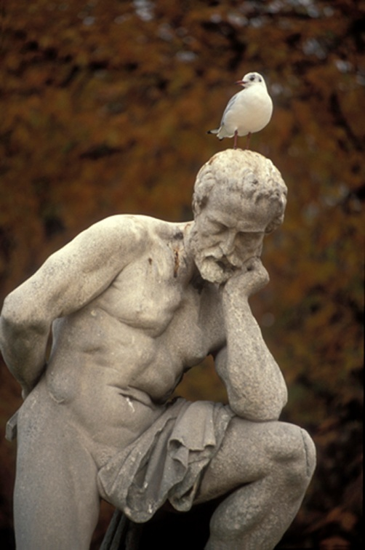
Renaissance Jeopardy
A Unit Review Project

Introduction
From the early 14th to the late 16th century, a revival of interest in the values and arts of Greece and Rome led to a golden age of cultural blending and innovation. This Renaissance transformed western European life. During the Renaissance, the western European world image shifted. Renaissance intellectuals had a growing confidence in individual human spirit and abilities. This new focus on personal worth of the individual is called 'humanism'.

Mini Lesson on Levels of Questioning
You are provided with a resource on Bloom’s Critical Thinking Questioning Strategies. You've learned what makes a good question (comprehension, application, analysis, synthesis and evaluation). Equipped with this new understanding you will be developing a review game using a template. You will use your learning to complete the task below.

Task
You are the teacher!
With a fellow teacher (your partner) you are to develop a review of the Renaissance for your class. It will take the form of a Renaissance Jeopardy Game! The categories of the game have been provided for you.
Using the “Renaissance Jeopardy Question Board” and the “Renaissance Jeopardy Answer Board”, you need to formulate the questions and answers for each category.

- The '10 point' questions must be Comprehension questions.
- The ’20 point’ questions must be Application questions.
- The '30 point' questions must be Analysis questions.
- The '40 point' questions must be Synthesis questions.
- The '50 point' questions must be Evaluation questions.
Process
STEP ONE:
Use the information from the following website, combined with the knowledge you gained from this unit, to develop your game questions.
- Renaissance Exhibits Collection

STEP TWO:
Record your questions on your “Renaissance Jeopardy Question Board” and the answers in the “Renaissance Jeopardy Answer Board”. Remember that you will need to create questions from all levels of Bloom's Taxonomy (comprehension, application, analysis, synthesis and evaluation).
STEP THREE:
When your Question and Answer Boards are complete, you will place your questions and answers in the Jeopardy game template. First, open the template and save it to your computer with your names in the title. Then to enter your questions and answers, click once on the text on the slide. Type over what's there to replace it. If you hit Delete or Backspace, it sometimes makes the text box disappear. When you are finished make sure to SAVE AS (Renaissance Game) in your student folder.

CREATED FOR
THE CENTRAL ALBERTA REGIONAL CONSORTIUM BY
Rachelle Haggerty and Margaret Lopetinsky
MAY, 2007

