**Exit/Entrance Slips for Sinusoidal Functions**



**8.1.  Describe, orally and in written form, the characteristics of a sinusoidal function by analyzing its graph.**

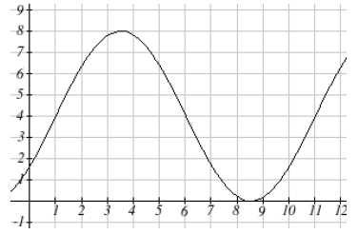

Describe the graph using the words amplitude, vertical displacement and period. Is there a phase shift?



**Answer:**

**Please note that students need only to discuss a phase shift has occurred, not the magnitude or direction. That is beyond the scope of 30-2.**

Allow the students to either discuss it use the sine or the cosine function.

**Sine Function**

Amplitude = 4

Phase Shift = Yes

Vertical Displacement = 4 up

Period = 

**Cosine Function**

Amplitude = 4

Phase Shift = Yes

Vertical Displacement = 4 up

Period = 

Students who get the above question, can work in groups to discuss the following questions. The others are with me to review the characteristics of sinusoidal graphs.

These questions would be assigned for homework for those students who were working with the teacher.



**Graph A Graph B**

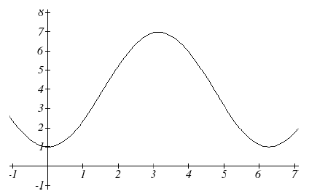 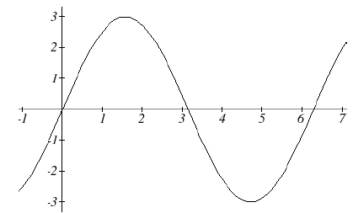

Using the words amplitude, phase shift, vertical displacement and period, describe how the two sinusoidal graphs are different. How are they similar?



**Graph A Graph B**

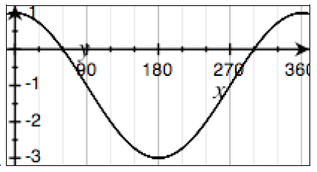 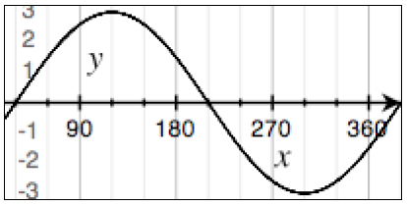

Using the words amplitude, phase shift, vertical displacement and period, describe how the two sinusoidal graphs are different. How are they similar?