Math 30-1

Function OPERATIONS



STUDENT NAME:_____________________________________________________

CHAPTER EXAM DATE:_______________________________________________

**Math 30-1**

**Unit: Function Operations**

**Topic: Sums and Differences of Functions**

Objectives:

* Sketching the graph of a function that is the sum or difference of two functions
* Determining the domain and the range of a function that is the sum or difference of two functions.
* Writing the equation of a function that is the sum or difference of two functions

**Example**

Consider the function and . Use the table of values to comare the output values for , and given input values of -2, -1, 0, 1, and 2.

|  |  |  |  |
| --- | --- | --- | --- |
| *x* |  |  |  |
| -2 |  |  |  |
| -1 |  |  |  |
| 0 |  |  |  |
| 1 |  |  |  |
| 2 |  |  |  |

Sketch the graphs of ,, and on the grid provided.

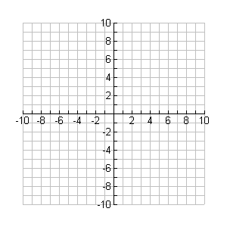

How could you use the values in the columns  and to determine the values in the column for?

How are the y-coordinates on the graph of related to those on the graphs ofand ?

Fill in the table.

|  |  |  |  |
| --- | --- | --- | --- |
|  |  |  |  |
| Domain |  |  |  |

**Example**

Consider the function and . Use the table of values to comare the output values for , and given input values of -2, -1, 0, 1, and 2.

|  |  |  |  |
| --- | --- | --- | --- |
| *x* |  |  |  |
| -2 |  |  |  |
| -1 |  |  |  |
| 0 |  |  |  |
| 1 |  |  |  |
| 2 |  |  |  |

Sketch the graphs of ,, and on the grid provided.



How could you use the values in the columns  and to determine the values in the column for?

How are the y-coordinates on the graph of related to those on the graphs ofand ?

Fill in the table.

|  |  |  |  |
| --- | --- | --- | --- |
|  |  |  |  |
| Domain |  |  |  |
| Range |  |  |  |

Determine the values of when x = 3.

**Example**

Consider the function and .

a) Determine the equation of the function .

b) Sketch the graphs of ,, and on the grid provided.

c) State the domain and range of .

d) Is equal to ? If not, what are the similarities and the    differences?



**Example**

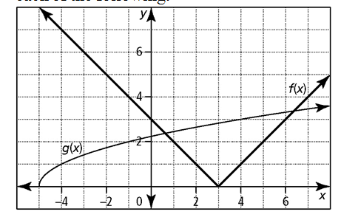Sketch the graph of given the graphs of and 

**Example**

Sketch the graph of given the graphs of and 

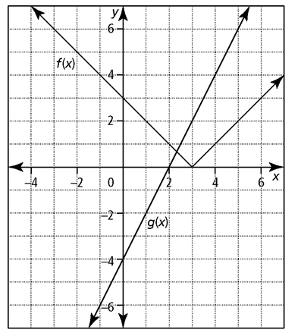



**Summary**

|  |  |  |
| --- | --- | --- |
|  | *Sum of Functions* | *Difference of Functions* |
| Notation | or | or |
| Example | , | , |
| Domain |  |  |
| Range |  |  |

**Math 30-1**

**Unit: Function Operations**

**Topic: Product and Quotients of Functions**

Objectives:

* Sketching the graph of a function that is the product or quotient of two functions
* Determining the domain and the range of a function that is the product or quotient of two functions.
* Writing the equation of a function that is the product or quotient of two functions

**Example**

Consider the function and . Use the table of values to comare the output values for , and given input values of -2, -1, 0, 1, and 2.

|  |  |  |  |
| --- | --- | --- | --- |
| *x* |  |  |  |
| -2 |  |  |  |
| -1 |  |  |  |
| 0 |  |  |  |
| 1 |  |  |  |
| 2 |  |  |  |

Sketch the graphs of ,, and on the grid provided.



How could you use the values in the columns  and to determine the values in the column for?

How are the y-coordinates on the graph of related to those on the graphs ofand ?

Fill in the table.

|  |  |  |  |
| --- | --- | --- | --- |
|  |  |  |  |
| Domain |  |  |  |

**Example**

Consider the function and . Use the table of values to comare the output values for , and given input values of -2, -1, 0, 1, and 2.

|  |  |  |  |
| --- | --- | --- | --- |
| *x* |  |  |  |
| -2 |  |  |  |
| -1 |  |  |  |
| 0 |  |  |  |
| 1 |  |  |  |
| 2 |  |  |  |

Sketch the graphs of ,, and on the grid provided.



How could you use the values in the columns  and to determine the values in the column for?

How are the y-coordinates on the graph of related to those on the graphs ofand ?

Determine the values of when x = 4.

Fill in the table.

|  |  |  |  |
| --- | --- | --- | --- |
|  |  |  |  |
| Domain |  |  |  |
| Range |  |  |  |

**Example**

Consider the function and .

a) Determine the equation of the function .

b) Sketch the graphs of ,, and on the grid provided.

c) State the domain and range of .



**Summary**

To combine two functions, , multiply or divide as follows:

*Product of Functions Quotient of Functions*

Notation

Domain

Range

**Math 30-1**

**Unit: Function Operations**

**Topic: Composite Function**

Objectives:

* Determining values of a composite function
* Writing the equation of a composite function and explaining any restrictions
* Sketching the graph of a composite function

Consider the function given by. This function can be thought of as being composed of two functions:

the “multiply by 2” function denoted by  and the “add 3” function denoted by .

Given that , determine an equation for  and 

The composite function, says first multiply by 2 and then add 3. Complete the arrow diagram below.

x multiplied by 2 2x add 3 2x+3

0

1

2

Composite function –

**Example**

If  and  determine each of the following.

a)  b) 

**Example**

If  and  determine each of the following.

a)  b)  c)  d) 

**Example**

If  and  determine each of the following.

a) 

b) 

c) Does the order matter when composing functions?

d) State the domain of,, , and.

**Example**

If  and . Determine the equation of each composite function, graph it and state its domain and range.

a)  b) 

**Example**

Determine two functions, and where  .

a)  b) 