Math 30-1

Trigonometric Identities

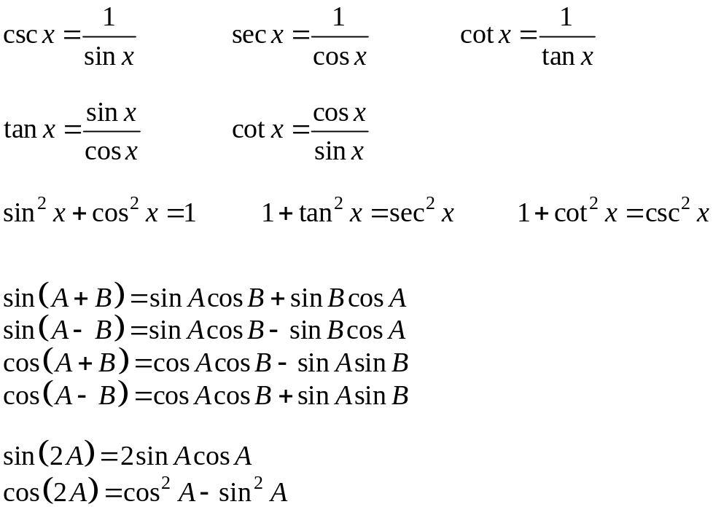

NAME:

Math 30-1
Unit: Verifying Trigonometric Identities
Topic: Reciprocal, quotient and Pythagorean identities
Objectives:
- Learn to verify a trigonometric identity numerically and graphically using technology
- Learn to explore reciprocal, quotient, and Pythagorean identities
- To determine non-permissible values of trigonometric identities
- To explain the difference between a trigonometric identity and a trigonometric equation

What is the difference between an equation and an identity?

Example
is an equation. It is only true for certain values of the variable x. Determine the solutions to this equation.

Example
is an identity. It is true for all values of the variable x. Prove it.

Comparing Two Trigonometric Expressions
1. Graph the curves y = sin x and y = cos x tan x over the domain Graph the curves on separate grids using the same range and scale. What do you notice?

2. Use the table function on your calculator to compare the two graphs. Describe your findings.

3. Use your knowledge of tan x to simplify the expression cos x tan x

4. What are the non-permissible values of x in the equation sin x = cos x tan x?

The equations y = sin x and y = cos x tan x are examples of trigonometric identities. Trigonometric identities can be verified both numerically and graphically.

Numerically
Verify that y = sin x and y = cos x tan x are equal for the following values of x.

- 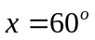

- 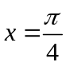

Graphically
If you wanted to verify graphically that y = sin x and y = cos x tan x are indeed the same thing, what would you expect to see on your calculator when you enter the two equations?
Example
For each of the following identities, state the restrictions and verify algebraically using the given values for .

a. 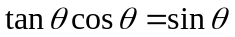 for 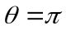.

b. 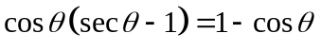 for 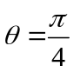.

c. 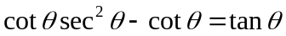 for 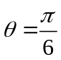.

Assignment: pg. 296-297 #1-8, 10-14, 15

Math 30-1
Verifying Trigonometric Identities
For each of the following identities:
- State the restrictions on , and
- Verify each identity for the value given.

1. 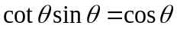, 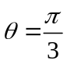 4. , 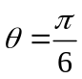

2. 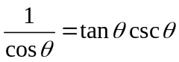 , 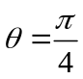 5. 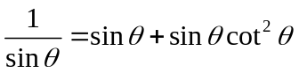, 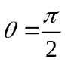

3. 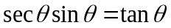 , 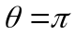 6. 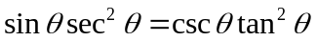,

7. 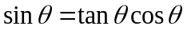 , 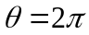 11. 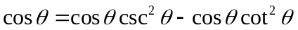,

8. 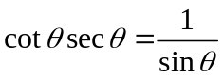 , 12. 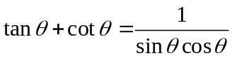,

9. 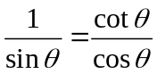 , 13. 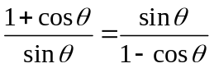, 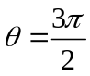

10. 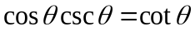, 14. 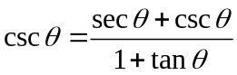,

Math 30-1
Unit: Trigonometric Identities
Topic: Reciprocal, quotient and Pythagorean identities
Objectives:
- Learn to explore reciprocal, quotient, and Pythagorean identities
- To determine non-permissible values of trigonometric identities
- To explain the difference between a trigonometric identity and a trigonometric equation

Reciprocal Identities:
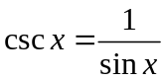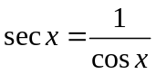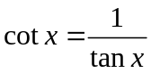
Quotient Identities:
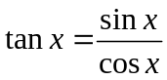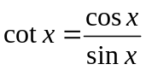

Pythagorean Identity
Mark off a point in Quadrant I that is on the unit circle. Write the coordinates of that point in terms of sine and cosine. Apply the Pythagorean Theorem in the right triangle to establish the

Pythagorean Identity:

Pythagorean Identities: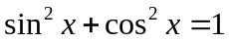 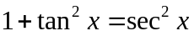 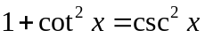
These identities can be written in several ways:

Verifying Identities for a Particular Case:
When verifying an identity we must treat the left side (LS) and the right side (RS) separately and work until both sides represent the same value.
This technique does not prove that an identity is true for all values of the variable – only for the value of the variable being verified.

Example
Verify that .
a. Determine the non-permissible values, in degrees, for the equation.

b. Verify using θ= 30˚.

Example
Express each as a single trig ratio.

a. 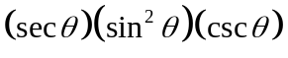 b. 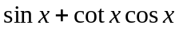

c. 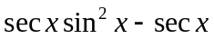 d. 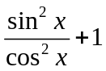

e. f. 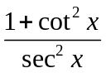

Assignment: pg. 296-297 #1-8, 10-14, 15

Math 30-1
Unit: Trigonometric Identities
Topic: Proving Identities
Objectives:
- To prove trigonometric identities algebraically
- To understand the difference between verifying and proving an identity
- To show that verifying the two sides of a potential identity are equal for a given value is insufficient to prove the identity

To prove that an identity is true for all permissible values, it is necessary to express both sides of the identity in equivalent forms. One or both sides of the identity must be algebraically manipulated into an equivalent form to match the other side.
You cannot perform operations across the equal sign when proving a potential identity. Simplify the expressions on each side of the identity independently.

Hints in Proving an Identity:
1. Begin with the more complex side
2. If possible, use known identities given on the formula sheet, (ie. try to use
the Pythagorean identities when squares of trigonometric functions are
involved)
3. If necessary change all trigonometric ratios to sines and/or cosines, eg.
replace tan x by 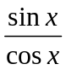, or sec x by 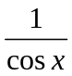.
4. Look for factoring as a step in trying to prove an identity.
5. If there is a sum or difference of fractions, write as a single fraction
6. Occasionally, you may need to multiply the numerator or denominator of
a fraction by its conjugate.

It is usually easier to make a complicated expression simpler than it is to make a simple expression more complicated.
Example
Consider the statement 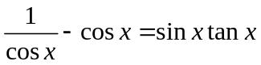
a. Verify the statement is true for 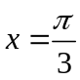
L.S. R.S.

b. Prove the statement algebraically:
L.S. R.S.

c. State the non-permissible values for x. Work in degrees.

Example
Prove the following identities. You should also be able to state restrictions for each identity.

a. 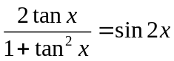 b. 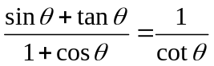

c. 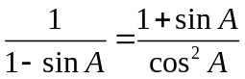 d. 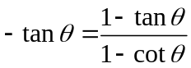

e. 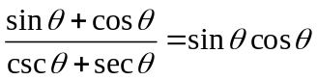 f. 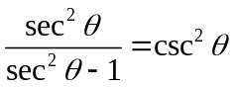

Example
Prove that is an identity.

For what values of x is this identity undefined?

Assignment: pg. 314-315 #1-8, 10-15, 16-18 & proofs worksheet on following page.
Math 30-1
Trigonometric Proofs
On a separate piece of paper, algebraically prove each of the following identities by using any combination of the basic relations. You do not have to state the non-permissible values (even though you should).

1. 17.
2. 18.
3. 19.
4. 20.
5. 21.
6. 22.
7. 23.
8. 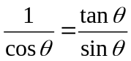 24.
9. 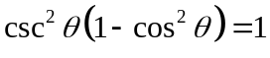 25. 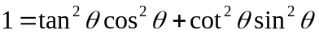
10. 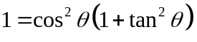 26. 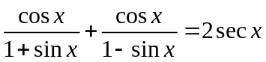
11. 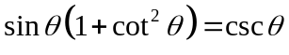 27. 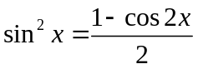
12. 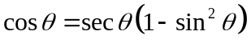 28. 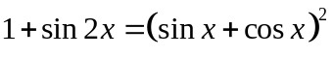
13. 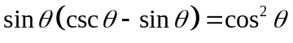 29. 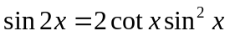
14. 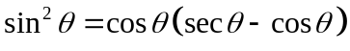 30. 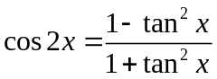
15. 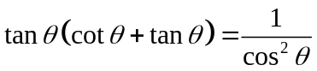 31. 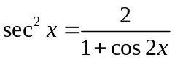
16. 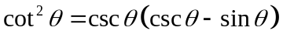 32. 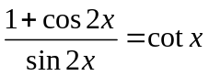
Math 30-1
Unit: Trigonometric Identities
Topic: sum, difference and double angle identities.
Objectives:
- Learn to apply sum, difference, and double-angle identities to verify the equivalence of trigonometric expressions
- To verify a trigonometric identity numerically and graphically using technology
Example
Use exact values to verify the following statement:
L.S. =
R.S. =

Sum and Difference Identities:
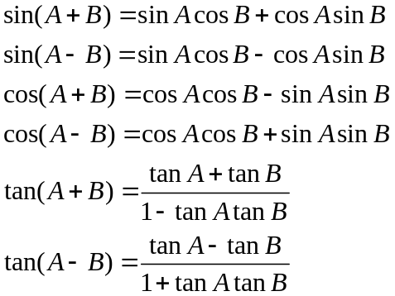
These are on the formula sheet

Example: Write the expression as a single trigonometric function.

Example: Find the exact value of 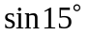

Example: Determine the exact value of

Example: Simplify each
a) b) 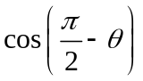

c) 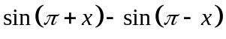

Example: Given 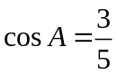and 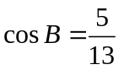, where 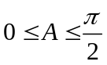 and 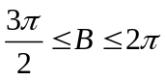, find the exact value of
Double Angle Identities:

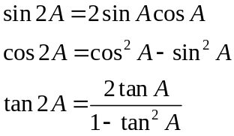

These identities are on the formula sheet

Example
Express each in terms of a single trigonometric function:

a. 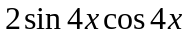

b. 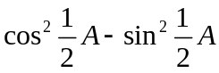

c. 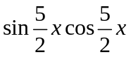
Example
Determine an identity for 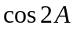 that contains only the sine ratio.

Example
Determine an identity for that contains only the cosine ratio.

Example
Simplify the expression to one of the three primary trigonometric ratios

Assignment: pg. 306-308 #1-11, 15-17, 20, 23
Math 30-1
Unit: Trigonometric Identities
Topic: solving trig equations using identities
Objectives:

- To solve trigonometric equations algebraically using know identities
- To determine exact solutions for trigonometric equations where possible
- To determine the general solution for trigonometric equations
- To identify and correct errors in a solution for a trigonometric equation

Investigation
1. Graph the function over the domain . Describe the graph.

2. From the graph, determine an expression for the zeros of the function over the domain of all real numbers.

3. Algebraically solve over the domain. Compare your answers to the question above.

To solve some trigonometric equations, you need to make substitutions using the trigonometric identities that you have studied in this chapter. This often involves ensuring that the equation is expressed in terms of one trigonometric function.

Example
Solve the following equation where 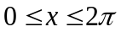.

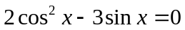

Example
Solve for x as an exact value where

Example
Solve the equation algebraically over the domain

Verify your answer graphically.

Example
Algebraically solve . Give general solutions expressed in radians as exact values.

Example
Algebraically solve Give general solutions expressed in radians as exact values.

Unless the domain is restricted, give general solutions. Check that the solutions for an equation do not include non-permissible values from the original equation.

Assignment: pg. 320-321 #1-11, 14-16, 17

