Ant Models!
Mrs. Michaud brings an ant farm into her classroom so her students can learn more about insects. The students learn that an ant is made up of 2 antennae, one body and six legs. They each make a model of the ant.

Use pictures, words, numbers and/or symbols to show how you solved each of the following questions.

How many antennae, bodies and legs would be needed to model 8 ants?

To feed 2 ants, you need 4 milligrams of food per day. How many milligrams of food would you need each day for 14 ants?
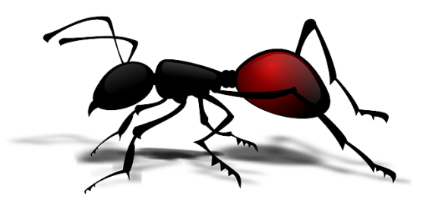
How many ants could you feed with 44 milligrams of food per day?

