Let’s Have a Picnic!

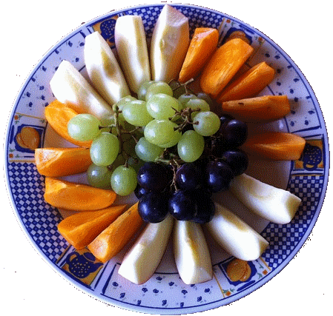
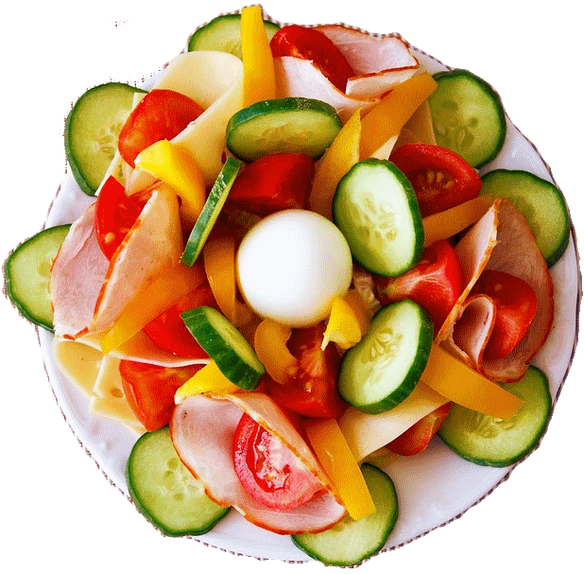
Natasha is setting up for a picnic. She uses a very special blanket, made up of many pieces that are exactly the same size. On top of the blanket, she places a large plate of fruit and a plate of vegetables. How many pieces were used to make the blanket? Using pictures, words, numbers and/or symbols, show how you figured it out.

