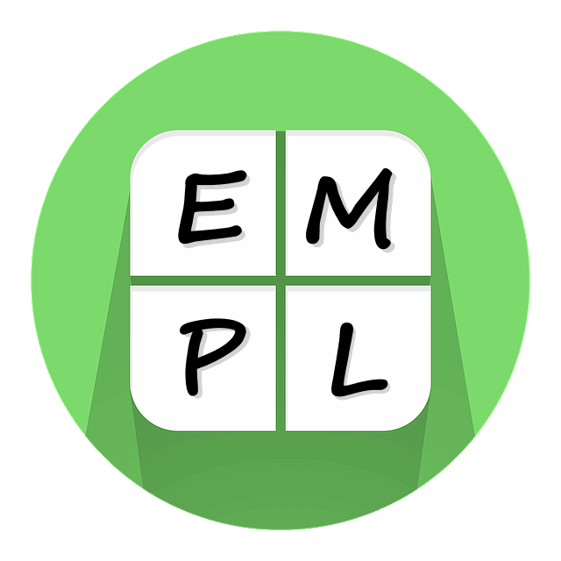

Big Idea 1
Additive Thinking

Parent Communication
This is not a test! These questions and example tasks are provided to give you insight into the importance of additive thinking in mathematics. Remember, we all come to the tasks with different levels of understanding. If you are using it with your child, both of you should focus on thinking and talking and comparing what you thought. Let your child respond first and listen carefully. You may be surprised by what they say or already know. Try to avoid statements like “No. That’s wrong. Here’s the answer.” Instead, ask questions like “What makes you think that?” and “Can you show me what you’re thinking?” Then turn the page over and look at the information on the back. Compare your thinking to what is explained here. What’s the same? What’s different? Did anything surprise you? At home activities are a chance to further explore your child’s understanding.

Caution: Additive Thinking’s Big Idea 1 develops the understanding needed for Big Idea 2 and Big Idea 3.

- True or False? 9 + 4 = 10 + 3

- Solve the following in your head.
51 + 34
252 + 358
547 + 389
- Each of the following is a mental strategy for solving the question 23 + 41. Do you like some strategies better than others?
  - 23 + 41 = 60 + 4
  - 23 + 41 = 23 + 40 + 1
  - 23 + 41 = 3 + 1 + 20 + 40
  - 23 + 41 = 40 + 24
  - 23 + 41 = 41 + 20 + 3
  - 23 + 41 = 20 + 44

- True or False? Children can use whatever strategy they want in order to find an answer.

Big Idea 1: Once students trust the “count”, they can flexibly manipulate numbers in order to make solving problems easier.

- True or False?
This is true. “Making Tens” is a strategy that is strongly encouraged in school as it supports the development of mental mathematics. The more you can do in your head, the faster you can do your work. You can manipulative/rearrange the numbers in the question so that you can use the number ten to your advantage. For example, in the question 9 + 4, 9 is only 1 away from 10. So you can take 1 from the 4 (which leaves 3) and add it to the 9 (which gives you 10). The result is the same regardless of whether you did 9 + 4 or 10 + 3.
At home, play board games, card games and dice games. Model to your child how you can make ten and encourage them to try it,

- Solve 51 + 34, 252 + 358, and 547 + 389
The answers are 85, 610 and 936. However, the important question is “How did you solve it?” Focus on the thinking. We want students to explain their thinking because that’s how they become confident. Would you be surprised to learn that many adults will solve this left to right? For example, in order to solve 547 + 389, they would start by adding 547 + 300 = 847. 847 + 80 = 927. 927 + 9 = 936. Please note, it took longer to write those steps out, then it took to solve in my head. In order to see a variety of ways that adults choose to solve similar questions, please check out the video at: http://bit.ly/empl-ATBI1vid1
- At home, when the opportunity presents itself, ask your child to find answers mentally and discuss the strategy used. Share your strategy and discuss how they are similar and different. Working together, can you find another strategy that will work? As with any skill, practice makes perfect. The more you practice mental computation, the better you will be at it. Which strategies do you prefer?
Different people use different mental strategies in order to make it easier to find the answer. Just as in the previous question, each person will use a strategy that makes sense for them.
At home, you can read more about strategies at http://bit.ly/abstrats

- True or False?
What really matters is that your child uses a strategy that is efficient (find them the correct answer in a reasonable amount of time), effective (finds them the correct answer every time), and explainable (they can explain why it works ). Strategies evolve over time and must be deliberately practiced. Strategies are algorithms and all algorithms must be practiced with understanding in order for you to become efficient at them. At home, use any and all opportunity to do mental math and explain and compare strategies with your child.

