Big Idea 1
Multiplicative Thinking

Parent Communication
This is not a test! These questions and example tasks are provided to give you insight into the importance of multiplicative thinking in mathematics. Remember, we all come to the tasks with different levels of understanding. If you are using it with your child, both of you should focus on thinking and talking and comparing what you thought. Let your child respond first and listen carefully. You may be surprised by what they say or already know. Try to avoid statements like “No. That’s wrong. Here’s the answer.” Instead, ask questions like “What makes you think that?” and “Can you show me what you’re thinking?” Then turn the page over and look at the information on the back. Compare your thinking to what is explained here. What’s the same? What’s different? Did anything surprise you? At home activities are a chance to further explore your child’s understanding.

Caution: Additive Thinking’s Big Idea 1 develops the understanding needed for Big Idea 2 and Big Idea 3.

- This is a picture of 12. Use equal groups to describe this 12.

- Predict how many small yellow paper clips fit the length of the pencil.

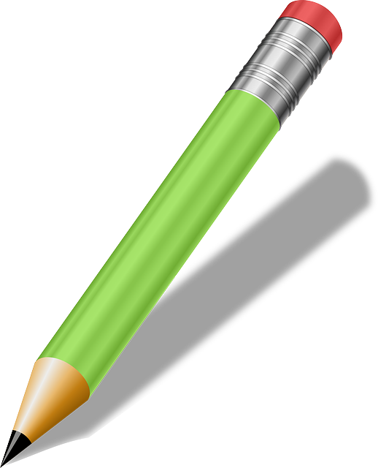
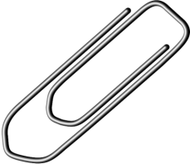
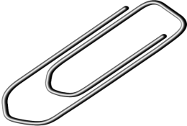

Big Idea 1: The foundations for thinking multiplicatively are embedded in outcomes as early as Kindergarten.

- Describe 12.

You could have said
- Two 6s
- Four 3s
- Six 2s
- Twelve 1s
- Three 4s

Symbolically, these could be described as
- 2 x 6 or 2(6)
- 4 x 3 or 4(3)
- 6 x 2 or 6(2)
- 12 x 1 or 12(1)
- 3 x 4 or 3(4)

When students are thinking additively, they might describe it as 2+2+2+2+2+2. When they are thinking multiplicatively, they see 2 x 6.
At home, explore the idea that when they see equal groups, they can explain it using multiplication instead of addition.

- How many small yellow paper clips?
Six small yellow paper clips fit the length of the pencil. Because one large silver paper clip = two small yellow paper clips, there are two ideas going in this image. The number of yellow paper clips are twice the number of silver paper clips. The number of silver paper clips is half the number of yellow ones.
At home, look for situations that describe a ratio. For example, two hands for every one person. Two eyes for every one person. Four feet for every dog. Five fingers for every hand. For every hours, there are 60 minutes. For every week, there are 7 days. For every toonie, there are two loonies. Discuss with your child, doubling and halving.

