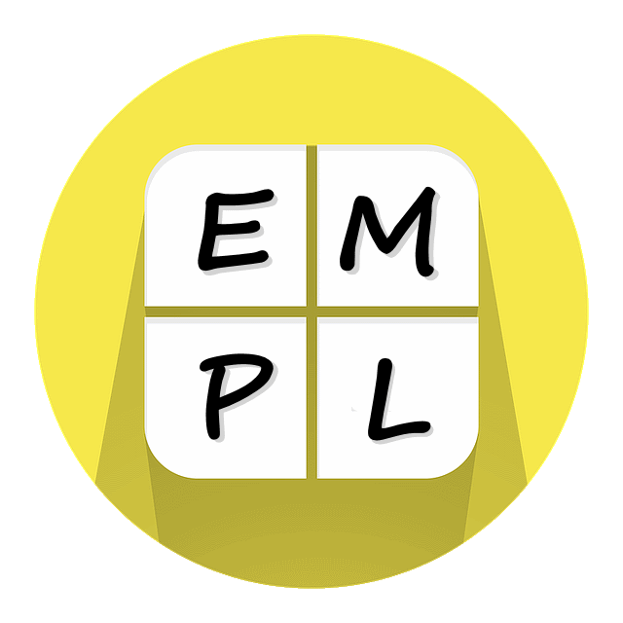

Big Idea 2
Multiplicative Thinking

Parent Communication
This is not a test! These questions and example tasks are provided to give you insight into the importance of additive thinking in mathematics. Remember, we all come to the tasks with different levels of understanding. If you are using it with your child, both of you should focus on thinking and talking and comparing what you thought. Let your child respond first and listen carefully. You may be surprised by what they say or already know. Try to avoid statements like “No. That’s wrong. Here’s the answer.” Instead, ask questions like “What makes you think that?” and “Can you show me what you’re thinking?” Then turn the page over and look at the information on the back. Compare your thinking to what is explained here. What’s the same? What’s different? Did anything surprise you? At home activities are a chance to further explore your child’s understanding.

- We’re unpacking the groceries. There are 12 cans of tomato soup. We can fit stacks of 3 cans on the shelf. How many stacks will there be? What if we could fit four in a stack? How would the answer change?

- Imagine a piece of paper. Fold it into three equal pieces in one direction, unfold and then fold it in four equal pieces in the other direction. How many rectangles will you have?

- What happens when you double this model?
What does your new object look like?

Big Idea 2: Multiplication is not just repeated addition even though multiplication can often be solved using repeated addition.
Second Fold: In Four Equal Pieces
First Fold: In Three Equal Pieces
- Unpacking groceries.
You will have 4 stacks if there are 3 cans in each stack. You will have 3 stacks if there are 4 cans in each stack.
At home, take opportunities to talk about taking objects and placing in equal groups: sharing candy, cookies, cutting a cake, etc.

- Solve the question.
If you fold the paper in three equal pieces in one direction, unfold it and then fold it in four equal pieces in the other direction, you will end up with 12 rectangles on your paper. The idea of equal parts and equal pieces is just as important as the idea of equal g roups.
At home, play with paper folding. You don’t need to focus on “how is this multiplication”. It’s the actual action of folding in two directions that helps your child help develop the thinking they need. Origami is a great tool for this.

- Double the model.
Does your object look like one of these?
You doubled 1 dimension. |  | You doubled 2 dimensions. |  | You doubled 3 dimensions.

At home, build 3D objects like the cube above. Ask questions like “what would happen if we doubled this?” Encourage them to consider all three situations – 1 dimension, 2 dimensions and 3 dimensions. Lego pieces are a great tool for this.

