Draw
ONE vertical line A DIFFERENT Vertical Line
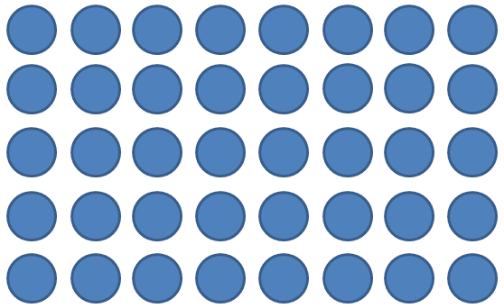

ONE horizontal Line A DIFFERENT Horizontal Line

If student only knew up to x 2 If student only knew up to x 3

7 dots by 9 dots 4 dots by 13 dots

17 x 14 3 x 6.5

23

14

