Dot Arrays with Numbers:
Introducing the Distributive Property
Materials:
- Smart Notebook file
- Manipulatives (about 50) per student or group of 2
- Mini whiteboards/markers

What it looks like | What to Say/Do
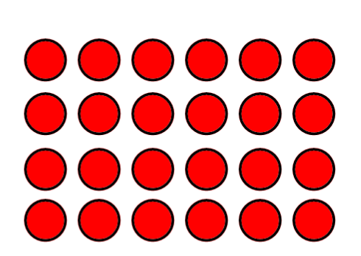 | Ask students to name the multiplication sentence this array represents. 6 x 4 or 4 x 6  Have students build (or draw) this array.
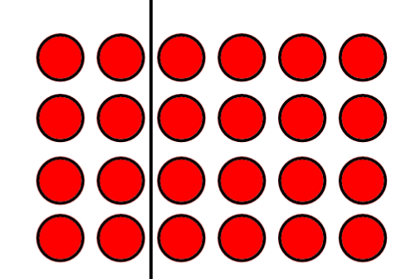 | Have students draw a single vertical or horizontal line splitting the array up into two arrays. (The images shown provide one example students might share).  Ask one student to share how they drew the line by drawing it on the smartboard.
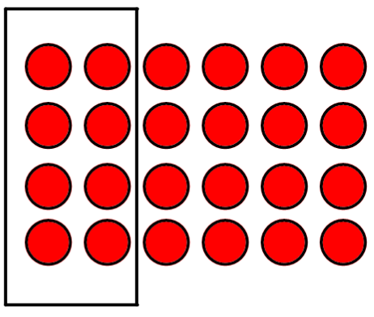 | Draw students’ attention to one of the sections.
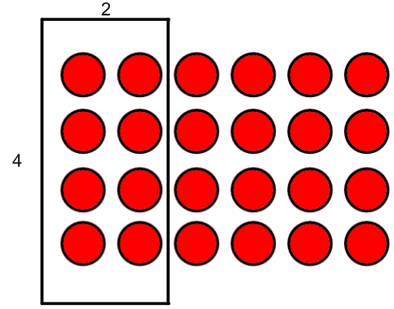 | Ask them what multiplication statement is shown here and write on the screen. 2 x 4
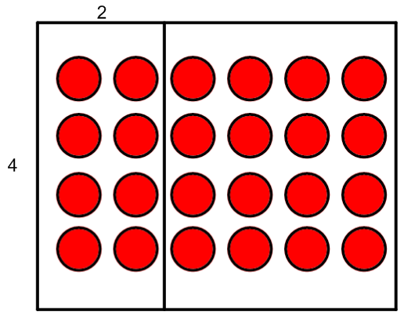 | Draw students’ attention to the other section.
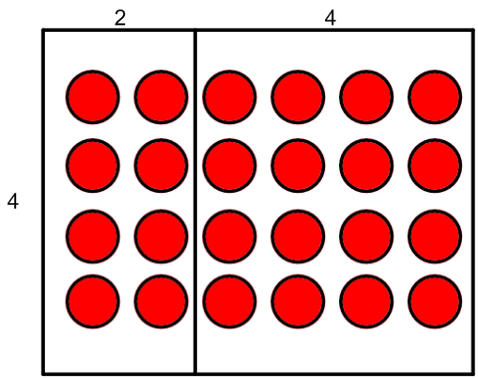 | Ask them what multiplication is shown in here and write on the screen. 4 x 4
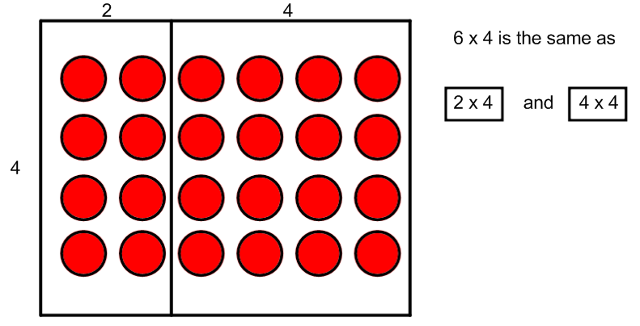 | Remind them “We started with 6 x 4 but we can see that it’s the same as 2 x 4 and 4 x 4.” Write this on the screen using boxes instead of brackets as an introduction.
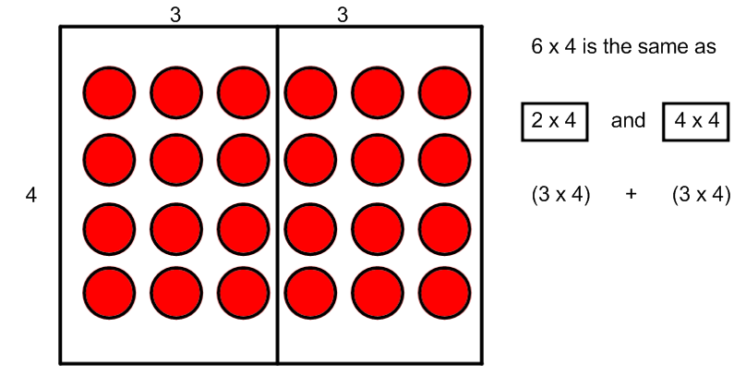 | Remove the lines. Ask another student how they drew the line. Repeat the process: draw the line, write down the mathematical statements; but this time, don’t draw the square, write brackets and explain that it means the same thing. Ask them what mathematical operation can we use instead of the word and? On the screen, write + instead of and.  Repeat until all possibilities show up, including horizontal divisions. If students don’t come up with all of them, just ask them to find the rest.  Have students repeat this activity on their own using their own multiplication to start (anything that is less than 9 x 9 and more than 5 x 5). How many multiplication statements can they make?  Students could share their original statement (ex. 3 x 7) and say two of their equivalent statements – one horizontal and one vertical. For example: 3 x 7 is the same as (2 x 7) + (1 x 7). 3 x 7 is the same as (3 x 4) + (3 x 3).
 | Tell students that mathematicians are the laziest people in the world. We really don’t want to have to draw all those dots. Let’s pretend we’ve drawn the dots but do all of the rest of the steps the same way. For example, draw 6 x 4 on the board again.
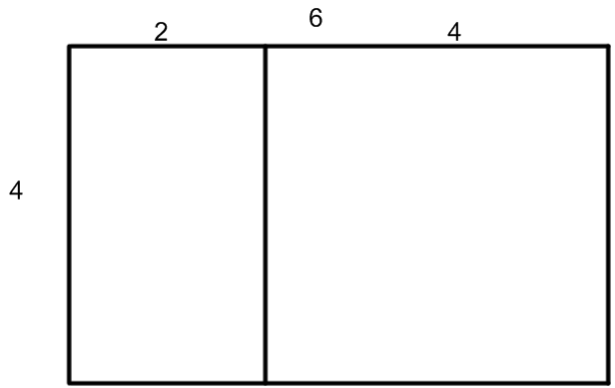 | Use your imagination to picture the dots there. Let’s break this one up with one horizontal or vertical line. What would it look like? Have a student share how they split it.
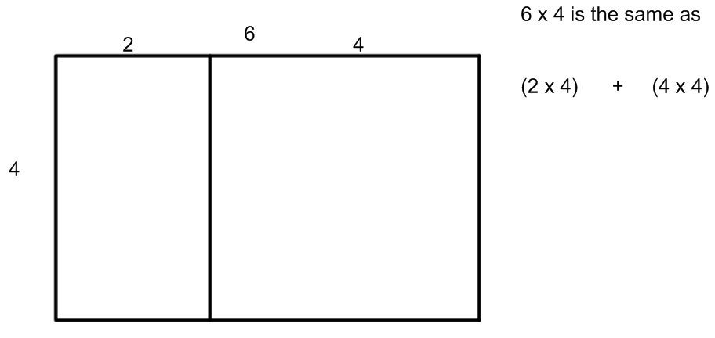 | Record the mathematical statement on the right. Repeat with other students’ work.
Puzzler: Ask students to see if they can draw one for 13 x 4.
Extra Puzzler: Figure out the answer. <without drawing the dots>

