Name:__________________
Math 30-2
Unit 2 – Combinatorics

Outcome
SO 4 | Solve problems that involve the fundamental counting principle.
SO 5 | Solve problems that involve permutations
SO 6 | Solve problems that involve combinations

Vocabulary (define the following)

- Fundamental counting principle
- Permutation
- Factorial Notation
- Combinations
- Pathways
- Constants/Vowels

WS#1—Fundamental Counting Principle

- You are ordering dinner at a restaurant. How many ways can you order a meal if you have two choices for a drink (coffee or tea), three main courses to choose from (chicken, beef, or fish) and two deserts (pie or cake)?
- Draw a tree diagram
- Use the fundamental counting principle

- If three albums are placed in a multi-disc stereo, how many ways can the albums be played?

- Television stations in Canada usually have call letters that are 4 letters long and begin with the letter C. If CRTC made this a law in Canada:
- How many television stations could the CRTC license?
- How many stations could CRTC license if repetition of letters is NOT allowed?

- In Canada, postal codes consist of 6 characters –three letters and three digits. Each postal code starts with a letter and alternates with a digit.
- How many postal codes are there?
- How many start with the letter S?
- How many start with letter S and end in the digit 8?
- How many start with the letter S, digit 6 and NO letter or digit is repeated?

- In how many ways can ALL of the letters of the word TRAVEL be arranged if:
- There are NO restrictions?
- It must start with T?
- It starts with a consonant and ends in a vowel?

- How many ODD four digit numbers can be made from all of the digits , if:
- Repetition is allowed?
- Repetition is not allowed?

BONUS: How many ways can you order the letters in KEYBOARD if K and Y must always be kept together?

WS#2—Factorial Notation

1. Evaluate each of the following without a calculator.

a) 5! b) c) d)

2. Simplify:
a) b) $\frac{\left(n-3\right)!}{\left(n-2\right)!}$

c) $\frac{\left(n+l\right)!}{\left(n-1\right)!}$ d) $\frac{\left(3n\right)!}{\left(3n-2\right)!}$

3. Solve
a) $\frac{\left(n+l\right)!}{n!}$ = 6 b) (n + 1)! = 6(n-1)!

c) $\frac{\left(n+2\right)!}{n!}$ = 12 d) $\frac{\left(n+1\right)!}{\left(n-2\right)!}$ = 20(n-1)

WS#3—Permutations

1. An investment club has five members and wants to choose a president and a vice-president. In how many ways can this be done?

2. Find the number of arrangements that are possible with:
a) three letters from the word COMPUTER
b) five letters from the word UNIVERSAL
c) four letters from the word KEYBOARD

3. In how many ways can ALL of the letters of the following words be word be arranged:
a) ASSIST?
b) MATHEMATICS?

4. A string of Christmas tree lights has 12 bulbs. If you have 5 red, 4 blue and 3 green bulbs, How many different arrangements of the lights are possible?

5. A cook is putting out the food for a buffet and was told by his manager to put out the salads first, then the bread, pasta, main courses, and dessert. If he must choose 4 of 5 salads, 2 of 3 types of bread, 2 types of pasta, 5 of 7 main courses and 3 desserts, how many ways can the chef arrange the buffet?

6. How many 3-digit, 4-digit or 5-digit numbers can be made using the digits of 46723819?

7.How many ways can you travel from point A to point B? (if question can be solved using pathways and permutations use both methods; no backtracking)

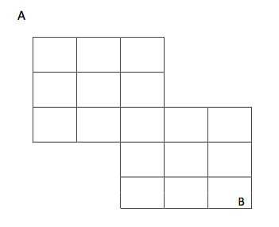
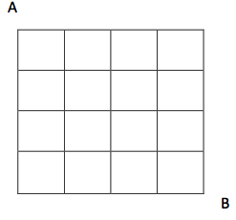
a) b)

8. How many ways can you travel from point A through the dot to point B?
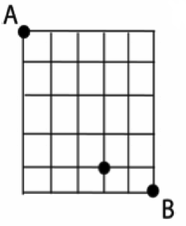

- Expand and simplify each of the following without using a calculator:

a) ₅P₃ b) express $\frac{7!}{3!}$ as a permutation

- Solve for n in the following equation: _{n}P₂₌ 56.

WS#4—Combinations

- How many 3 letter combinations can be formed from the letters of the word OSAGE?

- There are 15 technicians and 11 chemist working in a research lab. They need to form a 5 person safety committee. In hoe many ways can this committee be formed if
- may be chosen in any way?
- May be all technicians?
- May be all chemist?

3. A class has 15 boys and 12 girls. A committee of 6 must be chosen to represent the class at a meeting. In how many ways can this be done if:
a) there must be all girls
b) there must be 4 boys and 2 girls on the committee?
c) 3 boys and 3 girls on the committee?
d) the majority on the committee is girls?

- A toy box contains 4 different cars and 6 different trucks.
- in how many ways can a collection of 5 toys be chosen if the collection must consist of 2 cars and 3 trucks?
- In how many ways can the collection of 5 toys be chosen if the collection must consist of at least 3 cars?

- How many 5 card hands can be dealt from a standard deck of 52 cards if :
a) exactly 3 red cards?
b) 4 are Aces and 1 is a King ?
c) at least 2 kings
d) at most 2 clubs

6. Solve _{n}C₂ = 10

