**Exit/Entrance Slips for Sinusoidal Functions**



**8.3.  Match equations in a given set to their corresponding graphs.**

Which equation below represents the graph shown?

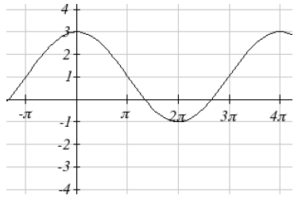

**A. **

**B. **

**C. **

**D. **



**Answer:**

D.

Students who get the above question, can work in groups to discuss the following question(s). The others are with the teacher to review the concept.

These questions would be assigned for homework for those students who were working with the teacher.



Discuss a strategy to determine the equation of the sinusoidal graph below. Is there more than one equation? Why or why not?

