Exit/Entrance Slips for Sinusoidal Functions

8.4. Graph data, and determine the sinusoidal function that best approximates the data.
8.5. Interpret the graph of a sinusoidal function that models a situation, and explain the reasoning.
8.6. Solve, using technology, a contextual problem that involves data that is best represented by graphs of sinusoidal functions, and explain the reasoning

The average monthly temperature in Savannah is given in the table below.

Month  t | Jan.  1 | Feb.  2 | Mar.  3 | Apr.  4 | May  5 | June  6 | July  7 | Aug.  8 | Sept.  9 | Oct.  10 | Nov.  11 | Dec.  12
Temperature  (F) | 48.9 | 51.8 | 59.2 | 66 | 73.5 | 79.1 | 81.8 | 81 | 76.6 | 67.3 | 59.1 | 51.7

a. Write a sinusoidal regression function of the form y = a • sin(bx + c) + d, where x is the month number and y is the average monthly temperature, that could be used to model these data. Round the values of a, b, c, and d to the nearest hundredth.

b. What does the equation of the midline represent in the context of this question?

c. What does the amplitude of the graph represent in the context of this question?

Answers:
a.
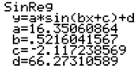

b. The equation y = 66.27 represents the average yearly temperature in Savannah.
c. The amplitude 16.35 represent how much warmer or colder the maximum and minimum temperatures are from the average in Savannah.
Students who get the above question, can work in groups to discuss the following question(s). The others are with the teacher to review the concept.
These questions would be assigned for homework for those students who were working with the teacher.

Harmonic Motion
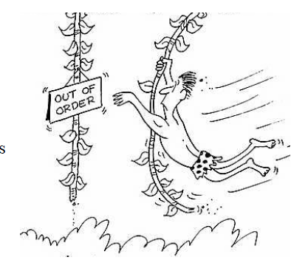
Suppose Tarzan is swinging back and forth on his grapevine. As he swings, he goes back and forth over the river bank, hovering alternately over land and water.
Jane decides to mathematically model his motion and starts her stopwatch.

Let t be the number of second the stopwatch reads and let y be the number of meters Tarzan is from the riverbank (not his height). Assume that y varies sinusoidally with t and that y is positive when Tarzan is over water and negative when Tarzan is over land.

Jane finds that at 2 seconds, Tarzan is at one end of his swing 23 feet from the riverbank over land. At 5 seconds, Tarzan is at the other end of his swing 17 feet from the riverbank over water.

a) Generate the equation that represents Tarzan’s swing model.
b) Where was Tarzan when Jane started her stopwatch?
c) Find the smallest value for t when Tarzan was directly over the riverbank.
d) How long is Tarzan over water?
e) Where will Tarzan be one minute from the time Jane started the stopwatch?

Mark Twain sat on the deck of a river steamboat. As the paddlewheel turned, a brightly painted yellow dot on the paddle blade moved in such a way that its distance from the water’s surface was a sinusoidal function of time. When the watch read 4 seconds, the dot was at its highest point, 16 feet above the water’s surface. The wheel’s diameter was 18 feet and it completed a revolution every 10 seconds.

a) Generate an equation for the sinusoidal curve.
b) How far above the surface was the dot when Mark’s stopwatch read 5 seconds?
c) How long was the dot below the water’s surface?
d) From the time when the stopwatch was started, when was the first time that the dot was at the surface of the water? At that time was in emerging from or entering the water?

