Radian or Degrees
What is my Measure?

Just like you can measure a piece of word in centimeter or inches, degrees are not the only unit of measure for angles. To explore the relationship between radian measure and degrees follow the instructions below.

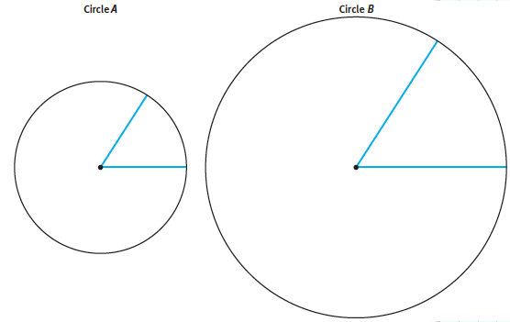

Cut a piece of string equal in length to the radius of each circle.

- Bend the string around each circle and mark off as many arcs as possible that are equal in length to the radii. Write the approximate number of radii that fit around each circle.

Circle A: Circle B:

b. What do you notice about your answers in Part (a)? How can you explain this? What is the exact number of radii that fit around each circle?

c. In each circle, mark off a central angle that intercepts an arc with the same length as the radius of the circle. Each such angle has a measure of one radian.

