We Are All Connected

Outcomes:

3.2 Global Citizenship
General Outcome
Students will demonstrate an understanding and appreciation of Canada’s roles and responsibilities in
global citizenship in relation to communities in India, Tunisia, Ukraine and Peru.

Specific Outcomes
􀀗Values and Attitudes
Students will:
3.2.1 appreciate elements of global citizenship:
• recognize how their actions might affect people elsewhere in the world and how the actions
of others might affect them (C, GC)
• respect the equality of all human beings (C, GC, I)
􀀗Knowledge and Understanding
Students will:
3.2.2 explore the concept of global citizenship by reflecting upon the following questions for
inquiry:
• In what ways can individuals and groups contribute to positive change in the world? (C,
GC, PADM)
• How do international organizations support communities in need throughout the world
(e.g., UNICEF, Red Cross, Development and Peace)? (C, GC)
• What are examples of international organizations formed by individuals (e.g., Free the
Children, Médecins sans frontières (Doctors Without Borders))? (C, GC)
• What are examples of international organizations formed by nations (e.g., UN)? (C, GC,
PADM)

SOCIAL PARTICIPATION AS A DEMOCRATIC PRACTICE
Students will:
3.S.5 demonstrate skills of cooperation, conflict resolution and consensus building:
• demonstrate cooperative behaviour to ensure that all members of the group have an
opportunity to participate
• demonstrate willingness to seek consensus among members of a work group
• consider the needs and points of view of others
• work and play in harmony with others to create a safe and caring environment
􀂾 share information collected from electronic sources to add to a group task
3.S.6 develop age-appropriate behaviour for social involvement as responsible citizens
contributing to their community, such as:
• participate in projects that improve or meet the particular needs of their school or
community
Students will develop a better understanding of different international organizations and how they can contribute to the needs of the global community.
----------------------------------------------------------------------------------------------------

Activity Process:
Discuss ways that children help others (in the home, at their school, in their family, in their community, in the world).
Read students a picture book about helping others, for example:
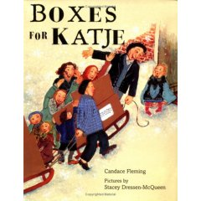

Boxes for Katje
By Candace Fleming

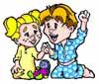

Patrick and Sara Volunteer and Learn About Homeless Families
By Linda Morcom
Calgary, AB, 2002

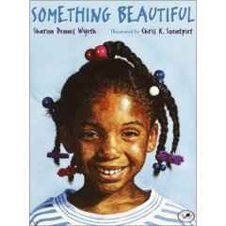

Something Beautiful
By Sharron Denis Wyeth
Ask the students: Why do we help others? How do we help others?

Focus into how we help others in the world. Why is it important to help others in the world? Why should we help others that we don’t know and will probably never meet? Why should we even care? Discuss the idea of being a global citizen.

This discussion should relate to quality of life as already been introduced.

Brainstorm different international organizations that they know of… discuss what the students think they do.

Some websites of service organizations:

www.unicef.ca

www.redcross.ca

www.doctorswithoutborders.org

www.freethechildren.com

www.worldvision.ca

www.devp.org (Development and Peace)

www.ryanswell.ca

www.samaritanspurse.org

*Many of these websites have a teacher resource section and/or a kids section. For example:
Unicef World Heros Game - Learn about UNICEF’s programs as you deliver vital supplies worldwide!
http://www.unicefgames.com/heroes/frames_large.html

Have students work together to find out more information about each organization as well as how you (the class) could help or become involved with the organization. Provide websites for the students to explore. Have students come back to class and web new information. If the class has a SmartBoard this can be done on Inspiration or another similar program. Make connections between the different organizations.
Have each student find a picture from their website that represents global citizenship to them. Have them choose a picture and copy/paste it into a Word document. Using AutoShapes (insert picture-→ autoshapes), add a callout to the picture and have each student then add what they think the person in the picture is thinking about (what they’re doing) or they could also write what they themselves are thinking about the picture. The callouts could be colour-coded (ex: red for what the person in the picture is thinking, yellow for what the student is thinking)
callout

I’m so glad we can provide a warm meal to these children.
For example:

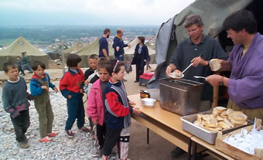

Assessment: Students should print their completed Callout Picture. This document could be used as an informal assessment tool to evaluate the student’s understanding of the purpose and role of service organizations.
Show the video:
Friends of the Family
Source Credit: © 1982 National Film Board of Canada
Format : Video
Duration: 9 minutes, 3 seconds
This is found on www.learnalberta.ca under grade three-→ social studies → videospace.

* NOTE: you will need a school login/password to access this resource)

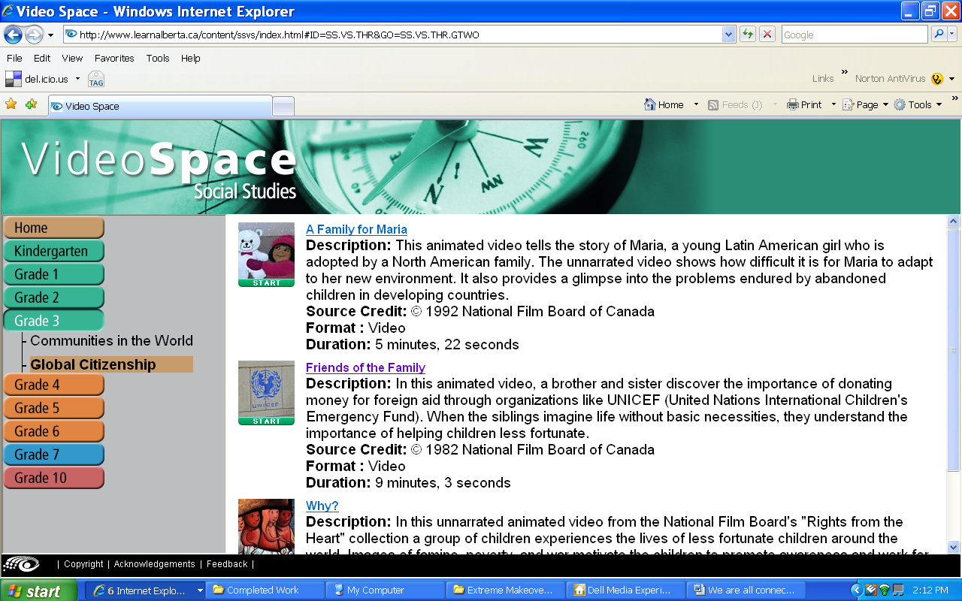

As a class decide on a service project that you would like to undertake. This can be as small as filling shoeboxes at Christmas Operation Christmas Child http://tinyurl.com/2ardqu or as big as raising money to build a school.

Have the class graph their progress (money raised, shoeboxes filled, etc). This can be done with many different computer programs such as Create a Graph http://nces.ed.gov/nceskids/createagraph/ .

Students can write letters to imaginary gift recipients sharing how they feel about what they’re doing and what the results of their actions will be.

Have students turn their words into an imovie, Windows Movie Maker or slide show using pictures to represent their feelings and ideas (digital storytelling). A good song that could go with a presentation is Give a Little Bit – Goo Goo Dolls. Many video or sound clips can be found on the internet. For example, http://www.youtube.com/watch?v=OnPtq2ewiTI
For more about digital storytelling using imovie, Windows Movie Maker or PhotoStory go to: http://tinyurl.com/2jhy4d

Follow up discussions should lead to students understanding how their contributions to the global community also have an impact on their personal identity. *Big Idea!

