So What’s Quality of Life?
CARC Social Studies
Please note, all support materials are after the lesson plan template beginning on page 5. Each support page is linked in the lesson plan. Click on the red push pin () in each support page to return to the lesson plan template.
Grade Level |  | 3 | General Outcome |  | 3.1 Students will demonstrate an understanding and appreciation of how geographic, social, cultural and linguistic factors affect quality of life in communities in India, Tunisia, Ukraine and Peru.
Time Frame |  | 8 – 9 classes | Enduring Understanding  (purpose of the lesson) |  | During this introductory lesson, students will review what basic needs are, reflect on how they meet those needs, and understand that how they meet their basic needs reflects their quality of life. Students will also understand and appreciate that others will have similar and different points of view about quality of life in their community
Developed By |  | Central Alberta Teachers
Critical Challenge/Big Idea |  | How does your community reflect quality of life?
Value and Attitude  Outcomes  3.1.1 Students will appreciate similarities and differences among people and communities. |  | Knowledge and Understanding Outcomes  3.1.2 examine the social, cultural and linguistic characteristics that affect quality of life in communities in other parts of the world  3.1.2.1 What determines quality of life? (CC)  3.1.2.2 How does daily life reflect quality of life in the communities (e.g., employment, transportation, roles of family members)? (CC, ER, GC) |  | Skills and Process  Outcomes  decision making and problem solving  3.S.4.4 use technology to organize and display data in a problem-solving context  cooperation, conflict resolution and consensus building  3.S.5.1 demonstrate cooperative behavior to ensure that all members of the group have an opportunity to participate.  3.S.5.4 work and play in harmony with others to create a safe and caring environment  oral, written and visual literacy  3.S.8.5 Use technology to support and present conclusions
Note: Not all of the outcomes are summatively assessed. Those whose numbers appear in bold are summatively assessed, however the task can be altered to emphasis and assess the other outcomes as well at the teacher’s discretion.
Summative Assessment Strategies | Illustrating Quality of Life Rubric
Introductory Activity/  The Hook | Activity 1: What are basic needs?  - Pose the question to your students. Use an idea web to record their responses on the board. An alternative would be to use a concept-mapping program such as Kidspiration, Inspiration, Gliffy (free online tool) or SMART Ideas.  - Brainstorm ways the students in your community might meet their basic needs. Chart these on the board.  - Have students make a PowerPoint, using text and images, to show how they would meet their basic needs in their own community. Example slide below:  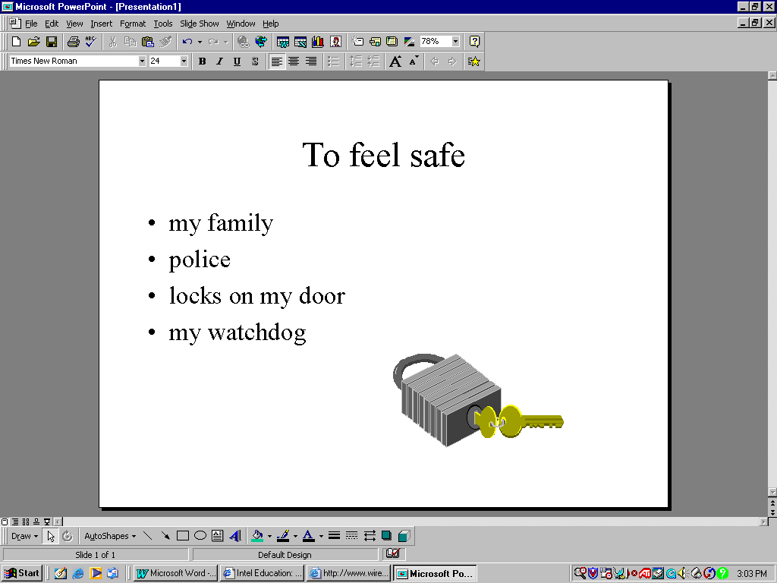
Teaching/ Learning Strategies and  Activities | Activity 2: What is Quality of Life?  - As a set for the lesson, read Eve Bunting’s book, Fly Away Home. The story talks about a homeless boy and his father who make their home in an airport. Discuss with the children how the pair meets their basic needs. Also ask students to state what they felt was important to the boy and to his father.  - Pose the following question to the students and write it on the board: What is important to your life? Brainstorm ideas and post them to the board. Type out the descriptors your students came up with. Some suggestions for descriptors are:  - belonging to a family  - feeling important and cared for  - eating nutritious food  - feeling safe and secure  - having places to learn and play  - staying healthy  - having a home  - having clean water  - having clean air  - celebrating my families’ traditions  - Think-Pair-Share activity. Have students think about how they would rank the descriptors, from most important to least based on the following two criteria:  - has a frequent effect on your life,  - has a big effect on your life.  Pair them up and have each student talk to his/her partner about the ranking. Encourage them to listen as each partner shares his/her ideas.  - Use the Visual Ranking Tool found on the Intel Education site. Scroll down to the “Teacher Workspace” where you can register with the free site. The tool allows you and your students to rank the descriptors they have brainstormed regarding quality of life, and then to compare their rankings with other classmate teams. They can also compare their rankings with the class average. You as the teacher may also choose to have them print their pages to be included in their student notebooks or portfolios.  * Hint: Give students a handout sheet for this activity. Include the URL for the student logon page for the Visual Ranking Tool. This will make it easier for the students to access the page. All they’ll have to enter is the teacher name and their team name/ logon (I used the following log-on pattern: Log-on: color word (such as red, blue etc) Password : number (ex: 01, 02, 03 etc)  * For further info regarding quality of life descriptors refer to Quality of Life of Life Among Adolescents  Activity 3: What makes my community a good place to live?  * Prior to doing this activity, Use the Learn Alberta activity Investigating Pictures to help teach students this skill.  - Pose the question, “What makes our community a good place to live?” Brainstorm their responses on the board, using an idea web format. An alternative would be to use a concept-mapping program such as Kidspiration, Inspiration, Gliffy or SMART Ideas. Refer back to the descriptors list regarding quality of life as you do so.  - Have the students take pictures of their community with a digital camera. Have them focus on the question “What makes my community a good place to live?” Download the pictures to your computer.  - Load each student’s picture(s) onto a word document and have students choose a dialogue callout (voice bubble) from “insert” and “shapes” to insert on the picture. In the callout students will tell how their picture illustrates the different aspects of quality of life and why/how it contributes positively or negatively to quality of life. An enlarged and alterable sample of the picture study image is in the support materials.  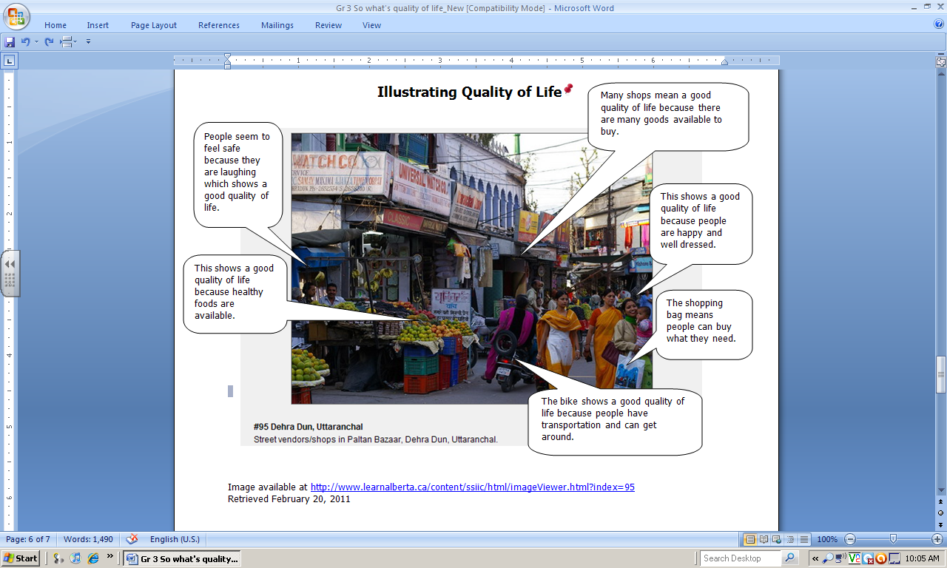  - Have the students present their picture orally or use a voice recorder to tape their explanation and their observations from their callout document.
Resources | - Gliffy: http://www.gliffy.com/  - Visual Ranking Tool (Intel Education): http://www.intel.com/education/tools/  - Quality of Life of Life Among Adolescents: http://www.utoronto.ca/qol/adolescents.htm  - Modeling the Tools: Investigating Pictures: http://www.learnalberta.ca/content/ssmt/html/investigatingpictures_mt.html
Formative Assessment  Strategies | Partner Work Self Reflection.
Other ICT Outcomes Addressed | C.1 - Students will access, use and communicate information from a variety of technologies.  1.1 access and retrieve appropriate information from electronic sources for a specific inquiry  C.4 – Students will use organizational processes and tools to manage inquiry  1.1 follow a plan to complete an inquiry  C.7 - Students will use electronic research techniques to construct personal knowledge and meaning.  1.4 make predictions based on organized information  Note: All ICT outcomes for social studies are infused in the Program of Study for each grade level in the “Outcomes” section of this document.
Adapted from: Wiggins, Grant and J. Mc Tighe. (1998). Understanding by Design, Association for Supervision and Curriculum Development
ISBN # 0-87120-313-8 (ppk)
Illustrating Quality of Life Rubric

Level  Criteria | 4  Excellent  Wow! | 3  Proficient  Yes! | 2  Adequate  A good start! | 1  Limited  Not yet! | Insufficient  Evidence
Demonstrates understanding  (3.1.2.1) | Demonstrates a comprehensive understanding of quality of life. | Demonstrates a thorough understanding of quality of life. | Demonstrates a beginning understanding of quality of life. | Demonstrates an unclear understanding of quality of life.
Communicates evidence  (3.S.8.5) | Offers significant evidence for positive or negative contributions to quality of life. | Offers relevant evidence for positive or negative contributions to quality of life. | Offers general evidence for positive or negative contributions to quality of life. | Offers little evidence for positive or negative contributions to quality of life.
Considers others in cooperative learning  (3.S.5.1  3.S.5.4) | Purposefully listens to, shares with, and supports the efforts of others | Effectively listens to, shares with, and supports the efforts of others | Appropriately listens to, shares with, and supports the efforts of others | Little evidence that student listens to, shares with, and supports the efforts of others

Comment
Many shops mean a good quality of life because there are many goods available to buy.
Illustrating Quality of Life

People seem to feel safe because they are laughing which shows a good quality of life.

This shows a good quality of life because people are happy and well dressed.

Use Image

http://www.learnalberta.ca/content/ssiic/html/imageViewer.html?index=95
This shows a good quality of life because healthy foods are available.

The shopping bag means people can buy what they need.

The bike shows a good quality of life because people have transportation and can get around.

Partner Work Self Reflection

Check the box that applies to you.
Level  Descriptor | 3  Yes, we did this without help. | 2  We needed some help from the teacher. | 1  No, we were unable to do this.
We were able to access Internet site successfully.

We were able to rank the quality of life descriptors.

We were able to compare our rankings with those of our classmates.

We stayed on task and managed our time well.

We took turns and worked well together.

One thing that worked really well for us was _______________________________________________________

___________________________________________________________________________________________

One thing I’ll do better next time is _______________________________________________________________

by _________________________________________________________________________________________

___________________________________________________________________________________________

