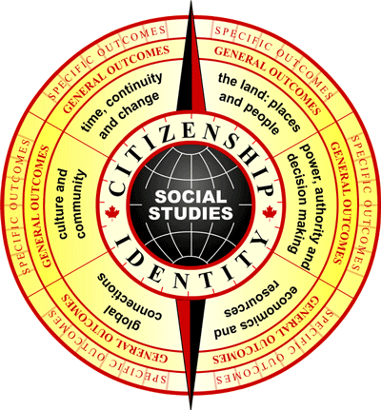

SOCIAL STUDIES

LESSON PLANNER

Title: Grade:

BACKGROUND:
Does this lesson fit into an ongoing focus (if so, describe) or does it stand alone?

STEP 1: What essential questions do we want to answer?
In the end what do we want our kids to know and be able to do?

STEP 2: What outcomes are we addressing in this unit?

General Outcome (s)

Specific Outcomes

Skills/Processes Knowledge/Understanding Values/Attitudes

STEP 3: How will we answer the questions?
What will the learning activities be?

STEP 4: How will we know we have learned?
Assessment strategies?

STEP 5: What modifications might we need to make to this lesson to meet the needs of all learners?

STEP 6: What resources will we use?
Colleagues, reference books, audio-visual materials, related literature, music, art, internet, and guest speakers.

STEP 7: Reflection:

- What worked well?

- What will I do next time?

- What do I need to keep working on with the students?

