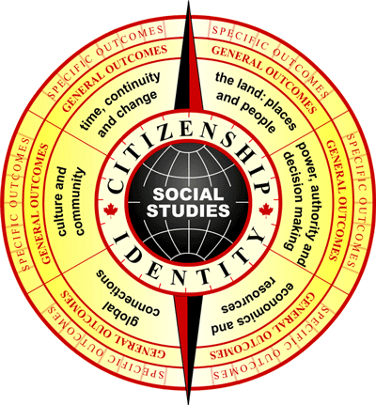
Social Studies K-3
Checklist

Use the following checklist to identify the key areas of focus during your lesson.

This lesson includes a focus on:

- Values and attitudes
- Knowledge and understanding
- Skills and processes
  - Dimensions of thinking
- Critical thinking
- Creative thinking
- Historical thinking
- Geographic thinking
  - Social participation as a democratic process
  - Research for deliberative inquiry
- Infusion of technology
  - Communication
- Oral, written and visual literacy
- Media literacy skills
- Citizenship
- Identity
- Aboriginal perspectives
- Francophone perspectives
- Multiple perspectives
- Pluralism
- Diversity
- Issues-focused approach
- Current affairs
- Controversial issues
- Time, continuity and change
- The land: Places and people
- Power, authority and decision making
- Economics and resources
- Global connections
- Culture and community

