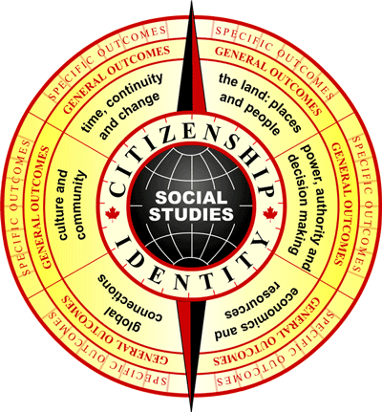

SOCIAL STUDIES

LESSON PLANNER

Title: Researching/Creating Inuit Art Grade: 2
“Keeping Our Stories Alive”

BACKGROUND:
Does this lesson fit into an ongoing focus (if so, describe) or does it stand alone?

Ties into lessons on art forms in Meteghan, Saskatoon, and local city/town.

STEP 1: What essential questions do we want to answer?
In the end what do we want our kids to know and be able to do?

How does Inuit environment and culture influence their art?

STEP 2: What outcomes are we addressing in this unit?

General Outcome (s)
2.1 Students will demonstrate an understanding and appreciation of how geography, culture, language, heritage, economics and resources shape and change Canada’s communities.

Specific Outcomes

Skills/Processes Knowledge/Understanding Values/Attitudes

2.1.3 investigate the cultural and linguistic characteristics of an Inuit, an Acadian and a prairie community in Canada by exploring and reflecting upon the following questions for inquiry:
- What are the cultural characteristics of the communities (eg., special symbols, landmarks, languages spoken, shared stories or traditions, monuments, schools, churches?)
- What are the traditions and celebrations in the communities that connect the people to the past and to each other?
- How are the communities strengthened by their stories, traditions and events of the past?

STEP 3: How will we answer the questions?
What will the learning activities be?

A. Research stations:
- Listening: video “Keeping Our Stories Alive” 23 minutes
- An artifacts station (various collected Inuit items/art/tools/historical pieces)
- Teacher guided websites
- A variety of teacher provided books

Depending on the time available and class dynamics, the teacher could either have students circulate to all stations, or assign small groups of students to one station, do the research, and then come together to “jigsaw” their expert knowledge at the end. Students will be provided with a research guidelines chart to prompt and guide their thinking. (see attached file)

B. If using jigsaw method, have students share learning in small groups. If using circulation method, come together as a large group to discuss the outcomes of student research. The teacher needs to direct the discussion to move in a direction of having students think about what they would like to carve based on what they discovered in their research. What aspects of Inuit culture would they like to depict in their carving? What message do they want to give to viewers? What key influences could affect their carving?

C. Depending on available resources you could then choose from a variety of art projects for students based on the different art forms researched. (see attached art lesson ideas in hard copy format) We have chosen to demonstrate an art project on Inuit Sculpture with Ivory Soap. (See attached document “Soap Carving Tips and Tricks.)

Have students make a plasticine prototype to get a feel for the dimensions before they move to the soap carving. You may want to send a note home in advance to parents, asking for volunteers on carving day, a bar of Ivory soap per child, and also to ask them to send a collection of carving tools for the class to use (craft sticks, nail files, dull knives, spoons, etc …)

STEP 4: How will we know we have learned?
Assessment strategies?

Research:
Check over sheets to see if they appropriately filled in each section.

Group Work:
Checklist (see attached): ”Look What You Have Learned”

Art:
Criteria checklist (see attached)

STEP 5: What modifications might we need to make to this lesson to meet the needs of all learners?

Many different learning styles are covered in this lesson: tactile, visual, and auditory. It also accommodates struggling and stronger students.

Cooperative learning strategy: assign tasks to each group, eg: recorder, timer, reporter

STEP 6: What resources will we use?
Colleagues, reference books, audio-visual materials, related literature, music, art, internet, and guest speakers.

Video:
Video “Keeping Our Stories Alive” from the Inuit Art Center (www.ainc-inac.gc.ca/art/inuit contact Diane Webster--available in French and English)

Literature:
Celebrating Inuit Art 1948-1970 (ISBN 155263104-4)
Iqaluit: The All About Series (ISBN 1-896132-18-9)
The Inuit by Andrew Santella (ISBN 0-51622217-1)
The Lonely Inukshuk by Inuglak School (ISBN 0-590-51650-7)
Iqualuit: Gateway to the Arctic by Jaren Keen (ISBN 1-896990-55-X)
Nunavut (ISBN 1-896990-81-9)

Websites:
Indian and Northern Affairs Canada Site under “Culture and History: at ww.inac.gc.ca
Canada’s Digital Collections for Cap Dorset artists at http://collections.ic.gc.ca/cape_dorset
McMichael Canadian Art Collection at www.mcmichael.com/inuit.htm

Artifacts:
Any that you can beg borrow and steal!

STEP 7: Reflection:

- What worked well?

- What will I do next time?

- What do I need to keep working on with the students?

