Changes Over Time
ICT Outcomes, Division 1

C.2 - Students will seek alternative viewpoints, using information technologies.
Specific Outcomes
1.1 compare and contrast information from similar types of electronic sources

C.6 - Students will use technology to investigate and/or solve problems.
Specific Outcomes
1.1 identify a problem within a defined context
1.2 use technology to organize and display data in a problem-solving context
1.3 use technology to support and present conclusions

C.7 - Students will use electronic research techniques to construct personal knowledge and meaning.
Specific Outcomes
1.3 draw conclusions from organized information
1.4 make predictions based on organized information
Grade 2 S.S. Outcomes

2.2 A Community in the Past

General Outcome
Students will demonstrate an understanding and appreciation of how a community emerged, and of how the various interactions and cooperation among peoples ensure the continued growth and vitality of the community.
Values and Attitudes
Students will:
2.2.4 appreciate how connections to a community contribute to one’s identity (I)

Knowledge and Understanding
Students will:
2.2.6 analyze how the community being studied emerged, by exploring and reflecting upon the following questions for inquiry:
• What characteristics define their community? (CC, I)
• What is unique about their community? (CC, I)
• What are the origins of their community? (TCC)
• What were the reasons for the establishment of their community (e.g., original fur trade fort, original inhabitants)? (CC, TCC)
• What individuals or groups contributed to the development of their community? (CC, TCC)
2.2.7 examine how the community being studied has changed, by exploring and reflecting upon the following questions for inquiry:
• In what ways has our community changed over time (e.g., changes in transportation, land use)? (CC, TCC)
• What has caused changes in their community? (CC, TCC)

DIMENSIONS OF THINKING
Students will:
2.S.2 develop skills of historical thinking:
• correctly apply terms related to time (i.e., long ago, before, after)
• arrange events, facts and/or ideas in sequence
2.S.4 demonstrate skills of decision making and problem solving:
• apply ideas and strategies to decision making and problem solving
• propose new ideas and strategies to contribute to decision making and problem solving

SOCIAL PARTICIPATION AS A DEMOCRATIC PRACTICE
Students will:
2.S.5 demonstrate skills of cooperation, conflict resolution and consensus building:
• demonstrate the ability to deal constructively with diversity and disagreement
• work and play in harmony with others to create a safe and caring environment
• consider the needs and ideas of others
􀂾 share information collected from electronic sources to add to a group task

Best Practice:
Changes Over Time
See below:
1. This lesson can be begun as a large group lesson on the SMART Board, projected, or completed on individual computers. * NOTE: You will need the SMART Notebook Software even if you do not have a SMART Board.
Downloading and Accessing SMART Notebook Software on Your Home Computer

To download SMART Notebook Software, first navigate to the SMART Technology Website at: http://www.smarttech.com
Click on “Software downloads” in the lower right hand corner of the main page of the SMART Technology website. | 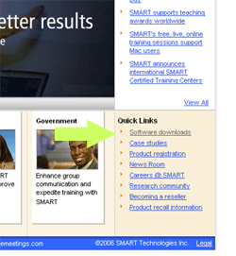
Select the operating system that you are downloading the software to. | 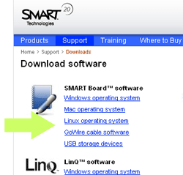
Click the download button. | 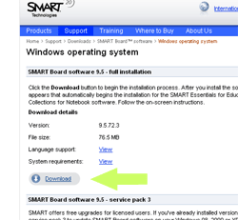
Enter in your first and last name, industry (K-12) and your email address. Be sure to click the “no” radio button if you do not want to be contacted or updated with information from SMART Technology. Click the “download” button. | 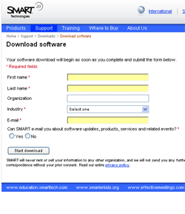
Download the software by following the directions in the file download box. Install the program just as you would with any other software. | 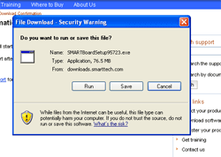
The Gallery Collection:
The full gallery collection is often not included in the download you have just downloaded. You will need to download the “essentials for educators” gallery package in a separate download.

Navigate back to the initial page. Click on “software downloads”
Choose your operating system by clicking on it.
Scroll down to the bottom of the page until you see “SMART Essentials for Educators: Gallery Collections Download.” Click “download” and follow the same steps as above. Once you have downloaded and installed both downloads, the program will automatically integrate the two. When you open up SMART Notebook, the full “Essentials for Educators” gallery will be seen in the gallery tab along with the “sample gallery” collection. | 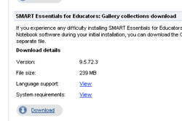
NOTE: Online support with this software and any other SMART Technologies products can be found at:
http://www2.smarttech.com/st/en-US/Support/

- Open SMART Notebook. Ensure that you are in the “Page Sorter” View so that on the right side of the screen you can see each of the pages that you create. Copy pictures onto Notebook pages. Ensure that you have sufficient pictures to match one from the past with one from the present for each student. Add pages as needed. Pictures should be mixed (not all from the past on one page).
- Try these sites (be sure to check for copyright):
http://www.pbase.com/turnstyle/calgary

http://aboutcalgary.ab.ca/history/

http://www.viewcalgary.com/Barry/bjIndex.html

http://www.harrypalmergallery.ab.ca/galcalplaces8283/galcalplaces8283.html

http://www.viewcalgary.com/downtown/index.html

- When you have sufficient pictures, add 2 pages to be used for sorting purposes. Label one page, “Present” and the other, “Past”. If you are doing this as a whole class lesson, have students take turns to go to the SMART Board, choose a picture, click and drag it onto the appropriate page located in the right hand scroll screen. 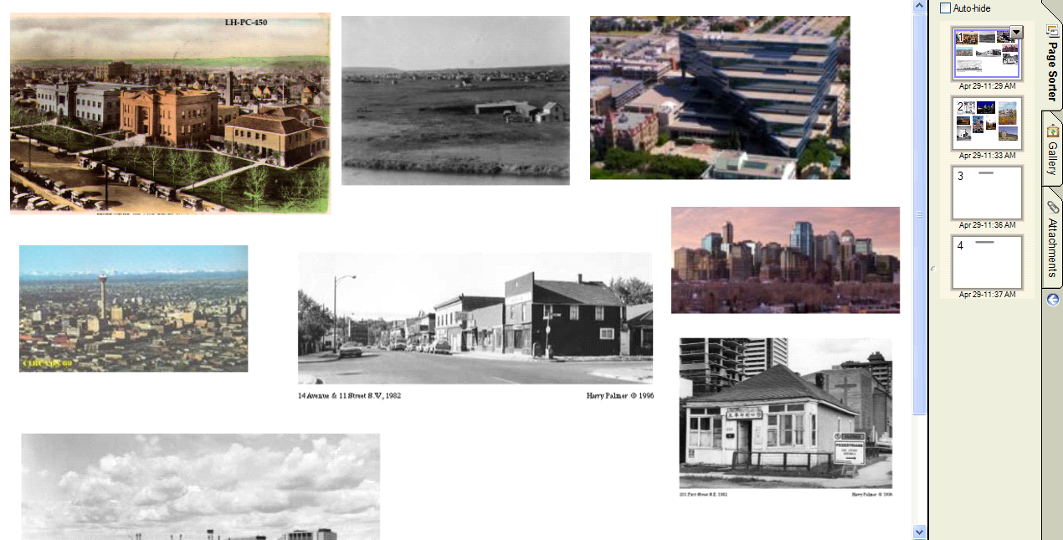
Drag pictures from the large page onto the small page in the right hand column. Once pictures from the first page have all been sorted, simply click on the second page to bring it to the left, enlarged view. Continue to sort.

- Once all pictures have been sorted, open the “Past” page, and study all of the pictures to ensure that they all belong. Discuss attributes that are shared by pictures of the past. Move pictures to the “Present” page as needed. Repeat this procedure for the “Present” page (moving incorrectly sorted “Past” pictures onto the “Past” page).
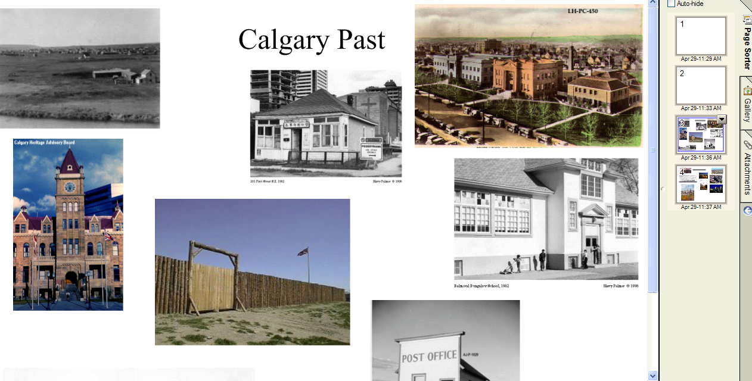
This is what your page will look like once the pictures have been sorted. Notice the empty pages at the top of the sorter. The bottom two show the sorted pictures for past and present.
- Choose one picture from the past and one picture from the present. You will use these two pictures to create a VENN diagram or a T-Chart. You could project the pictures and create the VENN on chart paper, or you could use large calendar or poster size pictures and create the VENN on http://www.readwritethink.org/materials/venn/index.html. You may wish to focus your discussion on land use, transportation, technology (street lights, equipment etc.), and architecture. The purpose is to show how their community has changed over time. Have them include unique features form the past and present as well as describing what characteristics of the community have remained the same.
- Have pairs of students choose a picture from the past and a picture from the present. They will repeat the modeled procedure to create a VENN diagram comparing the two. You may wish to have them create a paper copy, or use the above link to create a VENN on the computer. Alternately, you could create a T-Chart using the template located below.

See T-Chart Below

T-Chart

What is unique about the  PAST? | What has remained the  SAME? | What is unique about the  PRESENT?

- Use the completed diagrams or charts for assessment. Have students share with peers in groups of four. Students may take them home to share their learning with parents. Ask parents to contribute their observations and discuss results with their child.
- Use the following assessment rubrics to track student progress. (from Read/Write/Think)

Class Discussion/Technology Assessment (for use after students share)
ID: 64683

Objectives | Low Performance | At or Below Average | At or Above Average | Exemplary Performance | Earned  Points
Student responds to other students in the discussion group. | 1 point  Student seems distracted or engages in unrelated conversations while other students speak. | 2 points  Student often interrupts other students' comments and opinions by insulting them or by forcefully adding their own opinions. | 3 points  Student occasionally interrupts other students, but generally adds a related argument or opinion. | 4 points  Student waits until the speaker is done speaking before contributing and integrates past comments into their own statement.
Student is prepared for discussion. | 1 point  Student is unable to discuss due to not completing the assignment or activity leading to the discussion. | 2 points  Student makes random comments that repeat what others have said without contributing anything new or randomly adds opinions that are off topic. | 3 points  Student is engaged in the discussion, occasionally using references from the preparatory assignment or activity. | 4 points  Student is engaged in the discussion, and often cites specific references to the preparatory assignment or activity and clearly connects the references to main opinions.
Student demonstrates understanding of topic being discussed. | 1 point  Student does not engage in the discussion. | 2 points  Student offers opinions that are only occasionally related to the topic. | 3 points  Student connects the topic to life experiences and previous knowledge. | 4 points  Student uses examples to help struggling students see the ways the topic connects to life experiences and previous knowledge, and student is able to answer group members' questions with ease.
 |  |  |  | Score:

Comments:

Rubric for Assessing VENN Diagram/T-Chart (Adapted from Many Voices)
Student: ________________________________________
The student will:

4 | - uses correct format and groups related facts  - includes a variety of specific details about the pictures, including  information about land use, transportation, technology, and architecture  - includes specific and accurate details  - creates a VENN Diagram/T-Chart that is neat, organized, and easy to read
3 | - uses VENN Diagram or T-Chart format  - includes details about the picture, including some information  about land use, transportation, technology, and architecture  - includes general and accurate details  - creates a VENN Diagram/T-Chart that is neat and easy to read
2 | - attempts to draw a VENN Diagram/T-Chart  - includes few details about the picture, including some information  about land use, transportation, technology, or architecture  - includes some accurate information  - creates a VENN Diagram/T-Chart that is readable
1 | - records information  - includes minimal information about the picture  - includes information that is inaccurate and/or not related to the topic  - creates a product that is difficult to interpret

Name: ____________________________

Self-Assessment for VENN Diagram/T-Chart (adapted from Many Voices)

I put the correct titles for each circle/column in the correct place. | ❑
I added details about the pictures in the correct circle/column. | ❑
I wrote facts about land use and/or transportation. | ❑
I wrote facts about architecture and/or technology. | ❑
I discussed my work with my partners/group. | ❑
My VENN Diagram/T-Chart is neat and easy to read. | ❑

