Image used with permission from http://www.crystalinks.com/aztecgods.html
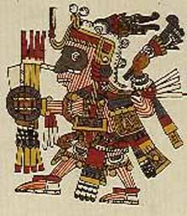
Aztec
Worldview
in
Pictures
Introduction:
[E]ven we who have seen these things with our own eyes, are yet so amazed and so be unable to comprehend their reality.
~ Hernan Cortés: Excerpt from Second Letter to Charles V, (1520)
(http://academic.udayton.edu/bradhume/hst103/hst103common.htm)

September 16th is Mexican Independence Day. This day celebrates Mexico's independence from Spain in 1810. Because the bicentennial is coming up, a committee has been set up to commission presentations on Mexican history and culture. You and your team have been commissioned to create a video story of the Aztec worldview to be shown in a pavilion. Each person on your team will become an expert on some aspect of the Aztec worldview. You will then come together at the end to create a visually powerful video of the overall Aztec worldview which contributed to their dominance of Mesoamerica.

Task | Instructions | Background Information | Roles
Sharing and Discussing | Evaluation | Conclusion | Learner Outcomes
Task:
Each member of your team will choose a specialty. You will use the links provided as well as other resources (textbook, etc.) to become experts on your roles. You and your team will work together to create a video story that presents your team's concept of the Aztec Worldview. By completing this Web Quest, you should achieve the following goals: 1) understand the key elements of the Aztec worldview; 2) understand how the Aztec Worldview shaped their society’s decisions; 3) use the power of the Internet for advanced exploration; 4) create a product that is both visually appealing and informative; and 5) work with teammates to determine a combined action plan.
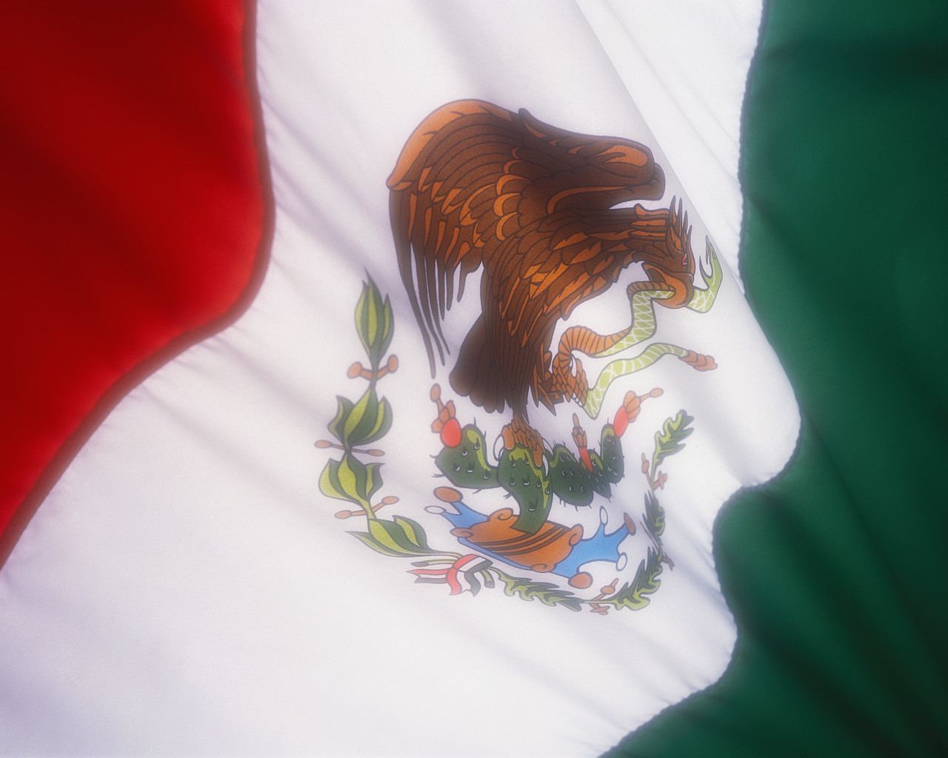
Instructions:
To accomplish this task, you will first form a group of four. As a group, explore the pages that are labelled 'Background Information' and decide what aspect of the Aztec world on which each person will become an expert. Your choices include: Geography, Beliefs, Society and Economics, and Education and Values. Then each member of the team has his/her own task to complete and a separate set of web sites to use. There is an Information Gathering Organizer and an Aztec Worldview in Pictures Rubric to guide your work. Be sure to note the websites from which you received your information.
[Top]

Phase 1: Background
These sites are important because they will provide basic information about the topic as a whole. Explore these sites together and decide which specialist can use which information from each article. Be sure to cite the article from which you have received specific pieces of information.
- Aztecs: Fierce Wanderers
- The Ancient Aztecs
- Aztec Gold
[Top]
Phase 2: Roles
These roles define some of the most important elements of Aztec worldview. Each of you has a particular role with links and instructions below. Here are the general instructions for all of you. Please also see your specific instructions and questions below.

INSTRUCTIONS:
1. Each team member will explore one of the roles below.
2. Read through the files designated for your role. Make notes on information relevant to your topic using the Information Gathering Organizer.
3. Remember to include the URL of the page from which you take information and the date you found it so you can return to it and use it in a citation.

Geography Instructions & Links
- Farming and Agriculture
- Ancient Mesoamerica
Use these links as well as those in the background information, to answer the following questions.
- How did the Aztecs manipulate their environment to suit their needs?
- What are chinampas, and why were they made?
- How were chinampas create?
- What was grown, and how was it processed?
- What types of food were available for different classes?
- Who originally inhabited the Aztec capital according to the Aztec?
- Describe the physical plan of the capital of the Aztec Empire.
- How did a growing population affect the change in how the Aztec dealt with their neighbours?
[Top]

Beliefs Instructions & Links
- The Aztec Gods
- Religious Beliefs
- Aztec Religion
- Aztec Gods and Goddesses
Use these links, as well as those in the background information, to answer the following questions.
- Of what importance was religion in the Aztec world?
- Who were the major Aztec gods? Of what were they the gods and/or what did they symbolize? Why was each important to the Aztecs?
- Why did the Aztec begin human sacrifices to the sun and rain gods?
- What did the Aztec believe about the balance of nature?
- What was at a teocalli?
- List some beliefs about the sun?
[Top]
Society and Economics Instructions & Links
- Sources of the Aztec Law
- Aztecs: Trade, Economy, and Merchants
Use these links, as well as those in the background information, to answer the following questions.
- What did the Aztecs use for currency? Why?
- What could be purchased in markets?
- What were valuable items? What does this say about what’s important in society?
- How were goods transported and their safety ensured?
- How did merchants fit into the social structure of the Aztec society?
- Who was exempt from tributes and why? What types of things were given in tribute?
- How did Aztec courts make their decisions?
- Who could own land? How could land be lost?
- What were some of the punishments for different types of theft?
- What was the variety of punishments for drunkenness? Why?
- What types of punishments were administered for various offences?
- How were slaves treated?
[Top]

Education and Values Instructions & Links 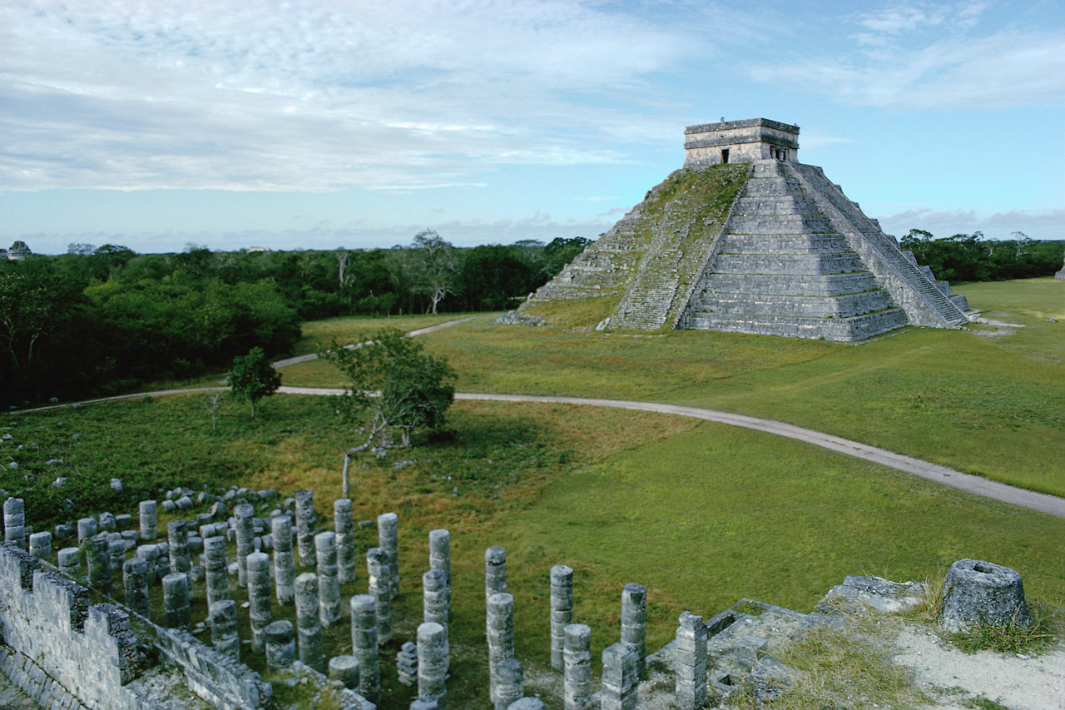
- Introduction to the Aztec Calendar
- The Aztec Calendar: The Pointer
- The Mesoamerican Ball Game
- Aztec Schooling
- Education and Moral Values
Use these links, as well as those in the background information, to answer the following questions.
- What are the names of the two calendars, and what are the differences between them?
- Why is the day-count calendar sacred?
- Describe the universe according to Aztec cosmology.
- Why is time divided among the gods?
- What were the different types of schooling? Who attended them, and what did students study there?
- What role did parents play in the education of children?
- What was the role of teachers?
[Top]
Sharing and Discussing
You have all learned about different parts of Aztec world. What conclusions can you draw about the Aztec worldview from what you have learned? Write a Conclusion on your Information Gathering Organizer. Remember to add evidence from your research. Now group members come back to the larger Web Quest team with expertise gained by searching from one aspect of Aztec society. You must now share your information with the rest of your team. Use the Sharing Information form to record others’ information. When you have done this, discuss answers to the following questions. Your answers will dictate what you include for your final product.
- What conclusions can you draw about what was important to the Aztec society?
- How does the Aztecs’ manipulation of their geographic world reflect their world view?
- What effect did their beliefs they held about the gods and the natural world influence their way of life?
[Top]
Video Product
You are now ready to create your video. This video will be no longer than two minutes. It will include appropriate words, images, and music. To do this, complete the following steps.
- Click on the following link to view tutorial of digital storytelling. http://www.techsoup.org/learningcenter/training/page5897.cfm
Click on the following links to view examples of a digital story:
http://www.rebooting.ca/storytelling-projects/ http://www.youtube.com/watch?v=DUF_IHYQvFI
- Decide what information you are going to use in each of the Worldview categories to convey the Aztec Worldview. What words will appear on your screen? What images could you use to illustrate each aspect of the Aztec worldview? What type of music would you put with each aspect of worldview? These decisions must be made first before you look for any resources. Remember that each aspect your team researched will have to appear on the video. Each aspect should have 20 – 30 seconds.
- Using the Storyboard form, create a storyboard that you will use to plan out your video. This also must be done before you look for any resources. What type of movement across images will you have?
- You are now ready to look for resources. You may use the following links for the listed features.
Free use of images:
http://www.worldviewimages.com/
http://flickr.com/
Free use of music:
http://freeplaymusic.com/
- Click on the following link for a tutorial on Microsoft Moviemaker http://www.microsoft.com/windowsxp/using/moviemaker/default.mspx
- Using Microsoft Moviemaker, create a video that shows the Aztec Worldview with music and words.
- Be sure your video includes transitions, effects and titles.
- The following links deal with copyright information:
http://www.2learn.ca/copyright/images.html
http://www.2learn.ca/copyright/gencopyright.html
http://www.umuc.edu/library/copy.shtml#define
[Top]
Evaluation
Click on the checkmark for the Aztec Worldview in Pictures Rubric 
Conclusion
When you only know part of the picture it’s difficult to decide on an overall concept. Now you all know a lot more. Nice work. You should be proud of yourselves! How can you use what you've learned to see beyond the black and white of a topic and into the greyer areas? What other parts of Aztec could still be explored? Remember, learning never stops. Complete the Group Self-Assessment form.
[Top]
________________________________________________________________
CREATED BY: Sharon Richter
Lacombe Junior High, 2007
Outcomes Addressed by this Web Quest:
8.3.4.1 – what were the key elements of the worldview of the Aztec civilization prior to contact with the Spanish?
8.3.4.2 – how did the Aztec civilization’s worldview influence its choices, decisions and customs?
8.S.1.5 – generate creative ideas and strategies in individual and group activities
8.S.4.1 – demonstrate skills of compromise and devise strategies to reach group consensus
8.S.4.2 – propose and apply new ideas and strategies to contribute to problem solving and decision making, supported with facts and reasons
8.S.7.3 – draw conclusions based upon research
8.S.7.5 – organize and synthesize researched information
8.S.7.7 – practice responsible and ethical use of information and technology
8.S.7.15 – analyze and synthesize information to create a product
8.S.7.16 – access and retrieve information through the electronic network in the context of a group research project
8.S.8.1 – communicate in a persuasive and engaging manner through speeches, multimedia presentations and written and oral reports, taking particular audiences and purposes into consideration

