**Math 20-2 Final Exam Study Guide: Units 1-4**

Use the following study guide to help you prepare for your final exam. It is taking place on ___________________ and is worth _______ of your final Math 20-2 grade.

**Helpful hints:**

* We have used the textbook and the workbook to complete the course. You should use both resources to study.
* Make a study plan. Try to study for 20 minutes then take a break then study for 20 minutes more at least 5 days a week. Cramming does not work and will make your brain mush.
* Your textbook has ‘study aid’ pages that are helpful to read through
* Do the practice questions at the end of each chapter.
* Don’t underestimate the power of the digital age… various websites can help you with these concepts. Try <http://www.khanacademy.org> or simply search a topic in *youtube*.
* Check off each learning objective below when you feel you thoroughly understand it.

**Math 20-2 Unit 1: Inductive and Deductive Reasoning**

Outcome 1: Analyze and prove conjectures, using inductive and deductive reasoning, to solve problems.

* 1. **I can make conjectures by observing patterns and identifying properties, and justify the reasoning.**

1. What is a conjecture? Provide an example.
2. Emma works part-time at a bakery shop in Saskatoon. Today, the baker made 20 apple pies, 20 cherry pies, and 20 bumbleberry pies. Which conjecture is Emma most likely to make from this evidence?

a. People are more likely to buy cherry pie than any other pie.

b. Each type of pie will sell equally as well as the others.

c. People are more likely to buy bumbleberry pie than any other pie.

d. People are more likely to buy apple pie than any other pie.

1. Which conjecture, if any, could you make about the sum of two odd integers and one even integer?

a. The sum will be an even integer.

b. The sum will be an odd integer.

c. The sum will be negative.

d. It is not possible to make a conjecture.

1. Guilia created the following table to show a pattern.

|  |  |  |  |  |  |
| --- | --- | --- | --- | --- | --- |
| **Multiples of 9** | 18 | 27 | 36 | 45 | 54 |
| **Sum of the Digits** | 9 | 9 | 9 | 9 | 9 |

Which conjecture could Guilia make, based solely on this evidence? Choose the best answer.

a. The sum of the digits of a multiple of 9 is equal to 9.

b. The sum of the digits of a multiple of 9 is an odd integer.

c. The sum of the digits of a multiple of 9 is divisible by 9.

d. Guilia could make any of the above conjectures, based on this evidence..

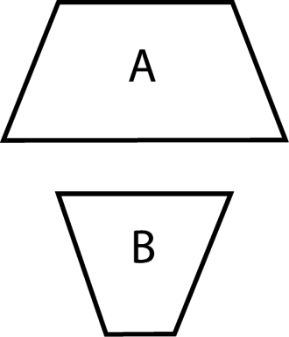

**1.2 I can explain why inductive reasoning may lead to a false conjecture.**

1. What is inductive reasoning?
2. Which figure has the longer top side, A or B? Make a conjecture and check the validity of your conjecture.
3. Mick and Sue were discussing what conjecture could be made regarding the prime number pattern shown.

They both agreed to the following conjecture: “The sum of two prime numbers is an even number.”

3 + 5 = 8

5 + 7 = 12

7 + 11 = 18

13 + 17 = 30

19 + 23 = 42

29 + 31 = 60

a) Provide a counterexample which shows their conjecture is false.

b) Revise their conjecture so it holds true for prime numbers.

c) Make a conjecture based on the number pattern if the condition “prime number” was removed.

**1.3 I can compare, using examples, inductive and deductive reasoning.**

1. What is the difference between inductive and deductive reasoning?
2. All camels are mammals. All mammals have lungs to breathe air. Humphrey is a camel. What can be deduced about Humphrey?
3. Prove, using deductive reasoning, that the product of an even integer and an even integer is always even.
4. Write a conclusion which can be deduced from each pair of statements.

a) Leona lives in 100 Mile House. 100 Mile House is in British Columbia.

b) Joan is taller than Stefan. Stefan is taller than Patrick.

c) The sides of a rhombus are equal. PQRS is a rhombus.

d) Prime numbers have two factors. 13 is a prime number.

**1.4 I can provide and explain a counterexample to disprove a given conjecture.**

1. What is a counterexample?
2. Austin told his little sister, Celina, that horses, cats, and dogs are all mammals.

As a result, Celina made the following conjecture:

All mammals have four legs.

Use a counterexample to show Celina her conjecture is not valid.

1. Abby made the following conjecture:

The sum of a multiple of 7 and a multiple of 8 will be an odd number.

Do you agree or disagree? Briefly justify your decision with a counterexample if possible.

**1.5 I can prove algebraic and number relationships such as divisibility rules, number properties, mental mathematics strategies or algebraic number tricks.**

1. What is a proof and how do you set up a 2 column proof?
2. Determine the error in reasoning to show that the proof of 5 = 4 is invalid.

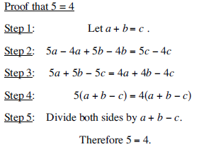

**1.6 I can Prove a conjecture, using deductive reasoning.**

1. Prove that the product of an even number and an odd number is always odd.

**1.7 I can Determine if a given argument is valid, and justify the reasoning.**

1. What type of error occurs in the following deduction?

Briefly justify your answer.

Felix is a barber.

Felix has a very good haircut.

Therefore, Felix is a very good barber.

**1.8 I can identify errors in a given proof; e.g., a proof that ends with 2 = 1.**

1. What type of error occurs in the following proof? Briefly justify your answer.

2 = 2

4(2) = 4(1 + 1)

4(2) + 3 = 4(1 + 1) + 3

8 + 3 = 6 + 3

11 = 9

**1.9 I can Solve a problem that involves inductive or deductive reasoning.**

1. Determine the unknown term in this pattern. 2, 2, 4, 6, ____, 16, 26, 42
2. What number should appear in the centre of Figure 4?

|  |  |  |  |
| --- | --- | --- | --- |
|  |  |  |  |
| Figure 1 | Figure 2 | Figure 3 | Figure 4 |

**Outcome 2: Analyze puzzles and games that involve spatial reasoning, using problem-solving strategies.**

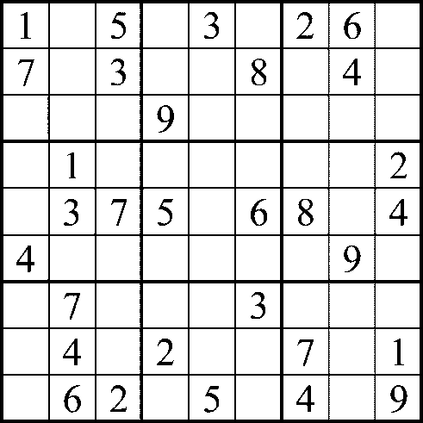**2.1 I can Determine, explain and verify a strategy to solve a puzzle or to win a game; e.g., guess and check, look for a pattern, make a systematic list, draw or model, eliminate possibilities, simplify the original problem, work backward, develop alternative approaches.**



1. What number(s) could go in the grey square in this Sudoku puzzle? How did you come to this solution?
2. Emma and Alexander are playing darts.

|  |  |
| --- | --- |
| Emma has a score of 48. To win, she must reduce her score to zero and have her last counting dart be a double. Give a strategy that Emma might use to win. |  |

**Unit 2: Properties of Angles and Triangle.**

Outcome 1: Derive proofs that involve the properties of angles and triangles.

**Outcome 2: Solve problems that involve properties of angles and triangles.**

**1.1 I can find solutions, using inductive reasoning, the relationships between pairs of angles formed by transversals and parallel lines.**

1. Use a pencil to thicken one transversal and a paralell line to that transversal in this pattern.



**1.2 I can prove, using deductive reasoning, properties of angles formed by transversals and parallel lines, including the sum of the angles in a triangle.**

1. Describe and draw examples of the F, Z and C angles.
2. What is the sum of the angles in a triangle? Is this true for all triangles?
3. Determine the measure of *ABF and* *BEF*.

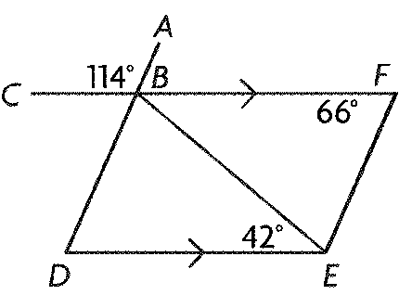

1. 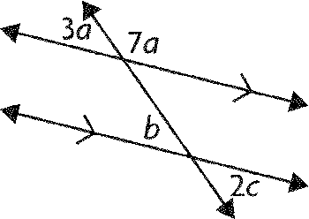Determine the values of *a*, *b,* and *c*.
2. Determine the values of *a*, *b*, and *c*.

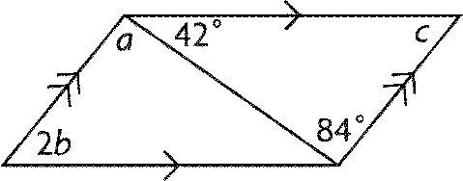

1. State the correct measures of the interior angles of *CDE*?

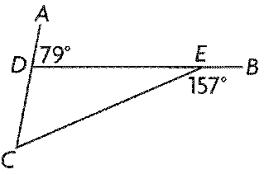

1. Given *LM* || *JK* and *LMJ* = *KMJ*, prove (using a 2 column proof) *JK* = *KM*.

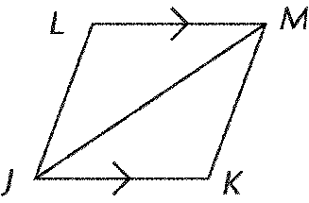

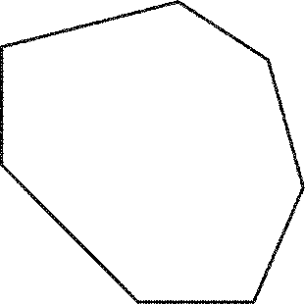**1.3 I can generalize, using inductive reasoning, a rule for the relationship between the sum of the interior angles and the number of sides (n) in a polygon.**

1. What is the formula for determining the sum of interior angles in a polygon? Does the polygon need to be regular?
2. Determine the sum of the measures of the interior angles of this seven-sided polygon. Show your calculation.
3. Each interior angle of a regular convex polygon measures 150°. How many sides does the polygon have?

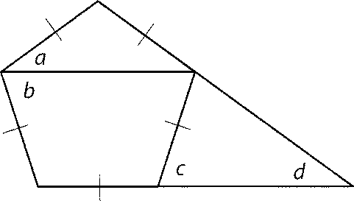

1. Determine the value of *c*.

**1.4 I can identify and correct errors in a given proof of a property that involves angles.**

1. Saito and Dileep determined different measures of the external angles of a regular 32-sided figure. Check each calculation. Identify any errors made and correct the work.

|  |  |
| --- | --- |
| **Saito’s Solution**  In a regular polygon with *n* sides, when you multiply the measure of the external angles by *n* – 2, the product is 360°.  Let *x* represent the measure of an exterior angle and *n* represent the number of sides.    The measure of an external angle is 12°. | **Dileep’s Solution**  Determine the interior angle, *x*, and subtract that value from 360°.    The measure of an external angle is:  180° – 168.75° = 11.25°. |

**1.5 I can verify if lines are not parallel.**

1. In which diagram(s) is *AB* parallel to *CD*? Why?

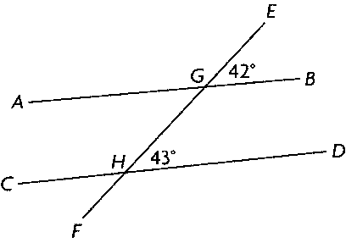 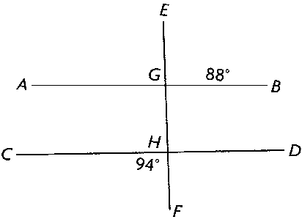

1. Given *UWX ~* *UYZ*, prove: *WX* || *YZ*

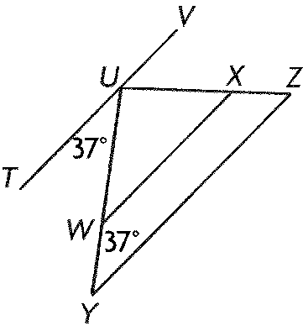

**1.6 I can prove that two triangles are congruent.**

1. What criteria can be used to prove if a triangle is congruent? Draw examples of each situation.
2. Can you conclude that *ABC* is congruent to *XYZ*? Explain your answer briefly.

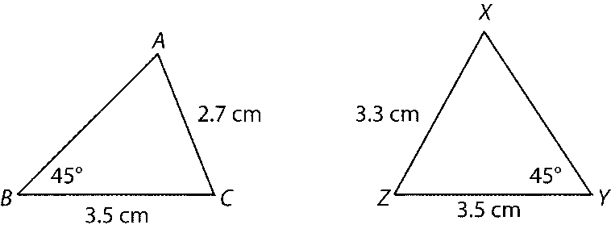

1. Joan drew these congruent triangles. List the equal angles.

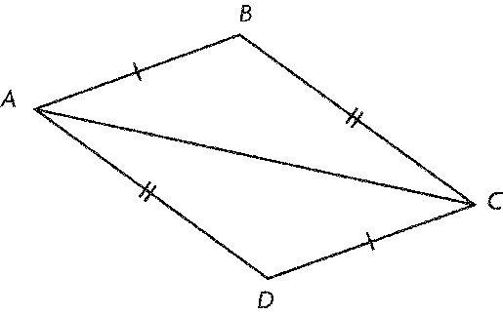

**Unit 3: Acute Triangle Trigonometry**

**Specific Outcome 3: Solve problems that involve the cosine law and the sine law, excluding the ambiguous case.**

**3.1 I can draw diagrams to represent a problem that involves the cosine law or the sine law.**

1. Sketch a triangle that corresponds to the equation. Then, determine the third angle measure and the third side length.

**

1. In *RST*, the values of *s* and *T* are known. What additional information do you need to know if you want to use the sine law to solve the triangle?
2. In *WXY*, the values of *w*, *x*, and *y* are known. Write the form of the cosine law you could use to solve for the angle opposite *w*.

**3.2 I can explain the steps in a given proof of the sine law or cosine law.**

1. *** This outcome will not be assessed on the final exam.

**3.3 I can solve a problem that requires the use of the sine law or cosine law, and explain the reasoning.**

1. What are the formulas for sine and cosine law?
2. 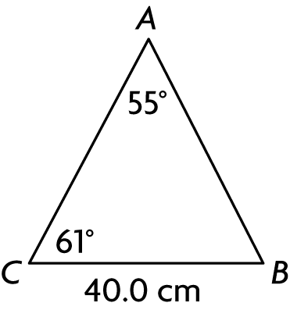In general, what pieces of information do you need to know in order for sine law to work?
3. Describe a situation where you could not use sine law but you could use sine law to solve a problem.
4. Determine the length of *c* to the nearest tenth of a centimeter.
5. Determine the measure of ** to the nearest degree.

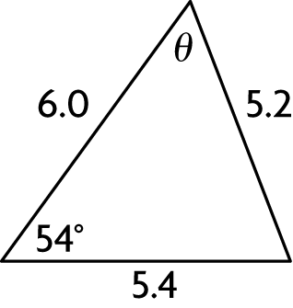

1. 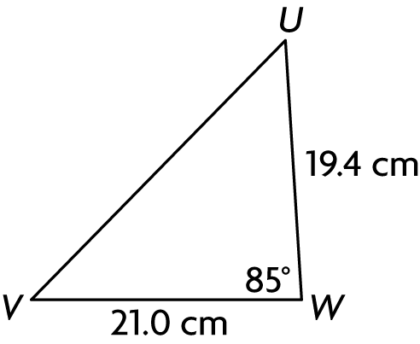Determine the length of *w* to the nearest tenth of a centimetre.
2. Determine the length of *s* to the nearest tenth of a centimetre.

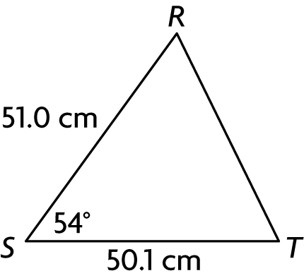

1. In *ABC*, *a* = 108 cm, *b* = 100 cm, and *c* = 124 cm. Determine the measure of *C* to the nearest degree.

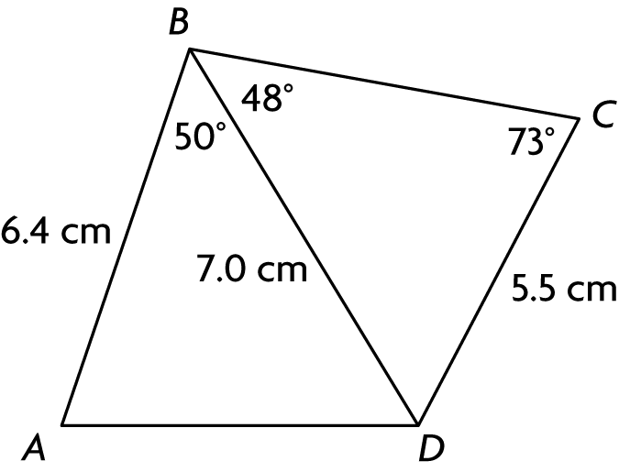

**3.4 I can solve a problem that involves more than one triangle.**

1. Determine the perimeter of this quadrilateral to the nearest tenth of a centimetre.

**Specific Outcome 2: Solve problems that involve properties of angles and triangles.**

**2.3 I can solve a problem that involves angles or triangles.**

1. A canoeist leaves a dock on Lesser Slave Lake in Alberta, and heads in a direction S20°W from the dock for 1.5 km. The canoeist then turn and travels north until he is directly west of the dock. How you can determine the distance between the dock and the canoe?
2. A kayak leaves a dock on Lake Athabasca, and heads due north for 2.8 km. At the same time, a second kayak travels in a direction N70°E from the dock for 3.0 km. How you can determine the distance between the kayaks?

Unit 4: Radical Numbers and Problems

**Specific Outcome 3. Solve problems that involve operations on radicals and radical expressions with numerical and variable radicands (limited to square roots).**

**3.1 I can compare and order radical expressions with numerical radicands.**

1. Which number is **not** expressed in the simplest form? How can you tell? Simplify the expression.

   

1. Lists these numbers in increasing order?

4, 2,, 3

**3.2 I can express an entire radical with a numerical radicand as a mixed radical.**

1. List the rules for converting entire radicals to mixed radicals.
2. Express  as a mixed radical in simplest form.

**3.3 I can express a mixed radical with a numerical radicand as an entire radical.**

1. List the rules for converting mixed radicals to entire radicals.
2. Express 7 as an entire radical.

**3.4 I can +, -, x, and ÷ to simplify radical expressions.**

1. Describe the rules for adding and subtracting radical numbers.
2. Describe the rules for multiplying and dividing radical numbers.
3. What is the simplest form of 2 + 5 + 6?
4. Express  as a product of two radicals.
5. Convert  –  –  into mixed radical form. Then simplify.
6. Add 4 + 4 + 4.
7. Express  in mixed radical form and entire form.
8. Expand the expression .
9. Write  in simplest form.

**3.5 I can rationalize the denominator of a radical expression.**

1. What does it mean to ‘Rationalize a denominator’ when dealing with radical fractions? Why would we do it?
2. Write out a set of rules for rationalizing a denominator.
3. Rationalize the denominator in .

**3.6 I can identify values of the variable for which the radical expression is defined.**

1. State any restrictions on the variable, then expand. 

**Specific Outcome 4. Solve problems that involve radical equations (limited to square roots or cube roots).**

**4.1 Determine any restrictions on values for the variable in a radical equation and 4.4 I can explain why some roots determined in solving a radical equation are extraneous.**

1. Can the total value of an expression in a radical be less than zero? Why or why not? Provide an example.
2. What is the value of *x* in ?
3. How many solutions are there for ? Explain your reasoning.

**4.2 Determine, algebraically, the roots of a radical equation, and explain the process used to solve the equation.**

1. What is the value of *x* in ?
2. What is the value of *x* in ?

**4.3 I can verify, by substitution, that the solution of a radical expression is true. And 4.5: I can solve problems by modelling a situation with a radical equation and solving the equation.**

1. Joss has been contracted to water lawns for the summer using circular sprayers. The radius of sprayed water, *r*, in metres, is modelled by *r* = *,* where *A* is the area of grads watered by in square metres. Determine the area covered for a circle with a radius of 12 m. Verify your answer by substitution.
2. State any restrictions on *x*, then solve .

**Math 20-2 Final Exam Study Guide: Units 5-8**

Use the following study guide to help you prepare for your final exam. It is taking place on ___________________ and is worth _______ of your final Math 20-2 grade.

**Helpful hints:**

* We have used the textbook and the workbook to complete the course. You should use both resources to study.
* Make a study plan. Try to study for 20 minutes then take a break then study for 20 minutes more at least 5 days a week. Cramming does not work and will make your brain mush.
* Your textbook has ‘study aid’ pages that are helpful to read through
* Do the practice questions at the end of each chapter.
* Don’t underestimate the power of the digital age… various websites can help you with these concepts. Try <http://www.khanacademy.org> or simply search a topic in *youtube*.
* Check off each learning objective below when you feel you thoroughly understand it.

**Unit 5: Statistics and Statistical Reasoning**

Specific Outcome 1. Demonstrate an understanding of normal distribution, including: standard deviation and z-scores

* 1. **I can explain, using examples, the meaning of standard deviation.**

1. What does it mean to have a large standard deviation compared to a small standard deviation?

**1.2 I can calculate, using technology, the population standard deviation of a data set. 1.3 I can explain the properties of a normal curve, including the mean, median, mode, standard deviation, symmetry and area under the curve.**

Joel researched the average daily temperature in his town. Average Daily Temperature in Lloydminster.

|  |  |  |  |  |  |  |  |  |  |  |  |  |
| --- | --- | --- | --- | --- | --- | --- | --- | --- | --- | --- | --- | --- |
| **Month** | **Jan.** | **Feb.** | **Mar.** | **Apr.** | **May** | **Jun.** | **Jul.** | **Aug.** | **Sep.** | **Oct.** | **Nov.** | **Dec.** |
| average daily temperature (°C) | –10.0 | –17.5 | –5.0 | 3.7 | 10.7 | 14.3 | 20.1 | 14.0 | 9.8 | 4.8 | –5.8 | –14.8 |

1. Determine the range of the data
2. Find the mean, median and mode.
3. What is the standard deviation?

**1.4 I can determine if a data set approximates a normal distribution, and explain the reasoning.**

1. What are the characteristics of a normal distribution?
2. Environment Canada compiled data on the number of lightning strikes per square kilometre in Saskatchewan and Manitoba towns from 1999 to 2008. Construct a frequency table and determine if the final result is approximately normally distributed.

2.03 1.31 0.25 1.03 1.20 0.17 0.99 1.01 0.24 0.94 0.92 0.09

0.86 0.71 0.05 0.81 0.63 0.01 0.80 0.58 0.00 0.72 0.49 0.52

0.43 0.46 0.40

Complete the frequency table.

|  |  |
| --- | --- |
| **Lightning Strikes (per square kilometre)** | **Frequency** |
| 0.00–0.49 |  |
| 0.50–0.99 |  |
| 1.00–1.49 |  |
| 1.50–1.99 |  |
| 2.00–2.49 |  |

1. Is the data in this set normally distributed? Explain.

|  |  |  |  |  |  |  |
| --- | --- | --- | --- | --- | --- | --- |
| **Interval** | 82–85 | 86–89 | 90–93 | 94–97 | 98–101 | 102–105 |
| **Frequency** | 5 | 3 | 8 | 20 | 11 | 1 |

**1.5 I can compare the properties of two or more normally distributed data sets.**

1. Claire ordered packages of beads from two online companies. The mean of the masses of the packages from company A is 72 g with a standard deviation of 3.4 g. The mean of the masses of the packages from company B is 68.5 g with a standard deviation of 1.8 g. She ordered 10 packages from each company. Which company’s packages have a more consistent mass?

**1.7 I can solve a contextual problem that involves the interpretation of standard deviation.**

1. The ages of members in a hiking club are normally distributed, with a mean of 32 and a standard deviation of 6 years. What percent of the members are younger than 20? Older than 20?
2. The ages of members in a hiking club are normally distributed, with a mean of 32 and a standard deviation of 6 years. What percent of the members are between 26 and 32?
3. A teacher is analyzing the class results for a computer science test. The marks are normally distributed with a mean (µ) of 79.5 and a standard deviation () of 3.5. Determine Daryl’s mark if he scored µ + .
4. In a population, 50% of the adults are taller than 172 cm and 10% are taller than 190 cm. Determine the mean height and standard deviation for this population.

**1.8 I can determine, with or without technology, and explain the z-score for a given value in a normally distributed data set.**

1. Determine the *z*-score for the given value. µ = 360,  = 20, *x* = 315
2. Determine the percent of data to the right of the *z*-score: *z* = –0.68.

**1.6 I can explain the application of standard deviation for making decisions in situations such as warranties, insurance or opinion polls**. **1.9 I can solve a problem that involves normal distribution.**

1. The manager of a customer support line currently has 200 unionized employees. Their contract states that the mean number of calls that an employee should handle per day is 40, with a maximum standard deviation of 8 calls. The manager tracked the number of calls that each employee handles. Does the manager need to hire more employees if the calls continue in this pattern? (hint: Start by finding the midpoint of each category)

|  |  |
| --- | --- |
| **Daily Calls (min)** | **Frequency** |
| 21–25 | 6 |
| 26–30 | 15 |
| 31–35 | 35 |
| 36–40 | 62 |
| 41–45 | 54 |
| 46–50 | 21 |
| 51–55 | 6 |
| 56–60 | 1 |

1. Yumi always waits until her gas tank is nearly empty before refuelling. She keeps track of the distance she drives on each tank of gas. The distance varies depending on the weather and the amount she drives on the highway. The distance has a mean of 520 km and a standard deviation of 14 km.

**a)** What percent of the time does she drive between 534 km and 562 km on a tank of gas?

**b)** Between what two values will she drive 95% of the time?

**Specific Outcome 2. Interpret statistical data, using: confidence intervals, confidence levels, margin of error. These outcomes are project based and will not be assessed on the final exam.**

~~2.1 Explain, using examples, how confidence levels, margin of error and confidence intervals may vary depending on the size of the random sample.~~

~~2.2 Explain, using examples, the significance of a confidence interval, margin of error or confidence level.~~

~~2.3 Make inferences about a population from sample data, using given confidence intervals, and explain the reasoning.~~

~~2.4 Provide examples from print or electronic media in which confidence intervals and confidence levels are used to support a particular position.~~

~~2.5 Interpret and explain confidence intervals and margin of error, using examples found in print or electronic media.~~

~~2.6 Support a position by analyzing statistical data presented in the media.~~

**Unit 6: Quadratic Functions**

**Specific Outcome 1. Demonstrate an understanding of the characteristics of quadratic functions, including: the vertex, intercepts, domain and range, and the axis of symmetry.**

**1.1 I can determine, with or without technology, the coordinates of the vertex of the graph of a quadratic function.**

1. What is the vertex form of the quadratic equation? What do the values mean?
2. Which set of data is correct for this graph?



|  |  |  |  |  |
| --- | --- | --- | --- | --- |
| **Set** | **Axis of Symmetry** | **Vertex** | **Domain** | **Range** |
| A. | *x* = –2 | (–2, 6) | *x*  R | *y*  R |
| B. | *x* = –6 | (–6, –2) | –8  *x*  4 | –8  *y* |
| C. | *x* = –2 | (–2, –6) | *x*  R | –6  *y* |
| D. | *x* = 2 | (2, 6) | –6  *x*  2 | –6  y |

1. The graph above has a y-intercept of -2. Describe how you would solve for the “a” value in the equation and then determine a.

**1.2 I can determine the equation of the axis of symmetry of the graph of a quadratic function, given the x-intercepts of the graph.**

1. What is the x-intercept form of the quadratic equation? What do the values of M and N stand for? How can they be used to determine the axis of symmetry?
2. The points (–3, 0) and (1, 0) are located on the same parabola. What is the equation for the axis of symmetry for this parabola? What letter does this correspond to in the vertex form of the quadratic equation?

**1.3 I can determine the coordinates of the vertex of the graph of a quadratic function, given the equation of the function and the axis of symmetry, and determine if the y-coordinate of the vertex is a maximum or a minimum.**

1. Which set of data is correct for the quadratic relation *f*(*x*) = –2(*x* – 12)2 + 15?

|  |  |  |  |
| --- | --- | --- | --- |
|  | **Direction parabola opens** | **Vertex** | **Axis of Symmetry** |
| **A.** | downward | (15, –12) | *x* = 15 |
| **B.** | downward | (12, 15) | *x* = 12 |
| **C.** | upward | (–12, 15) | *x* = –12 |
| **D.** | upward | (15, 12) | *x* = 15 |

1. Which function has a maximum value? How can you tell?

a. *f*(*x*) = –14(*x* + 4)2 – 7 b. *f*(*x*) = 4(*x* + 7)2 + 9

c. *f*(*x*) = (*x* – 9)2 –14 d. *f*(*x*) = 7(*x* + 14)2 – 4

1. Which quadratic function does not have *a* = –1 and vertex (5, 1)?

a. *y* = (4 – *x*)(*x* – 6) b. *y* = –(*x* + 4)(*x* – 6)

c. *y* = –*x*2 + 10*x* – 24 d. *y* = –(*x* – 5)2 + 1

**1.4 I can determine the domain and range of a quadratic function.**

1. What is the difference between domain and range? What do they really mean?
2. Which set of data is correct for this graph?



|  |  |  |  |  |
| --- | --- | --- | --- | --- |
|  | **Axis of Symmetry** | **Vertex** | **Domain** | **Range** |
| A. | *x* = 3 | (3, 2) | *x*  R | 2  *y* |
| B. | *x* = 3 | (2, 3) | *x*  R | *y*  R |
| C. | *x* = 2 | (2, 3) | –1  *x*  7 | 2  *y* |
| D. | *x* = 3 | (3, 2) | –2  *x*  8 | 0  *y* |

1. Which quadratic function does not have the domain *x*  R and the range *y* 4?

a. *y* = –0.25(*x* – 2)(*x* – 11) b. *y* = –(*x* – 5)(*x* – 9)

c. *y* = –2(*x* – 7)2 + 4 d. *y* = –*x*2 + 14*x* – 45

1. Which quadratic function does not have the domain *x*  R and the range *y*  –6?

a. *y* = 6(*x* – 4)(*x* – 2) b. *y* = 0.5(*x* – 3)2 – 6

c. *y* = 0.5*x*2 – 2*x* – 4 d. *y* = *x*2 – 2*x* – 6

1. Fill in the table for the relation *y* = –0.5*x*2 + 0.5*x* + 3.

|  |  |
| --- | --- |
| ***y*-intercept** |  |
| ***x*-intercept(s)** |  |
| **Axis of symmetry** |  |
| **Vertex** |  |
| **Domain** |  |
| **Range** |  |

**1.5 I can sketch the graph of a quadratic function.**

1. Make a table of values, then sketch the graph of the relation *y* = *x*2 + 2*x* + 11.

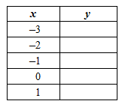

1. Which relation is quadratic? *y* = (*x* + 5)2 *y* = (2*x*2)(*x* + 1) *y* = *x*2 – *x*2 + 4*x* + 2

or *y* = 2*x* – 6*x* + 3. Explain your reasoning.

1. What are the *x*- and *y*-intercepts for the function *f*(*x*) *=x*2 –2*x* + 3?
2. Sketch the graph of *f*(*x*) = 6(*x* + 0.5)2 – 5, then state the domain and range of the function.
3. Determine the equation of a parabola with vertex (–2, –11) and point (–4, 5).
4. Given *a* = –3 and vertex (–2, 0.5), determine the quadratic function in vertex form:

*y* = *a*(*x – h*)*2* *+ k.*

1. Determine the quadratic function that contains the factors (*x* + 1.5) and (*x* + 10.5) and the point (7.5, 36). Express your answer in vertex form.
2. Sketch the graph of *y* = (*x* + 1)(*x* – 7).

**a)** State the maximum or minimum value of the function.

**b)** Express the function in standard form.

1. Sketch the graph of *y* = 0.25(*x* – 4)2 + 5*.*

**b)** State the maximum or minimum value of the function.

**c)** Express the function in standard form.

**1.6 I can solve a problem that involves the characteristics of a quadratic function.**

1. Describe when it would be best to use the standard form, the vertex form and the intercept form of a quadratic equation.
2. In many questions you will need to solve for ‘a’. Explain what you would need to have in order to find ‘a’ in any form of the quadratic equation.
3. Fill in the table for the relation *y =* *x*2 + 2*x* + 11*.*

|  |  |
| --- | --- |
| ***y*-intercept** |  |
| ***x*-intercept(s)** |  |
| **Axis of symmetry** |  |
| **Vertex** |  |
| **Domain** |  |
| **Range** |  |



1. Determine the quadratic function that defines the parabola on the right in vertex form, intercept form and standard form.

1. The height of a soccer ball above the ground, *y*, in meters, is modeled by the function:

*y* = –4.9*x*2 + 5*x* + 1,where *x* is the time in seconds after the ball is kicked.

**a)** Use technology to determine the maximum height the ball will reach. Round your answer to the nearest tenth of a meter.

**b)** State any restrictions on the domain and range of the function.

**c)** For how long is the ball in the air?

**Unit 7: Quadratic Equations**

**Relations and Functions Specific Outcome 2. Solve problems that involve quadratic equations.**

**2.1 I can find, with or without technology, the intercepts of the graph of a quadratic function.**

1. Using your calculator: What are the *x*- and *y*-intercepts for the function

*f*(*x*) *= x*2 + 7*x* + 10?

1. Solve *x*2 + 7*x* +10= 0 by graphing the corresponding function and determining the zeros.
2. Solve 2*x*2 – 14*x* +20= 0 by graphing the corresponding function and determining the zeros.
3. Rewrite 3*x*2 + *x* = –4*x* + 5 in standard form. Then solve the equation in standard form by graphing on a calculator. (you cannot factor this equation algebraically. It has decimals.)

**2.2 I can determine, by factoring, the roots of a quadratic equation, and verify by substitution.**

1. Describe a list of steps that you could use to factor a simple quadratic equation where the ‘a’ value is equal to one.
2. The sum of two numbers is 37. Their product is 312. What are the numbers?
3. Factor the following function: *f*(*x*) *= x*2 + 7*x* + 10?
4. Describe how to factor a quadratic equation by decomposition; where a ≠ 1.
5. Solve 2*w*2 + 4*w* –30 = 0 by factoring. (Take out a common factor first). Verify your solution.
6. Find the roots of *f*(*x*) *=* 6*x*2 - 11*x* + 4?
7. Determine the zeroes of 0 = 2*x*2 + 3*x* -2?

**2.3 I can find, using the quadratic formula, the roots of a quadratic equation.**

1. What is the Quadratic formula?
2. Solve 2*x*2 – 5*x* – 3 = 0 using the quadratic formula.
3. Solve *x*2 + 3*x =* –4*x* – 12 using the quadratic formula.
4. Solve –2*x*2 + 3*x –* 2 *=* –8*x*2 – 2*x* + 2 using the quadratic formula. (Combine like terms first)

**2.4 I can explain the relationships between the roots of an equation, its zeros, and the x-intercepts of the graph of the function.**

1. Explain what the words ‘roots’, ‘zeroes’, intercepts’, and ‘solutions’ mean in the context of a quadratic equation.
2. Determine the roots of 2*x*2 – 24*x =* –72 (rearrange first, then pull out a GCF)
3. Determine the roots of the corresponding quadratic equation for the graph.

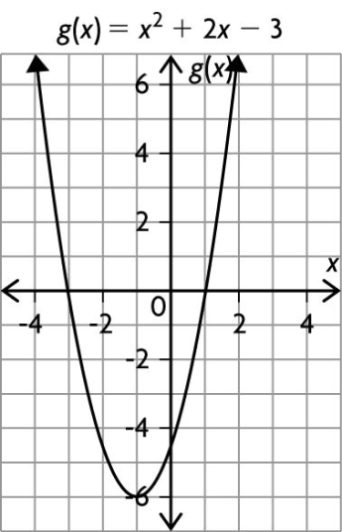

**2.5 I can explain, using examples, why the graph of a quadratic function may have zero, one or two x-intercepts.**

1. What are the *x*- and *y*-intercepts for the function *f*(*x*) *= x*2 + 7*x* + 10?
2. How many zeros does *f*(*x*) = *a*(*x* – 2)2 + 5 have if *a* > 0? Describe how you can tell.
3. How many zeros does *f*(*x*) = 0.5(*x* – 3)2 + 18 have? Test your prediction by sketching the graph.

**2.6 I can express a quadratic equation in factored (intercept) form, given the zeros of the corresponding quadratic function or the x-intercepts of the graph of the function.**

1. Assuming a= -1 what is the equation for this parabola in vertex form?



1. A quadratic function has an equation that can be written in the form *f*(*x*) = *a*(*x* – *r*)(*x* – *s*)*.* The graph of the function has *x*-intercepts at (3, 0) and (6, 0) and passes through the point (7, –4). Write the equation of the function.
2. A quadratic function has an equation that can be written in the form *f*(*x*) = *a*(*x* – *r*)(*x* – *s*)*.* The graph of the function has *x*-intercepts at (1, 0) and (3, 0) and passes through the point (–1, 16). Write the equation of the function.

**2.7 I can solve a problem by modelling a situation with a quadratic equation and solving the equation.**

1. Nadine dives with a senior swim club. In a dive off a 10 m platform, she reaches a maximum height of 10.5 m after 0.35 s. How long does it take her to reach the water?
2. Gravity affects the speed at which objects travel when they fall. Suppose a rock is dropped off a 7.5 m cliff on Mars. The height of the rock, *h*(*t*), in metres, over time, *t*, in seconds could be modelled by the function *h*(*t*) = –1.9*t*2 + 3.0*t* +7.5*.*

**a)** How long would it take the rock to hit the bottom of the cliff?

**b)** The same rock dropped off a cliff of the same height on Earth could be modelled by the function *h*(*t*) = –4.9*t*2 + 3.0*t* +7.5*.* Compare the time that the rock would be falling on Earth and on Mars.

**Unit 8: Proportional Reasoning**

**Specific Outcome 1. Solve problems that involve the application of rates.**

**1.1 I can interpret rates in a given context, such as the arts, commerce, the environment, medicine or recreation.**

1. The butcher shop sells a 3 lb package of chicken legs for $9.57. The supermarket sells chicken legs for $7.68/kg. Determine the price per kilogram that each store charges. Which store has the lower price per kilogram? (Assuming that there are 2.2 lbs per kg)

**1.2 I can solve a rate problem that requires the isolation of a variable.**

1. A medic administers a vaccine that comes in a 15 mL bottle. The adult dosage is 0.6 cc (1 cc is equivalent to 1 mL). How many adults can the medic vaccinate before the bottle is empty?
2. Moira loaned $300 to her roommate for 4 months and was paid back $310. What simple interest rate did she earn?

I=prt where

I = amount of interest

p = capital amount

r = percent interest rate

t = time period

**1.3 I can determine and compare rates and unit rates.**

1. Wayne and Steve work at a photocopy shop. They have an order to print and bind 500 copies of a business report. Steve finished 125 reports in 8.5 h and Wayne finished the remaining 375 reports in 22 h. Who worked at a faster rate?
2. On Wednesday a crew paved 12 km of road in 7 h. On Thursday, the crew paved 8 km in 6 h. On which day did they pave the road at the faster rate?
3. Yogurt is sold in 750 mL tubs and 125 mL cups. A 750 mL tub sells for $2.69 and twelve 125 mL cups sell for $4.19. Which size has the lower unit cost? Show your calculations

**1.4 I can make and justify a decision, using rates. And 1.8 I can describe a context for a given rate or unit rate.**

1. Describe a real life situation where a comparison of rates can influence a decision that you make?

**1.5 Represent a given rate pictorially. And 1.6 Draw a graph to represent a rate. And 1.7 Explain, using examples, the relationship between the slope of a graph and a rate. And 1.9 Identify and explain factors that influence a rate in a given context.**

1. Over one day, the outdoor temperature starts at 3 °C, increases at a rate of 1 °C/h for 6 h, remains constant for 3 h, and then decreases by 1.5 °C/h for 4 h. Draw a graph of the temperature over this period.

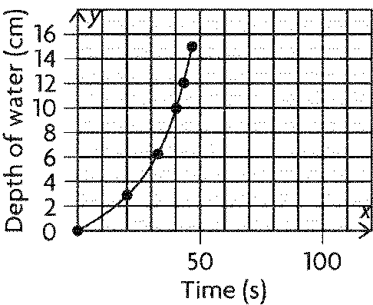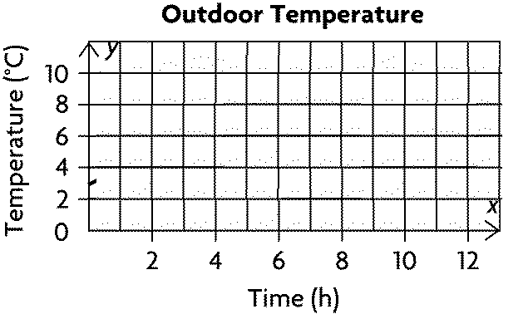

**1.10 Solve a contextual problem that involves rates or unit rates.**

1. Suppose that tap water, flowing from a faucet at a constant rate, is used to fill a container. Draw the container represented by the graph. Justify your answer.
2. Steve runs a kennel and purchases dog food from a U.S. supplier. The supplier sells 25 lb bags for $28.95 U.S. Each dog eats about 3.5 kg/week and Steve boards an average of 16 dogs per day. How many bags of dog food will he need for three months?
3. The floor plan for a small industrial company is drawn as shown, using a scale factor of 0.002. Anna, the company manager, wants to make a larger floor plan that she can laminate and use to keep track of work assignments and supplies. She wants the new plan to fit on a poster board that is 244 cm by 122 cm.

**a)** What scale should Anna use to fit the larger floor plan on the poster board? Explain.

**b)** What would be the new scale dimensions of the kitchen, will be.

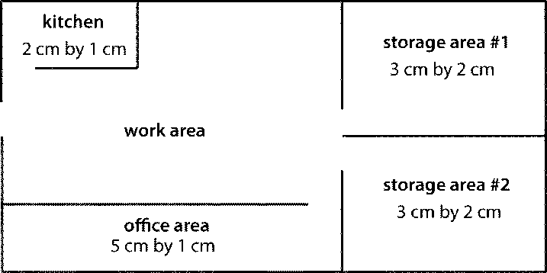

**Specific Outcome 2. Solve problems that involve scale diagrams, using proportional reasoning.**

**2.1 Explain, using examples, how scale diagrams are used to model a 2-D shape or a 3-D object.**

1. What is the relationship between the scale factor of 1D, 2D and 3D representations of the same figure? Put the equations in a table to show their distinction more clearly.

**2.2 Determine, using proportional reasoning, the scale factor, given one dimension of a 2-D shape or a 3-D object and its representation.**

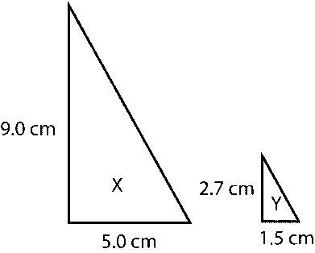

1. Determine the linear scale factor by which diagram X was reduced to form diagram Y. Express your scale factor as a fraction and as a percent.
2. On a plan, an actual length of 8.5 m is represented by 3 cm. Determine the scale and the scale factor of the plan.
3. The coffee mug used for this scale diagram was 9.0 cm tall. Measure to determine what scale factor was used for this diagram.

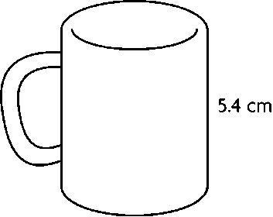

**2.3 Determine, using proportional reasoning, an unknown dimension of a 2-D shape or a 3-D object, given a scale diagram or a model.**

1. A rectangular computer chip on a circuit board is 4 mm wide and 7 mm long. Plans for the circuit board must be drawn using a scale factor of 25. Determine the dimensions of the chip on the scale diagram in centimetres.
2. A chair is 91 cm tall, 56 cm wide, and 58 cm long. Determine these dimensions on a scale model built using a scale of 1:2.
3. A high school basketball court is 26 m by 15 m. If an AREAS scale factor of 0.04 is applied to make a model, the new AREA will be?

**2.4 Draw, with or without technology, a scale diagram of a given 2-D shape, according to a specified scale factor (enlargement or reduction). And 2.5 Solve a contextual problem that involves a scale diagram.**

1. A billboard is 1 m by 2.5 m. Draw a scale diagram of the billboard that fits in a space that is 8 cm by 14 cm. What scale factor did you use?

**Specific Outcome 3.**

**Demonstrate an understanding of the relationships among scale factors, areas, surface areas and volumes of similar 2-D shapes and 3-D objects.**

**3.1 Determine the area of a 2-D shape, given the scale diagram, and justify the reasonableness of the result.**

1. The base and height of a trapezoid with an area of 35 cm2 will be enlarged by a scale factor of 4. Determine the area of the enlarged trapezoid.
2. Sooki enlarges this figure by a scale factor of 2. Determine the area of the enlarged figure, to the nearest square unit.

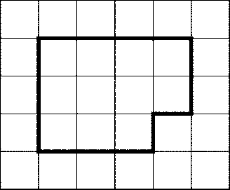

**3.3 Explain, using examples, the effect of a change in the scale factor on the area of a 2-D shape. And 3.5 Explain, using examples, the effect of a change in the scale factor on the volume of a 3-D object.**

1. A square has an area of 25 square units.
   1. What are the sides of the square?
   2. If the square has a square factor of 2 applied to it, what happens to the area?
   3. If the original square has a scale factor of 4 applied to it, what happens to the area?
2. How does the linear scale factor affect volume?

**3.6 Explain, using examples, the relationships among scale factor, area of a 2-D shape, surface area of a 3-D object and volume of a 3-D object. And 3.2 Determine the surface area and volume of a 3-D object, given the scale diagram, and justify the reasonableness of the result.**

1. Triangle A has an area of 19.00 cm2 and similar triangle B has an area of 118.75 cm2. Determine what LINEAR scale factor makes triangle B an enlargement of triangle A.
2. A potter creates a cylindrical vase with a volume of 7250 cm3. Then the potter creates a smaller, similar vase, in which the dimensions are reduced by a scale factor of . Determine the volume of the smaller vase.
3. A carpenter creates two similar boxes with their dimensions related by a scale factor of . The smaller box has a surface area of 670 m2. Determine the surface area of the larger box.

**3.7 Solve a spatial problem that requires the manipulation of formulas.**

1. The dimensions of cube are enlarged by a scale factor of 6.5.

Determine the value of .

Do not round your answer.

**3.8 Solve a contextual problem that involves the relationships among scale factors, areas and volumes.**

1. Parallelogram A is 1.5 in. wide and 0.75 in. high.

Parallelogram B is 0.5 in. wide and is similar to parallelogram A.

**a)** Determine the scale factor by which parallelogram A was reduced to form parallelogram B. Sketch the parallelograms if it will help you.

**b)** Determine the areas of parallelogram A and parallelogram B.

**c)** How many parallelograms congruent to parallelogram B would fit inside parallelogram A?