Unit 1: Inductive and Deductive Reasoning
Time Allotted: 2 weeks

Assessment Standards
Number and Logic
General Outcome: Develop number sense and logical reasoning.

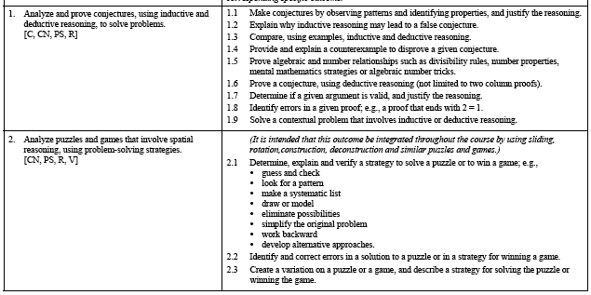

What do the Student know from Math 10-C?
No outcomes on Logic and Reasoning-- Student have an outcome on Numbers that may be helpful this unit.

What do Student know from Math 20-1?
No outcomes

What is Coming in Math 30-2
