LAWS FOR NON-RIGHT TRIANGLES Name: _____________

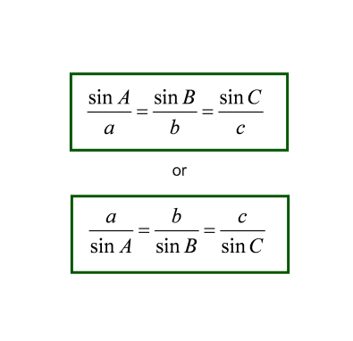
SINE LAW

COSINE LAW

or

TRIGONOMETRY – SELECT A STRATEGY

