

Moodle is a learning management system (LMS) that is designed to help educators create online courses with opportunities for rich interaction between teachers, students and parents. The word Moodle is actually an acronym for Modular Object-Oriented Dynamic Learning Environment, although originally the M stood for "Martin", named after Martin Dougiamas, the original developer.
Moodle can also be considered a verb, which describes the improvisational process of doing things as it occurs to you to do them, an enjoyable tinkering that often leads to insight and creativity. As such it applies both to the way Moodle was developed, and to the way a student or teacher might approach studying or teaching an online course. Although not all teachers at LCI are using the LMS, many of us have been ‘moodling’ for a number of years now!
The following information has been put together to introduce you to Moodle and to encourage you to begin using the tool to become more active in your son/daughter’s education.
You can access Moodle through the school website or by accessing the following website:
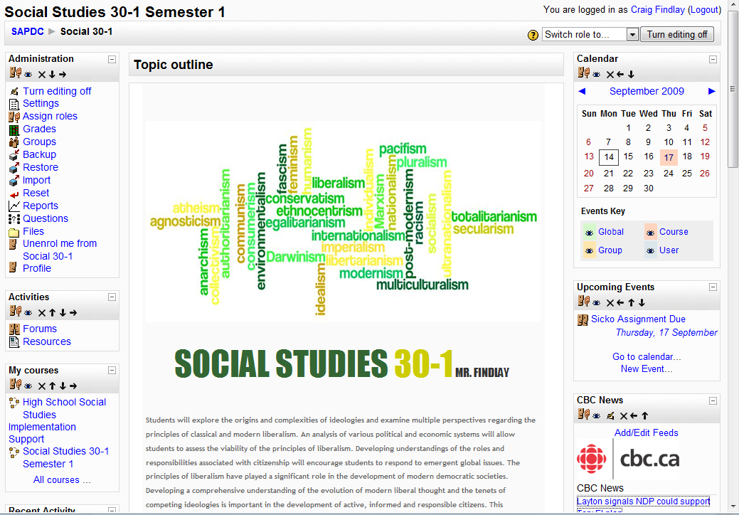
http://moodle.lethsd.ab.ca/sapdc

Ask your son or daughter for their username and password:

Username: _______________________ Password: _______________________

Moodle is a great tool to become engaged in your son/daughter’s education. It allows you to access the following:

    - assignment and test dates
    - classroom activities and assignments
    - classroom discussions and forums
    - websites and articles used in class



