
IDE LOGY
SOCIAL STUDIES 30-1
TO WHAT EXTENT SHOULD WE EMBRACE AN

MOODLE

Welcome to Moodle. The first thing you need to know is your username and password. Your username will be the first six letters of your last name and your first two letters of your first name (for a total of eight letters). I will use my name as an example:

Name: Craig Findlay Username: findlacr

*If your last name is less than six letters long then use all letters and add letters from your first name:

Name: Billy Lee Username: leebilly

The first time you login to Moodle your password will be: 123sapdc.

Once you login you will be prompted to change your password. Please insure you pick something you will remember.
http://moodle.lethsd.ab.ca/sapdc
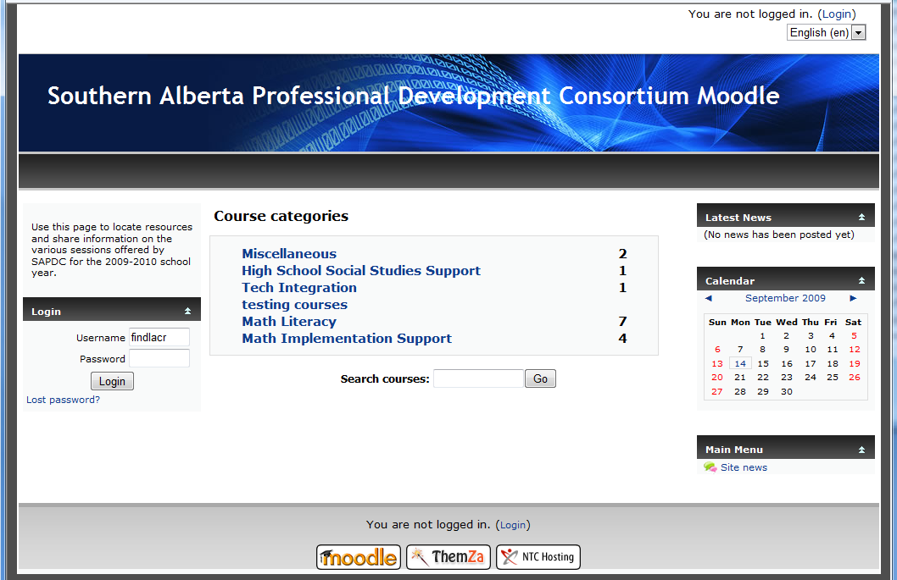

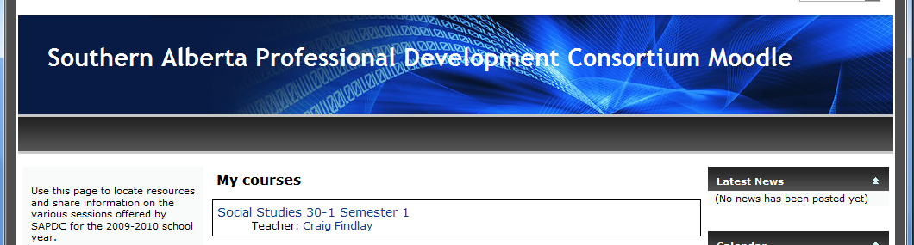

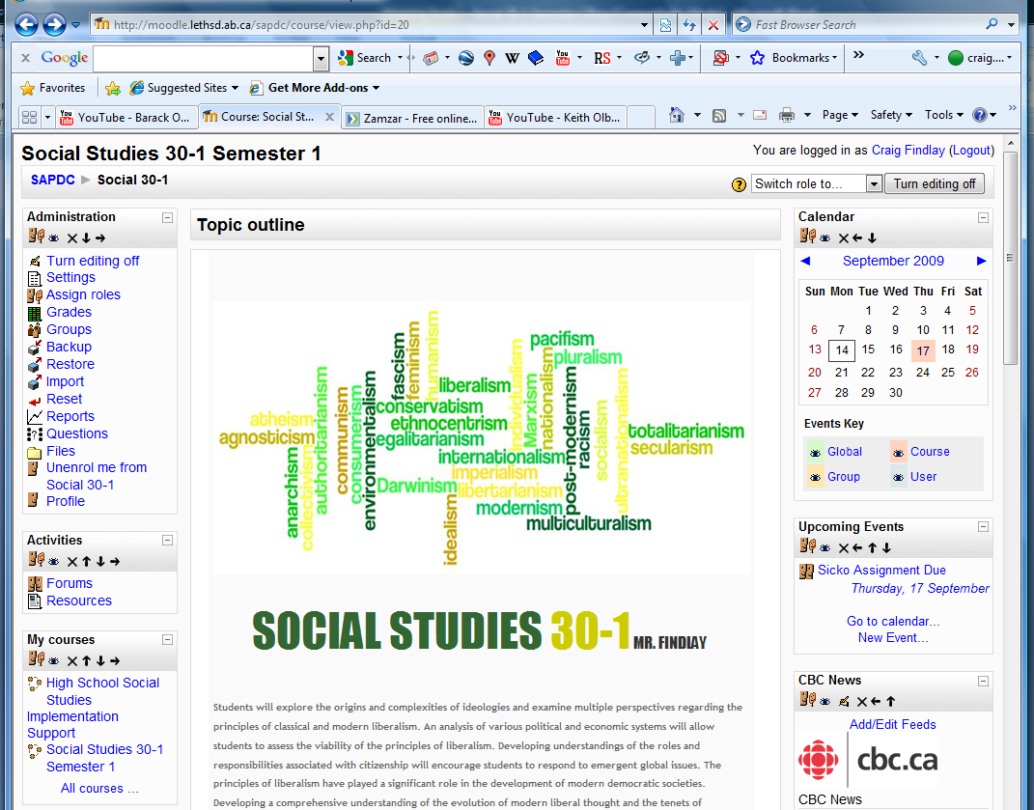

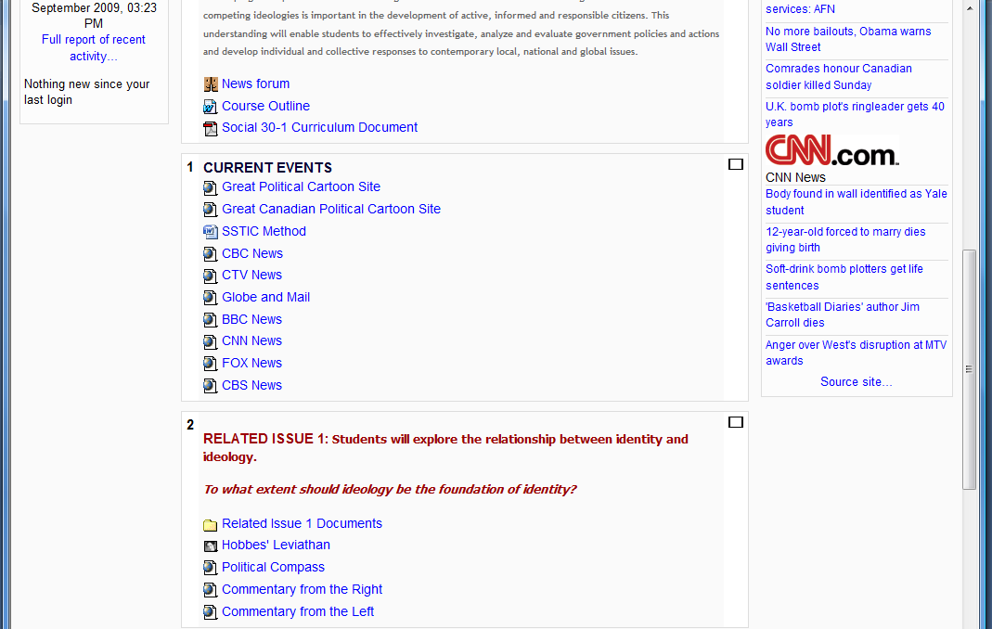
IDE LOGY
SOCIAL STUDIES 30-1
TO WHAT EXTENT SHOULD WE EMBRACE AN

