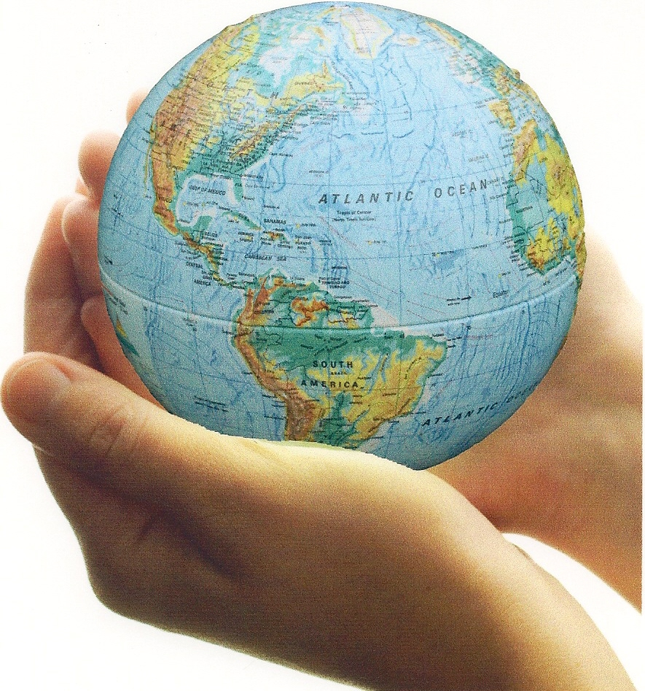

The curricular outcomes for related issue 2 are listed below:

2.1 appreciate Aboriginal contributions to the development of ideologies
2.2 appreciate how citizens and citizenship are impacted by the promotion of ideological principles
2.3 appreciate that individuals and groups may adhere to various ideologies
2.4 explore Aboriginal contributions to the development of liberalism
2.5 examine the relationship between the principles of liberalism and the origins of classical liberal thought (John Locke, Montesquieu, Adam Smith, John Stuart Mill)
2.6 analyze the impacts of classical liberal thought on 19th century society (laissez-faire capitalism, industrialization, class system, limited government)
2.7 analyze ideologies that developed in response to classical liberalism (classic conservatism,
Marxism, socialism, welfare capitalism)
2.8 analyze the evolution of modern liberalism as a response to classical liberalism (labour standards and unions, universal suffrage, welfare state, protection of human rights, feminism)
2.9 evaluate ideological systems that rejected principles of liberalism (Communism in the Soviet
Union, fascism in Nazi Germany)
2.10 analyze how ideological conflict shaped international relations after the Second World War
(expansionism, containment, deterrence, brinkmanship, détente, nonalignment, liberation movements)
2.11 analyze perspectives on the imposition of the principles of liberalism (Aboriginal experiences, contemporary events)
2.12 analyze the extent to which modern liberalism is challenged by alternative thought (Aboriginal collective thought, environmentalism, religious perspectives, neo-conservatism, postmodernism, extremism)
2.13 evaluate the extent to which resistance to the principles of liberalism is justified

In the textbook we explored the following:
classical liberalism
American Revolution
French Revolution
Montesquieu
capitalism
rule of law

Age of Reason
John
Locke
traditional economy
Enlightenment

laissez-faire
industrialization
free market

Adam Smith
class system
Chapter 3 Issue:

To what extent can classical liberalism
impact a society?
John Stuart Mill

Question for Inquiry #1:

What factors were most important in bringing about the emergence of classical liberalism?
Question for Inquiry #3:

How did classical liberalism influence 19th- century society?

Question for Inquiry #2:

How did classical liberal thought evolved into the principles of liberalism?

rights and freedoms

civil
liberties

limited government
welfare capitalism
Great Depression
Utopians
Edmund Burke
classical conservatism
communism
Chapter 4 Issue:

To what extent did classical liberalism
meet the needs of society?
Question for Inquiry #1:

Why did ideologies develop in opposition to classical liberalism?
Question for Inquiry #2:

How did classical liberalism respond to competing ideologies?
Question for Inquiry #3:

How did the
concept of
equality
expand?
progressivism
Chartists

command economy
universal suffrage
John Maynard Keynes
socialism
labour unions

Marxism
labour standards
human rights

CCF
feminism
Luddites
Mary Wollstonecraft

Chapter 5 Issue:

To what extent is the rejection of liberalism justified?
Question for Inquiry #1:

Why did ideologies that rejected liberalism emerge?
propaganda
proletariat
hyperinflation
Treaty of Versailles
Adolf Hitler
Great Purge
Lenin
communism
collectivization
Hitler
Youth

Nazism
Czar (Tsar)
scapegoat
Stalin
dissent
totalitarianism
reactionary

censorship
radical
fascism
Question for Inquiry #2:

How did ideologies that rejected liberalism affect citizens?

authoritarianism
Question for Inquiry #2:

In what ways have economies reflected the principles of liberalism since the Second World War?
Question for Inquiry #1:

In what ways did economies in the first half of the twentieth century reflect the principles of liberalism?
Chapter 6 Issue:

To what extent do contemporary economic policies and practices reflect the principles of liberalism?
Keynesian economics
Roaring twenties
‘Red Scare’
Friedman and Hayek
progressivism

Great depression
inflation
demand-side economics
New Deal

stock market crash
monetarism
FDR
Welfare state
trickle-down economics
social programs

income disparity
monopoly
consumerism
monetary and fiscal policy
Reaganomics and Thatcherism

supply-side economics

Question for Inquiry #2:

In what ways did this conflict of ideologies affect society's
and people’s
everyday lives?
Question for Inquiry #1:

To what extent did ideological conflict affect international relations after the Second World War?
Chapter 7 Issue:

To what extent does
ideological conflict
shape our world?
espionage
Proxy Wars
iron curtain
MAD
Korean
War
containment
McCarthyism
Cuban Missile Crisis

Vietnam
War
superpower
Berlin Wall
Nonalignment
expansionism
deterrence

Cold War
detente
brinkmanship
sphere of influence
Marshall Plan

liberal movements

Christian right
enfranchisement
Question for Inquiry #2:

How is liberalism challenged by alternative thought?
Question for Inquiry #1:

How far has liberalism strayed from its roots?
Chapter 8 Issue:

To what extent is
modern liberalism
continuing to evolve?
positive freedom
environmentalism
foreign policy
Neo-conservatism

civil rights movement
civil rights
Aboriginal justice
consensus
fundamentalism

negative
freedom

You should have a working understanding of the political and economic spectrum below:

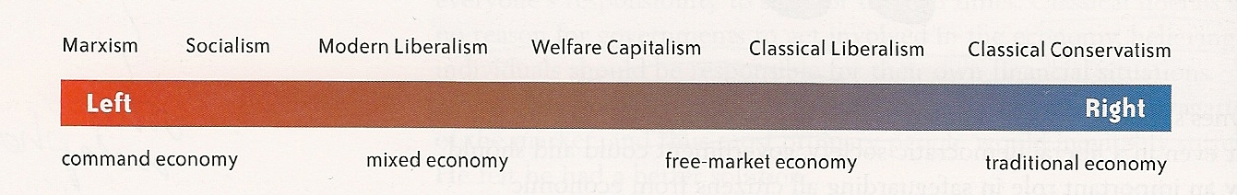

Essential understandings:

- you need to understand the principles of liberalism

- you need to understand the ideological contributions of John Locke, Montesquieu, Adam Smith, John Stuart Mill

- you need to understand the differences between classical liberalism and modern liberalism

- you need to understand the impacts of classical liberal thought on 19th century society (laissez-faire capitalism, industrialization, class system, limited government)

- you need to understand the evolution of modern liberalism as a response to classical liberalism (labour standards and unions, universal suffrage, welfare state, protection of human rights, feminism)

- you need to understand ideologies that developed in response to classical liberalism (classic conservatism, Marxism, socialism, welfare capitalism

- you need to understand the degrees of socialism (socialism, communism, Stalinism)

- You will need to know the following about Nazism and Stalinism:

- the pre-conditions that allowed the regimes to come to power
- the rise to power, including how power was taken
- the placement of each system on the political and economic spectrum
- the illiberal practices of the regime while in power (techniques of dictatorship)

- you need to understand the similarities and differences between fascism and communism

- you need to understand how Stalinism and Nazism used various techniques to undermine the principles of liberalism

- you need to understand how ideological conflict shaped international relations after the Second World War (expansionism, containment, deterrence, brinkmanship, détente, nonalignment, liberation movements)

- you need to understand how modern liberalism is challenged by alternative thought (Aboriginal collective thought, environmentalism, religious perspectives, neo-conservatism, postmodernism, extremism)

- you need to be able to explore aboriginal perspectives and contributions to the development of liberalism

