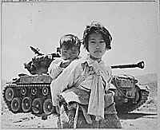
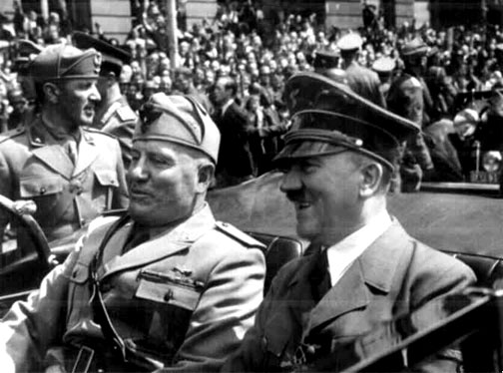

As you are well aware, Social Studies 30-1 is a very demanding course. On top of a huge collection of historical and philosophical content that you are asked to learn, there are also some things that are inherently expected of you. There is an unwritten expectation that you are a good reader. The word list below was created from pulling vocabulary from old social studies 30 diploma examinations. Can you define all of the words below? Can you use the words in a sentence?

alluding | diplomat | essential | annexing | accommodate | accountability | adherence | brokered
anarchism | entrepreneur | violation | anticipate | allegiances | anti-semitic | affirmative | ridicule
atrocities | globalization | lobby | arbitration | alterations | bourgeoisie | chronology | discontent
authoritarian | expansionist | inappropriate | assertion | antagonizing | budgetary | consolidate | animosity
civilian | dialogue | contemplating | conform | apathetic | bureaucracy | contemporary | ultranationalism
coercive | interventionism | extremist | counterproductive | banning | caricatures | contradiction | subsidize
consultation | incentives | capitalize | deregulation | broadening | combatants | conventional | idealism
cumulative | privatization | ambitions | designating | catastrophe | contrary | degradation | ceded
diminished | condemnation | constitutional | deterioration | coexist | corporate | deliberates | suffrage
disdain | implementation | emerging | deterrence | colonialism | dilemma | discounted | disenchantment
disempowerment | containment | diminish | devastation | conducting | disarm | enclaves | interpret
disillusionment | delegation | assurance | disintegration | consolidate | disarmament | entailing | verification
dissidents | assertion | turmoil | disobedience | cynical | dissolution | excessively | seizure
diverted | détente | aristocracy | dispassionately | declaration | ethnic | façade | juxtaposing
egalitarian | invoking | minority | dominance | dichotomy | excerpts | instrumental | guise
exploitation | corresponding | unilateral | electorate | divergent | fascist | internment | abandonment
fervor | deadlock | majority | entangled | enforce | feudalism | intervening | activism
fetter | imperialist | blunder | fundamentally | equitable | fiscal | invulnerable | rival
hierarchical | contradicted | multilateral | inciting | escalate | homeland | lenient | prosecute
humanitarian | jeopardize | coordination | indiscriminate | essence | implement | magnitude | deployment
impediment | isolationism | reactionary | legacy | immoral | ineptitude | mainstream | impede
indoctrination | centralized | impartial | legitimacy | imposition | inference | mechanism | severance
inevitability | brinkmanship | deficit | manifestation | incapable | initiatives | moderates | homogeneous
inflammatory | escalating | legality | neutrality | irrational | mandate | mutual | respective
infrastructure | vested | abandoned | obligations | legislative | minimize | nationalist | lavishly
inherently | annihilation | concession | partisans | marketplace | miscalculation | oppression | breaching
internationalism | sanction | alienation | preclude | maneuvers | modernization | overawed | diverse
ironic | appeasement | inflation | preliminary | mediation | monetary | plurality | overarching
manipulate | prosperity | dispute | prevalent | milestones | monopoly | proclamation | revulsion
nationalized | generalization | societal | reluctance | multinational | oligopoly | recessionary | haphazard
pacify | belligerent | judiciary | self-determination | occupation | outmaneuver | reinstatement | fellowship
perpetuate | proliferation | participatory | stabilizing | patronage | populace | remilitarization | contentious
provision | intervene | all-encompassing | stalemate | principally | proletariat | republics | despot
regimented | diplomacy | instability | suppressing | prosperity | prolonged | resolution | factional
reparation | radical | context | totalitarian | quarrel | propaganda | reunification | tariff
resurgence | non-alignment | spectrum | tribunal | rationalization | pursued | revenues | capability
rhetoric | inclusion | constitutionality | underlying | referendum | reprisal | stalemate | exclusively
scapegoat | inequalities | sovereignty | undermine | reoccupation | restraint | underrated | quota
supranatioanlism | collective | plebiscite | undertaking | resolve | scheme | ushered | franchise
totalitarian | stereotyping | hyperinflation | virtue | solidarity | stability | utilizing | distort
unbiased | decentralized | regime | widespread | valid | watchdog | utopia | liberation
analogies | metaphorical | conciliation | ceasefire | pact

It might be worth your while to spend some time looking up words that you cannot define or use in a sentence.

