[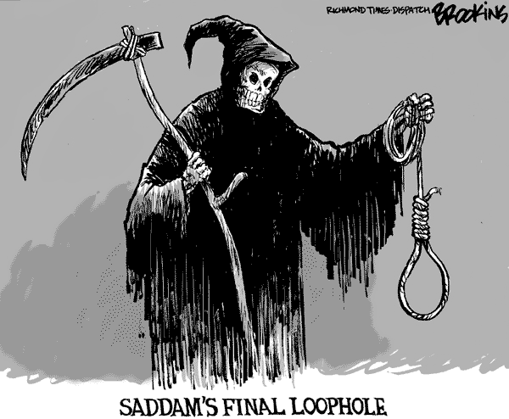](http://cagle.com/caglecards/main.asp?image=/news/SaddamDead/images/brookins.gif)

Your task is to go to the following site and select ***three*** cartoons to interpret. Your analysis of the cartoons needs to include a discussion of the differing perspectives on the topic or issue being described in the cartoon. You must also connect the cartoon to the principles of liberalism.

You need to save the cartoon to your server space. You can then cut and paste it into your final analysis. You will write an explanation for each of the cartoons you choose. You summaries should be approximately 150-200 words and make reference to the ***SSTIC*** method.

Use the following website to select your **three cartoons**:

[**http://cagle.com/**](http://cagle.com/)

[](http://cagle.com/)

***Here is an example of a summary:***

[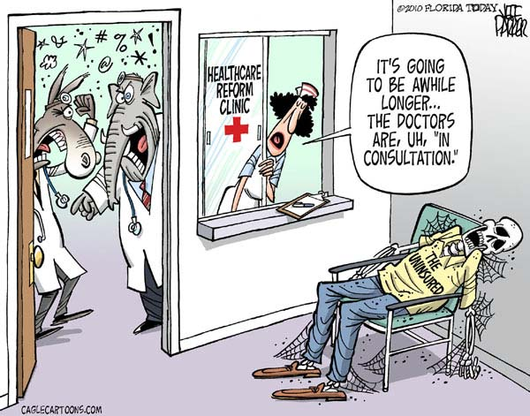](http://cagle.com/caglecards/main.asp?image=/news/ReformResistance/images/parker.jpg)This cartoon is by **Jeff Parker,** fromFlorida Today, March 16, 2010. The cartoon explores the current issue surrounding healthcare reform in the United States. The cartoon uses the well-known image of a doctor’s office to connect to people’s personal experience – most people have been in the situation. There are numerous symbols being used in the cartoon. The red cross on the clinic window is a commonly recognized symbol of healthcare, most notably the international ‘Red Cross’ organization. The two doctors, clearly disagreeing over something, are symbolized by the characters over their heads that indicate they are likely swearing at each other. The doctors are portrayed as a donkey and an elephant, the most common symbols of the two main political parties in the United States (the Democrats – donkey and the Republicans – elephants). The Democrats are pushing for changes to an American healthcare system built upon key principles of liberalism such as self-interest, completion and economic freedom. Democrats would say that the large private for-profit insurance companies who control the system, and who advocate these principles, have been corrupted by greed and put profit. They are calling for reforms that would introduce strong government controls to regulate the industry in the name of establishing more economic equality and collective interest for American citizens. The corpse in the cartoon symbolizes the millions of American citizens who are left without, or who are purposefully excluded from, healthcare coverage. Republicans, with individualist principles at their core, are against government regulation and any policies that counter the aforementioned principles of liberalism. Republicans believe that a free market of insurance providers should be left alone to meet the needs of Americans and that individuals should find their own healthcare needs. The cartoonist perspective appears to be looking past the ideological differences of the warring political parties and is more sympathetic to the perspective of Americans suffering with the healthcare system. The cartoon comments on the fact reality that as the parties fight over politics, people in the United States are suffering and some are dying.

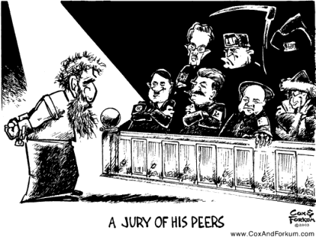

The following ***SSTIC*** acronym may help you better understand how political cartoons are made. Try to use these terms in the analysis of the cartoons you encounter.

**S – Symbolism** – many cartoonists use symbolism in their cartoons

YOU MAY USE ALL OF THE TECHNIQUES OR ONLY

A FEW

**S – Size** – the size of items in the cartoon can sometimes imply a certain meaning

**T – Text** – even though cartoons are visual, reading the text is crucial to understanding

**I – Imagery** – using a well-known image to evoke a certain understanding

**C – Color** – sometimes certain color can create a tone or mood to the cartoon

[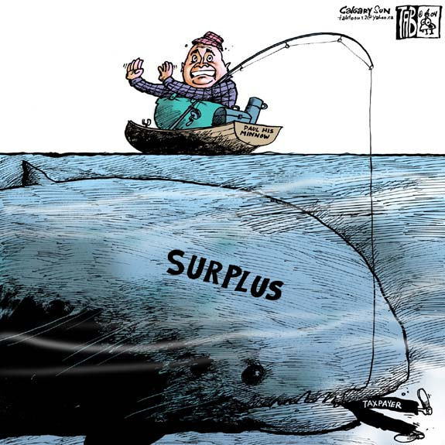](http://www.cagle.com/caglecards/main.asp?image=../../../working/041117/tab.jpg)

*Here are some examples:*

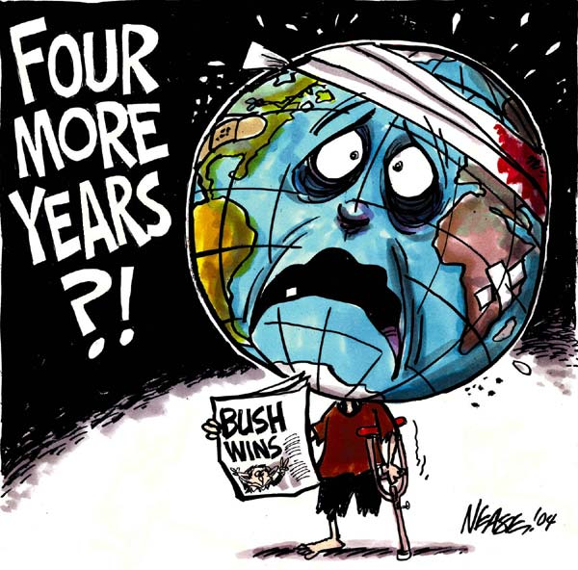

Dark ***color*** to set a serious and depressing mood to the cartoon

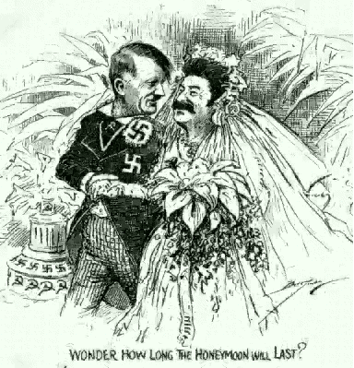[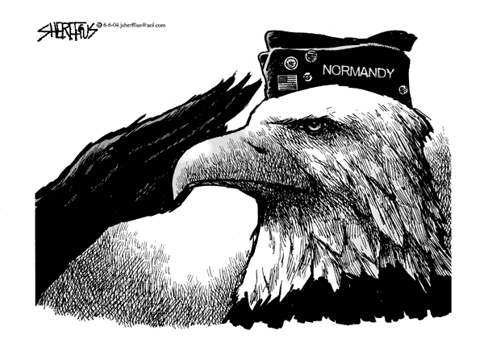](http://cagle.slate.msn.com/caglecards/main.asp?image=/news/DDay/images/sherffius21.gif)

Exaggerated ***size*** of fish to make a point about size of surplus

***Text*** provides underlying meaning to the cartoons.

Wedding scene is a well-known ***image*** of union or togetherness.

Eagle is a powerful ***symbol*** of the United States.