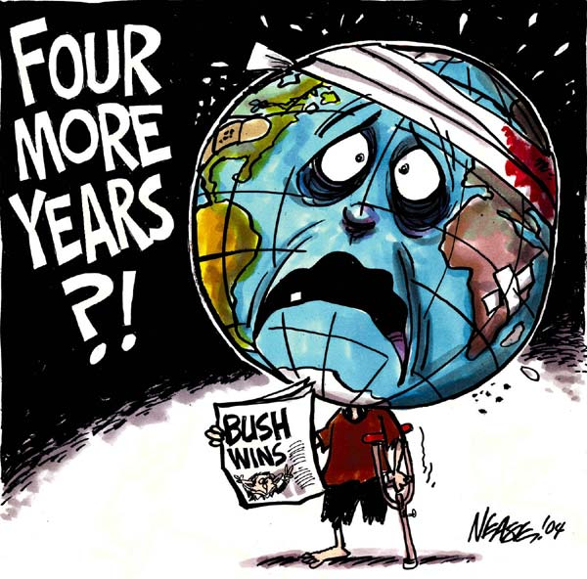

**Student Name** ___________________ **Cartoon:** _____________ **Date** ______________

|  |  |  |  |  |  |
| --- | --- | --- | --- | --- | --- |
| **Level**  **Criteria** | **4**  **Excellent** | **3**  **Proficient** | **2**  **Adequate** | **1**  **Limited** * | **Insufficient / Blank \*** |
| **Identifies main idea** | Main idea is specific and insightful | Main idea is meaningful and relevant | Main idea is general | Main idea is vague | No score is awarded because there is insufficient evidence of student performance based on the requirements of the assessment task. |
| **Demonstrates understanding** | Demonstrates a thorough and insightful understanding of the chosen cartoon and comprehensively explains historical and/or contemporary significance | Demonstrates a clear understanding of the chosen cartoon and explains historical and/or contemporary significance | Demonstrates some understanding of the chosen cartoon and explains historical and/or contemporary significance | Demonstrates little, or no understanding of the chosen cartoon with an unclear explanation of historical and/or contemporary significance |  |
| Communicates key ideas and information | Communicates key ideas and information convincingly | Communicates ideas and information effectively | Communicates some ideas and information | Communicates few ideas |  |
| **Explains**  **cartoonist techniques** | The explanation of cartoonist techniques (symbols, size, text, images, images and/or color) are specific and insightful | The explanation of cartoonist techniques (symbols, size, text, images, images and/or color) are meaningful and relevant | The explanation of cartoonist techniques (symbols, size, text, images, images and/or color) is general | The explanation of cartoonist techniques (symbols, size, images, images and/or color) is vague |  |

**[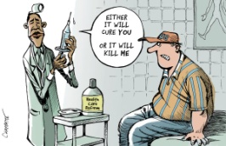](http://cagle.com/caglecards/main.asp?image=/news/HealthCareBillPasses/images/chappatte.jpg)COMMENTS:**