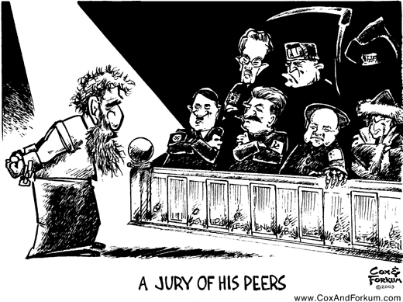

The following ***SSTIC*** acronym may help you better understand how political cartoons are made. Try to use these terms in the analysis of the cartoons you encounter.

**S – Symbolism** – many cartoonists use symbolism in their cartoons

**S – Size** – the size of items in the cartoon can sometimes imply a certain meaning

**T – Text** – even though cartoons are visual, reading the text is crucial to understanding

**I – Imagery** – using a well-known image to evoke a certain understanding

**C – Color** – sometimes certain color can create a tone or mood to the cartoon

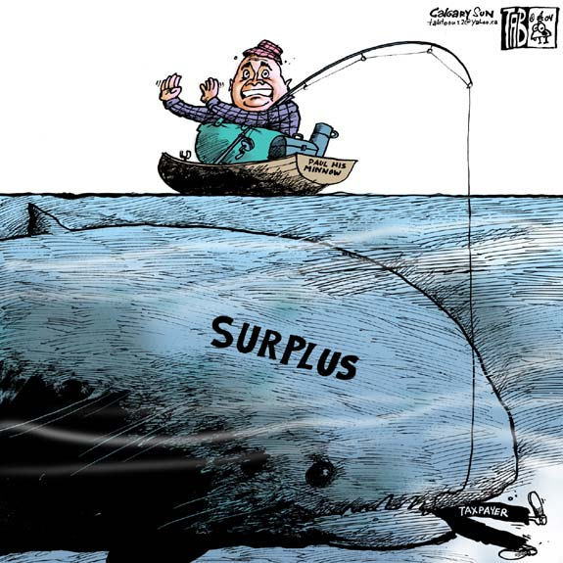

*Here are some examples:*

Dark ***color*** to set a serious and depressing mood to the cartoon

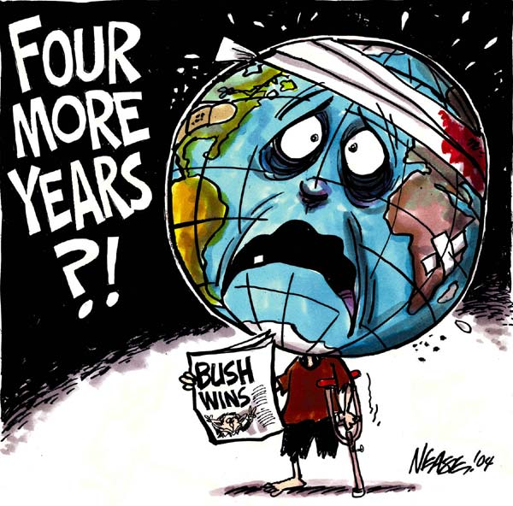

Exaggerated ***size*** of fish to make a point about size of surplus

***Text*** provides underlying meaning to the cartoons.

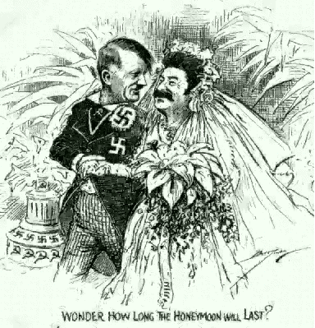

Wedding scene is a well-known ***image*** of union or togetherness.

Eagle is a powerful ***symbol*** of the United States.

