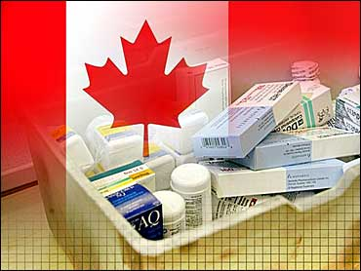

#### Background

Canada's health care system is a group of socialized health insurance plans that provides coverage to all Canadian citizens. It is publicly funded and administered on a provincial or territorial basis, within guidelines set by the federal government. Under the health care system, individual citizens are provided preventative care and medical treatments from primary care physicians as well as access to hospitals, dental surgery and additional medical services. Citizens qualify for health coverage regardless of medical history, personal income, or standard of living.

Canada's health care system is the subject of much political controversy and debate in the country. Some question the efficiencies of the current system to deliver treatments in a timely fashion, and advocate adopting a private system similar to the United States. Conversely, there are worries that privatization would lead to inequalities in the health system with only the wealthy being able to afford certain treatments.

Regardless of the political debate, Canada does boast one of the highest life expectancies (about 80 years) and lowest infant morality rates of industrialized countries, which many attribute to Canada's health care system. The Canada Health Act is federal legislation that puts in place conditions by which individual provinces and territories in Canada may receive funding for health care services.

There are **five main principles** in the ***Canada Health Act***:

* **Public Administration:** All administration of provincial health insurance must be carried out by a public authority on a non-profit basis. They also must be accountable to the province or territory, and their records and accounts are subject to audits.
* **Comprehensiveness:** All necessary health services, including hospitals, physicians and surgical dentists, must be insured.
* **Universality:** All insured residents are entitled to the same level of health care.
* **Portability:** A resident that moves to a different province or territory is still entitled to coverage from their home province during a minimum waiting period. This also applies to residents which leave the country.
* **Accessibility:** All insured persons have reasonable access to health care facilities. In addition, all physicians, hospitals, etc, must be provided reasonable compensation for the services they provide.

***Sources***: <http://www.cbc.ca/healthcare/index_05.html>,<http://www.canadian-healthcare.org/>

#### The Debate

#### The universal publicly funded healthcare system in Canada has been under stress for the last decade as a result of the growing cost of healthcare and healthcare technology. After working through the ‘Sicko Movie Assignment’ and discussing the recent healthcare debate in the United States, your class will debate the following:

#### Be it resolved, Canada should have a two-tiered healthcare

#### system that creates a private for-profit option for Canadians.

#### Read the following articles about healthcare. You must come up with four contentions (arguments) for each side of the healthcare debate – four in favor of a two-tiered healthcare a system that allows for a private for profit option (the affirmative) and four against a two-tiered healthcare a system that allows for a private for profit option (the negative).

#### As you read, highlight possible support for your positive contentions in one colour and support for your negative contentions in another colour. Use the retrieval charts that follow to help organize your ideas and your support.

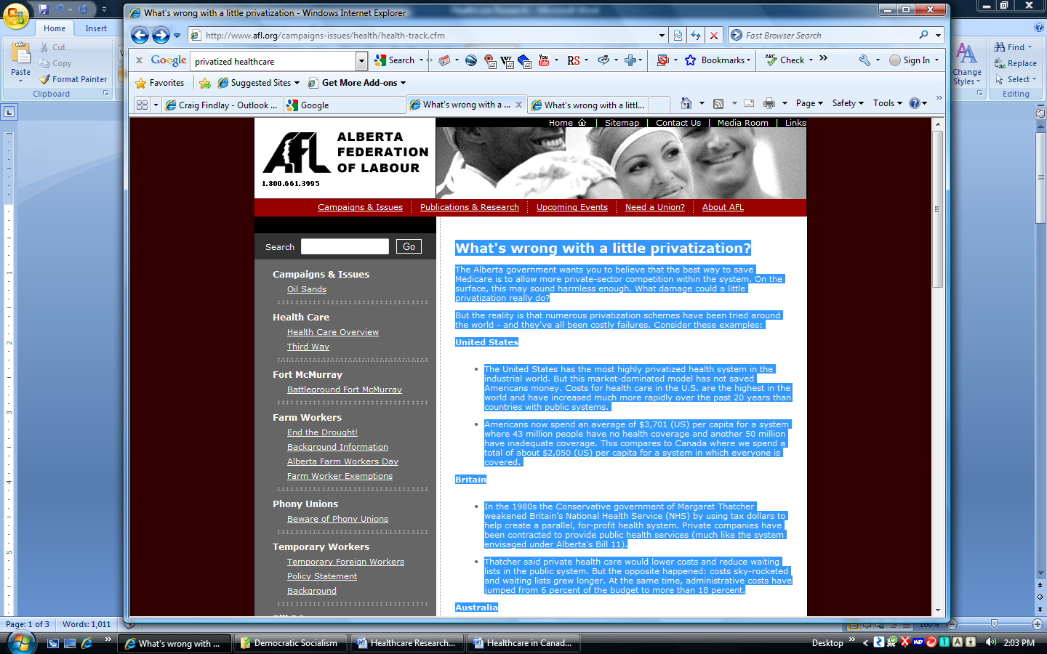

**What's wrong with a little privatization?**

The Alberta government wants you to believe that the best way to save Medicare is to allow more private-sector competition within the system. On the surface, this may sound harmless enough. What damage could a little privatization really do? But the reality is that numerous privatization schemes have been tried around the world - and they've all been costly failures. Consider these examples:

**United States**

* The United States has the most highly privatized health system in the industrial world. But this market-dominated model has not saved Americans money. Costs for health care in the U.S. are the highest in the world and have increased much more rapidly over the past 20 years than countries with public systems.
* Americans now spend an average of $3,701 (US) per capita for a system where 43 million people have no health coverage and another 50 million have inadequate coverage. This compares to Canada where we spend a total of about $2,050 (US) per capita for a system in which everyone is covered.

**Britain**

* In the 1980s the Conservative government of Margaret Thatcher weakened Britain's National Health Service (NHS) by using tax dollars to help create a parallel, for-profit health system. Private companies have been contracted to provide public health services (much like the system envisaged under Alberta's Bill 11).
* Thatcher said private health care would lower costs and reduce waiting lists in the public system. But the opposite happened: costs sky-rocketed and waiting lists grew longer. At the same time, administrative costs have jumped from 6 percent of the budget to more than 18 percent.

**Australia**

* During the 90s, Australia hired a private company - Healthcare of Australia - to build and operate the Port Macquarie Base Hospital, one of the biggest hospitals in the state of New South Wales.
* According to the state's auditor general, the government could have saved $93 million (Aus.) by building the Macquarie hospital itself. The auditor's report also shows that the hospital now costs $6 million (Aus.) more to run each year than if it were publicly operated. Other private hospitals in other Australian states have had similarly poor track records.

**Private Health Care Fails in Canada Too**

You don't have to go outside Canada to find evidence about the pitfalls of privatization in health care. Consider these examples from Alberta and Ontario:

***Calgary - Privatization leads to longer waits***

* In Calgary - where 100 per cent of cataract surgeries are now performed in private clinics - patients waited an average of 16 to 24 weeks for treatment.
* In Edmonton, where 80 per cent of cataract surgeries are done in public hospitals, waiting lists were five to seven weeks long.
* In Lethbridge - where 100 percent of cataract operations are performed in the public system - patients waited an average of only four to seven weeks.

In other words, people living in regions with a higher proportion of private surgeries actually wait longer for treatment than people living in regions where operations are still performed within the public system. Clearly, the argument that private health care "relieves pressure" on the public system is false.

***Ontario - Longer Waits and Higher Costs With Privatization***In a bid to reduce waiting lists, the Ontario government recently hired a for-profit company called Canadian Radiation Oncology Services to provide radiation treatments for cancer patients. But after more than a year of operation, the private company failed to improve upon the record of the public system - patients were still waiting as long as they always had.  
  
To top things off, Ontario's Auditor General, Erik Peters, revealed that the private clinic was costing taxpayers $3,500 per patient - $500 more than the cost of treating patients in the public system.

**Why won't private health care work?**

Spokespeople for the government are fond of saying that privatization will "relieve pressure" on the public system, helping to control costs and reduce waiting lists. But, in the real world, these benefits have never materialized. Why is it exactly that private health care doesn't work?

* Private hospitals and clinics cost more because, unlike public facilities, they need to set aside significant amounts of money for things like investor profits, marketing and taxes (which public hospitals don't pay). As a result, only a small proportion of each dollar spend in private facilities actually goes to patient care. In contrast, almost all the money spent in the public system goes directly to front-line care.
* Private health care creates longer waiting lists by siphoning personnel and resources way from the public system. Doctors and other professionals are lured away from the public system by higher salaries in the private sector. The resulting staff shortages in the public system lead to longer waits for treatment, not shorter ones.

**Don't take our word: Experts give "thumbs down" to private health care**  
*"No health care system in the industrialized world is as heavily commercialized as (the U.S.'s), and none is as expensive, inefficient and inequitable - or as unpopular. Indeed just about the only parts of U.S. society happy with our current market-driven health care system are the owners and investors in the for-profit industries now living off the system &Many of us south of the border have always believed that you Canadians had the right idea in deciding that the financing of health care is primarily a public responsibility. We still think you're right and that we ought to emulate you, rather than vice versa."*

Dr. Arnold S. Relman, Professor Emeritus of Medicine and Social Medicine at the Harvard Medical School, former editor-in-chief of the New England Journal of Medicine.

**Why won't they learn?**

These are literally roomfuls of information showing that privatization in health care doesn't make sense from any standpoint - either economic or ethical. The question is: why won't our government learn from these failed experiments in "market medicine"? Why are they still so attached to the idea of privatization when it's clear it won't work?



([**http://www.michaelmoore.com/sicko/checkup/**](http://www.michaelmoore.com/sicko/checkup/))

**SiCKO:** There are nearly 50 million Americans without health insurance.

* The Centers for Disease Control and Prevention actually reported that 54.5 million people were uninsured for at least part of the year. Health Insurance Coverage: Early Release of Estimates from the National Health Interview Survey, 2006. Centers for Disease Control. <http://www.cdc.gov/nchs/data/nhis/earlyrelease/insur200706.pdf>
* The amount of uninsured is rising every year, as premiums continue to skyrocket and wages stagnate. From 2004 to 2005 the number of uninsured rose 1.3 million, and rose up nearly 6 million from 2001-2005. Leighton Ku, "Census Revises Estimates Of The Number Of Uninsured People," Center on Budget and Policy Priorities, April 5, 2007 <http://www.cbpp.org/4-5-07health.htm>. With 44.8 uninsured in 2005, in 2007 the number will be much higher. Professors Todd Gilmer and Richard Kronick, in "It's The Premiums, Stupid: Projections Of The Uninsured Through 2013," Health Affairs, 10.1377/hlthaff.w5.143, "project that the number of non-elderly uninsured Americans will grow from forty-five million in 2003 to fifty-six million by 2013." According to these authors, by now the number of non-elderly uninsured by this date clearly would be nearly 50 million.

**SiCKO:** 18,000 Americans will die this year simply because they're uninsured.

* According to the Institute of Medicine, "lack of health insurance causes roughly 18,000 unnecessary deaths every year in the United States. Although America leads the world in spending on health care, it is the only wealthy, industrialized nation that does not ensure that all citizens have coverage." Insuring America's Health: Principles and Recommendations, Institute of Medicine, January 2004.   
  <http://www.iom.edu/?id=19175>

**SiCKO:** Richard Nixon and John Ehrlichman are heard discussing the concept of a health maintenance organization in Oval Office Recordings.

* On February 17, 1971, Richard Nixon met with John Ehrlichman to discuss the Vice President's position on health maintenance organizations, as heard in the film. The Miller Center of Public Affairs has this audio recording (conversation number 450-23. "Richard Nixon - Oval Office Recordings,"   
  [http://millercenter.virginia.edu/scripps/digitalarchive/presidentialrecordings/nixon/oval?PHPSESSID =b813e56b3017d097cd176720bc10fc74](http://millercenter.virginia.edu/scripps/digitalarchive/presidentialrecordings/nixon/oval?PHPSESSID%20=b813e56b3017d097cd176720bc10fc74)
* The next day, Nixon called for a "new national health strategy" that had four points for expanding the proliferation of health maintenance organizations, or HMOs. "Special Message to the Congress Proposing a National Health Strategy," February 18th, 1971, <http://www.presidency.ucsb.edu/ws/index.php?pid=3311>
* The term "health maintenance organization" was coined by Nixon advisor Paul Ellwood. Patricia Bauman, "The Formulation and Evolution of the Health Maintenance Organization Policy, 1970-1973, Social Science & Medicine, vol. 10. 1976. After Congress passed Nixon's HMO Act in 1973, HMOs in America increased nine-fold in just ten years. N. R. Kleinfield, "The King of the HMO Mountain," New York Times, July 31, 1983.

**SiCKO:** The American Medical Association distributed a record featuring Ronald Reagan discussing the evils of socialized medicine.

* Ronald Reagan's recording was widely available in the 1960s, and was a part of the American Medical Association's "Operation Coffee Cup," a coordinated rebuttal to Democrats' push for Medicare. Max Skidmore, "Ronald Reagan and Operation Coffee Cup: A Hidden Episode in American Political History," Journal of American Culture, vol. 12. 1989.

**SiCKO:** $100 million spent to defeat Hillary's health care plan.

* "Even before debate began in Congress, a powerful coalition had been cobbled together to fight Clintoncare, as opponents labeled it - congressional Republicans, the insurance industry, the pharmaceutical industry, the National Federation of Independent Businesses, the Business Roundtable, the Christian Coalition, the conservative radio talk show network. Those groups spent between $100 million and $ 300 million to defeat it. And the battle was fought like a presidential campaign - with a TV advertising campaign, a network of field operatives and public relations experts to lobby members of Congress back in their districts." Rob Christensen, "Who killed health care reform? Answer: Everyone," News & Observer, June 19, 1996.
* "In 1993-94, the Health Insurance Association of America, a trade group, spent about $15 million on advertising to defeat Clinton's proposed overhaul of the nation's health care system." John MacDonald, "Proponents, Opponents Join Battle Over Drug Price Limits," Hartford Courant, June 21, 2000.
* "'We spent $1.4 million to fight President Clinton's plan,' [Mike Russell of the Christian Coalition] says." Harold Cox, "Business will spearhead Health Reform II ; Old enemies of Clinton's plan in lead," Washington Times, December 27, 1994.
* "A study by Citizen Action, a consumer group, reports that doctors, hospitals, insurance companies and other providers of medical services made campaign contributions of $ 79 million during the 1993-1994 election cycle. The insurance industry passed out $16 million. The American Medical Association, which objects to cost-control measures, contributed $ 3 million." Froma Harrop, "The big lie about health reform," Rocky Mountain News, August 20, 1995.
* "According to [Citizens for a Sound Economy] spokesman Brent Bahler, the group has not bought any airtime for commercials but has 'tentative plans' for a grassroots advocacy effort that would include an advertising component. Last year, Bahler said, the CSE spent more than $2 million on print, radio and television advertising to defeat Clinton's health care reform plan." James A. Barnes, "RNC Turns To TV Ads On Budget," National Journal, 5.16.95.



**Article from:**  **Canada’s Healthcare in Crisis** March 20, 2005

**(AP)**A letter from the Moncton Hospital to a New Brunswick heart patient in need of an electrocardiogram said the appointment would be in three months. It added: "If the person named on this computer-generated letter is deceased, please accept our sincere apologies."   
  
The patient wasn't dead, according to the doctor who showed the letter to The Associated Press on condition of anonymity. But there are many Canadians who claim the long wait for the test and the frigid formality of the letter are indicative of a health system badly in need of emergency care.   
  
Americans who flock to Canada for cheap flu shots often come away impressed at the free and first-class medical care available to Canadians, rich or poor. But tell that to hospital administrators constantly having to cut staff for lack of funds, or to the mother whose teenager was advised she would have to wait up to three years for surgery to repair a torn knee ligament.   
  
"It's like somebody's telling you that you can buy this car, and you've paid for the car, but you can't have it right now," said Jane Pelton. Rather than leave daughter Emily in pain and a knee brace, the Ottawa family opted to pay $3,300 for arthroscopic surgery at a private clinic in Vancouver, with no help from the government.   
  
"Every day we're paying for health care, yet when we go to access it, it's just not there," said Pelton.   
  
The average Canadian family pays about 48 percent of its income in taxes each year, partly to fund the health care system. Rates vary from province to province, but Ontario, the most populous, spends roughly 40 percent of every tax dollar on health care, according to the Canadian Taxpayers Federation. The system is going broke, says the federation, which campaigns for tax reform and private enterprise in health care.   
  
It calculates that at present rates, Ontario will be spending 85 percent of its budget on health care by 2035. "We can't afford a state monopoly on health care anymore," says Tasha Kheiriddin, Ontario director of the federation. "We have to examine private alternatives as well."   
  
The federal government and virtually every province acknowledge there's a crisis: a lack of physicians and nurses, state-of-the-art equipment and funding. In Ontario, more than 10,000 nurses and hospital workers are facing layoffs over the next two years unless the provincial government boosts funding, says the Ontario Hospital Association, which represents health care providers in the province.   
  
In 1984 Parliament passed the Canada Health Act, which affirmed the federal government's commitment to provide mostly free health care to all, including the 200,000 immigrants arriving each year. The system is called Medicare (no relation to Medicare in the United States).   
  
Despite the financial burden, Canadians value their Medicare as a marker of egalitarianism and independent identity that sets their country apart from the United States, where some 45 million Americans lack any kind of health insurance or coverage.  
  
Raisa Deber, a professor of health policy at the University of Toronto, believes Canada's system is one of the world's fairest. "Canadians are very proud of the fact that if they need care, they will get care," she said. Of the United States, she said: "I don't understand how they got to this worship of markets, to the extent that they're perfectly happy that some people don't get the health care that they need."   
  
Canada does not have fully nationalized health care; its doctors are in private practice and send their bills to the government for reimbursement. "That doctor doesn't have to worry about how you're going to pay the bill," said Deber. "He knows that his bill will be paid, so there's absolutely nothing to stop any doctor from treating anyone."   
  
Deber acknowledges problems in the system, but believes most Canadians get the care they need. She said the federal government should attach more strings to its annual lump-sum allocations to the provinces so that tax dollars are better spent on preventive care and improvements in working conditions for health-care professionals.   
  
In Alberta, a conservative province where pressure for private clinics and insurance is strong, a nonprofit organization called Friends of Medicare has sprung to the system's defense. It points up the inequities in U.S. health care and calls the Canada's "the most moral and the most cost-effective health care system there is in the world." "Is your sick grandchild more deserving of help than your neighbor's grandchild?" It asks.   
  
Yes, says Dr. Brian Day, if that grandchild needs urgent care and can't get it at a government-funded hospital.   
  
Day, an English-born arthroscopic surgeon, founded Cambie Surgery Center in Vancouver, British Columbia — another province where private surgeries are making inroads. He is also former president of the Arthroscopy Association of North America in Orlando, Fla.   
  
He says he got so frustrated at the long delays to book surgeries at the public hospitals in Vancouver that he built his own private clinic. A leading advocate for reform, he testified last June before the Supreme Court in a landmark appeal against a Quebec ruling upholding limits on private care and insurance.   
  
George Zeliotis told the court he suffered pain and became addicted to painkillers during a yearlong wait for hip replacement surgery, and should have been allowed to pay for faster service. His physician, Dr. Jacques Chaoulli, said his patient's constitutional rights were violated because Quebec couldn't provide the care he needed, but didn't offer him the option of getting it privately.   
  
A ruling on the case is expected any time. (The decision went in favor of Mr. Zeliotis) If Zeliotis had been from the United States, China or neighboring Ontario anywhere, in fact, except Quebec — he could have bought treatment in a private Quebec clinic. That's one way the system discourages the spread of private medicine — by limiting it to nonresidents. But it can have curious results, says Day.   
  
He tells of a patient who was informed by Ontario officials that since Ontario couldn't help him, they would spend $35,000 to send him to the United States for surgery. Day said his Vancouver clinic could have done it for $12,000 but the Ontario officials "do not philosophically support sending an individual to a nongovernment clinic in Canada."   
  
Canadians can buy insurance for dental and eye care, physical and chiropractic therapy, long-term nursing and prescriptions, among other services. But according to experts on both sides of the debate, Canada and North Korea are the only countries with laws banning the purchase of insurance for hospitalization or surgery.   
  
Meanwhile, the average wait for surgical or specialist treatment is nearly 18 weeks, up from 9.3 weeks in 1993, according to the Fraser Institute, a right-wing public policy think tank in Vancouver. A Fraser study last year said the average wait for an orthopedic surgeon was more than nine months.   
  
Prime Minister Paul Martin's Liberal government has pledged $33.3 billion in new funding to improve health in all provinces and territories over the next 10 years. But critics aren't impressed.   
  
"It won't make a difference," said Sally C. Pipes, a Canadian who heads the conservative Pacific Research Institute in San Francisco. "They need to break the system down, or open the system up to competition."   
  
Pipes is a big supporter of the Bush administration proposal to allow Americans to divert some of their payroll taxes into medical savings accounts. She claims the two-tiered system feared by Canadian liberals already exists because those with connections jump to the head of the medical queue and those who can afford it can get treated in the United States.   
  
"These are not wealthy people; these are people who are in pain," said Pipes.   
  
Another watershed lawsuit was filed last year against 12 Quebec hospitals on behalf of 10,000 breast-cancer patients in Quebec who had to wait more than eight weeks for radiation therapy during a period dating to October 1997. One woman went to Turkey for treatment. Another, Johanne Lavoie, was among several sent to the United States. Diagnosed with invasive breast cancer in 1999, she traveled every week with her 5-year-old son to Vermont, a four-hour bus ride.   
  
"It was an inhuman thing to live through," Lavoie told Toronto's Globe and Mail.   
  
"This is the first time someone has decided to attack the source of problems — the waiting list," said Montreal attorney Michel Savonitto, who is representing the cancer victims. "We're lucky to have the system we do in Canada," he told the court. "But if we want to supply proper care and commit to doing it, then we can't do it halfway."   
  
An estimated 4 million of Canada's 33 million people don't have family physicians and more than 1 million are on waiting lists for treatment, according to the Canadian Medical Association. Meanwhile, some 200 physicians head to the United States each year, attracted by lower taxes and better working conditions. Canada has 2.1 physicians per 1,000 people, while Belgium has 3.9, according to the Organization for Economic Cooperation and Development.   
  
The World Health Organization in 2000 ranked France's health system as the best, followed by Italy, Spain, Oman and Australia. Canada came in 30th and the United States 37th. Alberta Premier Ralph Klein is pushing what he calls "the third way" — a fusion of Canadian Medicare and the system in France and many other nations, where residents can supplement their government-funded health care with private insurance and services.   
  
But some Canadians worry even partial privatization would be damaging.   
  
"My concern is that the private clinics would only serve to further drain the scarce physician resources that we already have," said Dr. Saralaine Johnstone, a 31-year-old family physician in Geraldton, a papermill hamlet in northern Ontario.   
  
"We first need to guarantee that everybody has access to quality health care," she said, "and we just don't have that."

<http://www.cbsnews.com/stories/2005/03/20/health/main681801.shtml>

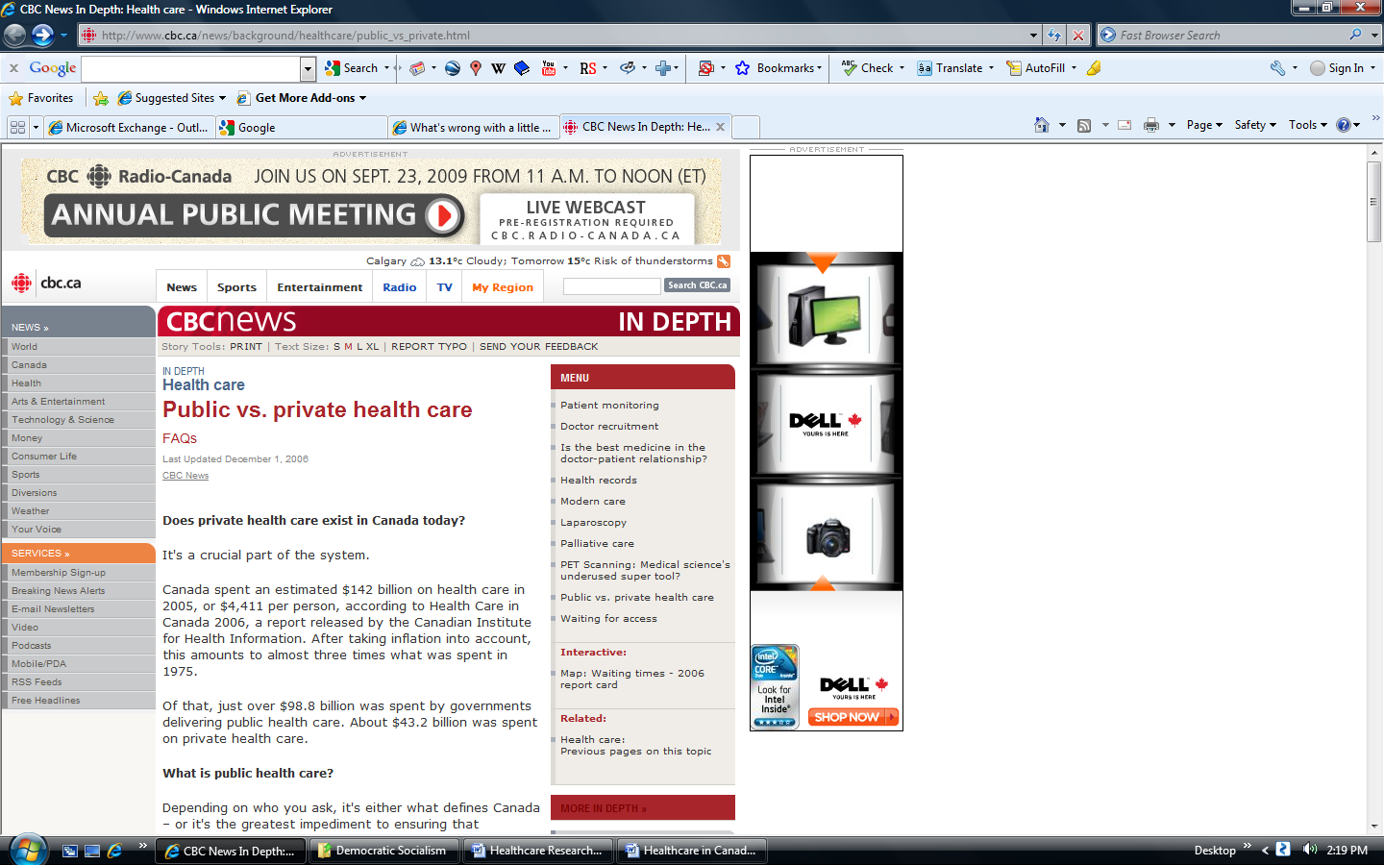

#### What's the difference between private health care and two-tier health care?

Again, depends who you ask. Private health care exists. It broadens coverage available under the public system, which was designed to guarantee all Canadians basic health coverage. Currently, private health care does not mean that you can move to the front of the line because you can afford to pay more. Proponents of expanding private health care to offer more health-care choices argue that if you have the means, you should be able to purchase health care services and get around unreasonably long waiting lists. They argue the public system will be maintained and that more choice does not mean one system for the rich and one for those who can't afford to pay extra.

Dr. Arnold Relman, professor emeritus of medicine and social medicine at Harvard Medical School and emeritus editor-in-chief of the New England Journal of Medicine, appeared before the Senate committee studying health care in February 2002.

He warned against relying on the market – or greater "consumer choice" – to control health-care costs and improve quality. "While there is much to be said for making more information available to people about their health care," Relman said, "it is a fundamental misconception to imagine that sick patients can or should behave like ordinary consumers in commercial transactions, selecting the services and prices they want. Health care is totally different from most goods and services, and that's why we have medical insurance and why sick people need the professional and altruistic services of physicians and other providers."

Schumacher argues further privatization will not spell the end of medicare as we know it.

"People worry that if doctors can go private, then they're going to quit the public system. I would argue the opposite. If a doctor can take part of their practice private, they're less likely to leave because they're not tied solely to the government's fee schedule."

#### Does private health care exist in Canada today?

It's a crucial part of the system. Canada spent an estimated $142 billion on health care in 2005, or $4,411 per person, according to Health Care in Canada 2006, a report released by the Canadian Institute for Health Information. After taking inflation into account, this amounts to almost three times what was spent in 1975.

Of that, just over $98.8 billion was spent by governments delivering public health care. About $43.2 billion was spent on private health care.

#### What is public health care?

Depending on who you ask, it's either what defines Canada – or it's the greatest impediment to ensuring that Canadians get quick access to the kind of medical services they deserve.

### Provincial Health Care Legislation

Health care legislation and its enforcement in Canada varies from province to province. Some provinces, like Nova Scotia, currently have no additional provincial legislation (for example to discourage extra billing), and follow the rules of the Canada Health Act. The province is, however, planning public consultation to develop health care legislation.

Other provinces, like British Columbia and Saskatchewan, have provincial health legislation that reinforces the Canada Health Act. This includes provisions forbidding extra billing for facilities or materials and a cap on what can be charged for services if a doctor opts out of the insured system. These rules do allow doctors to practice outside the provincial system, but often, as in BC, require them to charge the same or less than what the government would pay for the services under the insured system. The enforcement of this legislation, however, has recently come into question.

The incidence of health care providers practicing outside a provincial system is on the rise. Provinces like Quebec have seen significant growth in private, for-profit clinics. These clinics allow those who are willing to pay for services to obtain them without the usual wait times, which is in direct violation of the Canada Health Act.

Provinces such as Ontario have recently moved to strengthen the public system. Bill 8 - passed in June of 2004 - is designed to close loopholes that allow queue-jumping and extra billing, make health care providers accountable and establish an independent Ontario Health Quality Council to report on the health care system. In reality, it's probably something in between.

Public health care is governed by the Canada Health Act. It's designed to make sure that all eligible people in the country have reasonable access to insured health services on a prepaid basis, without direct charges at the point of service. Simply put, if you break your leg chasing the Canadian dream, you have the right to get fixed up without opening your wallet – except to pull out your provincial health insurance card.

The act is also designed to make sure that the delivery of health care is pretty consistent across the country. Ottawa has found that the best way to do that is by attaching conditions to the cash it transfers to the provinces to cover health care.

Among those conditions are that health care must be:

* Portable.
* Universal.
* Accessible.
* Free from extra charges (for insured services).

By portable, Ottawa means if you move from one province or territory to another, you won't lose your coverage. This doesn't mean you can go looking for health services in another province or country because the waiting list at home is too long for your liking. It does, however, mean that your out-of-province in-laws will be covered if they suddenly fall sick while on their annual visit.

Under the universality criterion, all insured residents of a province or territory must be entitled to the insured health services provided by the provincial or territorial health care insurance plan. Doesn't matter if you're rich or poor. You can't buy your way to the front of the line.

By accessible, the CHA means "insured persons in a province or territory have reasonable access to insured hospital, medical and surgical-dental services on uniform terms and conditions, unprecluded or unimpeded, either directly or indirectly, by charges [user charges or extra-billing] or other means [e.g., discrimination on the basis of age, health status or financial circumstances]."

#### What is private health care?

Anything beyond what the public system will pay for. For instance, should you have to spend some time in the hospital, the public system will cover the cost of your bed in a ward, which usually has three other patients. If you want a private room, the extra charge will come out of your pocket, unless you have extended health coverage either through your employer or through a policy you have bought yourself.

Need an ambulance ride? Expect to receive a bill. If you have extended health care coverage, your insurance company will likely pick up the tab. Dr. Albert Schumacher, former president of the Canadian Medical Association estimates that 75 per cent of health-care services are delivered privately, but funded publicly. "Frontline practitioners whether they're GPs or specialists by and large are not salaried. They're small hardware stores. Same thing with labs and radiology clinics …The situation we are seeing now are more services around not being funded publicly but people having to pay for them, or their insurance companies. We have sort of a passive privatization."

Most cosmetic procedures are not covered by the public system. If you're contemplating undergoing a cosmetic procedure, by the way, you might want to take a close look at your cosmetic surgeon's credentials. Almost any doctor in this country can call him/herself a cosmetic surgeon – and start operating – even if that person was not a surgeon before. There are no regulations in Canada governing who can – or can't – perform cosmetic surgery. Most procedures are not monitored because they are done in a doctor's office.

#### Are there other forms of private health care?

There are a few privately-run hospitals in the country, whose services may or may not be covered by health insurance.

Shouldice Hospital in Toronto opened in 1945 – before Canadians were covered by universal health care. Dr. Edward Earle Shouldice developed a unique method of repairing hernias and demand for the services of his staff quickly spread beyond Canada's borders. The hospital remains private today. Residents of Ontario who have a valid health card are covered by the provincial health-care system for the cost of surgery. If you're from outside Ontario, you will probably need extended – private – health coverage to get reimbursed.

Several privately-run clinics have opened across the country as well, offering CT scans and MRI services. Most have contracts with their provincial governments. The idea was to take pressure off the limited resources of hospitals. The clinics are paid by the province to provide their services.

Several clinics opened in Ontario after the then former Conservative government signed contracts with four companies. The companies were allowed to provide 40 hours of testing per machine per week. Physicians associated with the clinics are paid on a fee-for-service basis by the Ontario Health Insurance Plan to read the test results for OHIP-covered patients. While the clinics are allowed to take private customers after hours, they cannot sell MRI or CT scans to anyone who walks in off the street. You have to have a doctor's referral.

The clinics operate on a for-profit basis. The Canadian Health Care Coalition argues that clinics like these lay the groundwork for a private, parallel for-profit health-care system in Canada.

"The proliferation of investor-owned private, for-profit clinics and facilities acts like a viral infection in the body of Canada's public health-care system," the coalition said in a news release following the September 2004 First Ministers Conference on health care. "The for-profit health care virus cannot exist without feeding off and damaging public bodies."

Shortly after beating the Conservatives in Ontario's 2003 election, the Liberal government promised to shut down the private clinics and buy the machines. However, in 2006, the Conservatives were elected federally on a platform that pushed for a mix of public and private health care, provided that health care stays publicly funded and universally accessible. There are other signs of a shift toward more private health care.

In December 2006, B.C.'s first private emergency clinic opened in Vancouver. The Urgent Care Centre plans to offer emergency care on a user-fee basis, which raises questions about how it will operate legally under the Canada Health Act. The provincial government authorized B.C.'s Medical Services Commission to send inspectors to the clinic. Health Minister George Abbott said if they find evidence the law is being broken, the commission would seek an injunction to shut down the clinic. As well, the Canadian Medical Association elected a new president in August 2006: Vancouver physician Dr. Brian Day, a surgeon and private clinic owner who says he wants to see more private options for health-care services that are currently public. His main opponent was Dr. Jack Burak, also from B.C. and a staunch defender of Canada's public health-care system.

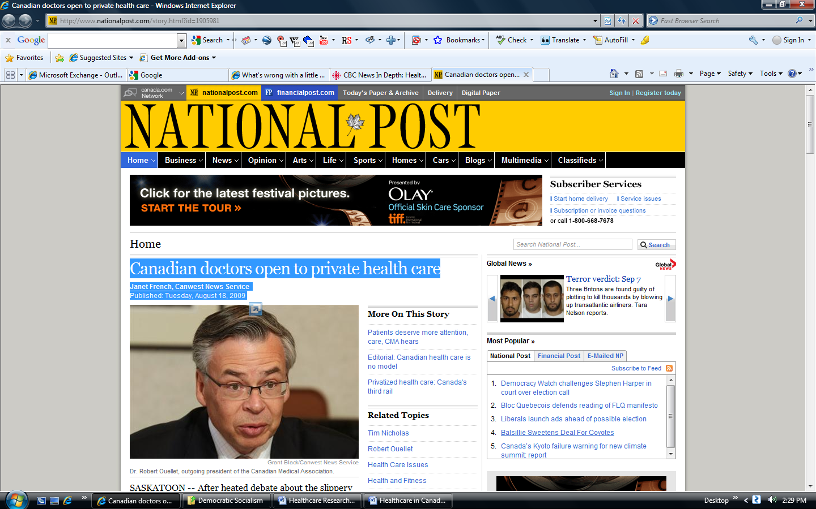

## Canadian doctors open to private health care

**Janet French, Canwest News Service** Published: Tuesday, August 18, 2009

<http://www.nationalpost.com/story.html?id=1905981>

After heated debate about the slippery slope of pursuing private health care, Canadian doctors voted Tuesday to push governments to look more closely at allowing competition for public health dollars. As part of a plan to create a "blueprint" to transform this country's health-care system, the Canadian Medical Association approved a resolution to implore governments and health authorities to "examine internal market mechanisms, which could include a role for the private sector, in the delivery of publicly funded health care in Canada."

"The vast majority of Canadian doctors believe there is an urgent need to fix Canada's health care system," outgoing association president Robert Ouellet said later at a news conference at the organization's annual convention, which is being held in Saskatoon this year.

"The physicians of Canada are serving notice that we are tired of the dogmatic, ineffective and faux public/private debate continually derailing any and all attempts to build a health-care system that serves patients."Doctors speaking in favour of the resolution Tuesday said "competition" should be invited into health care.

"Competition is not a negative thing," said Dr. Tim Nicholas of Aurora, Ont., speaking in favour of the motion. "Competition is good." "Competition" is already happening in Ontario, where hospitals are rated based on how their patients fare, he said. He said more competition will help create more access in a system that often leaves patients waiting.

Dr. Ouellet said "competition" doesn't just mean providers battling for dollars -- it could also mean publishing information such as hospital infection rates to see how institutions measure up. B.C doctor Victor Dirnfeld told delegates they shouldn't confuse the idea of competition for public health dollars with the introduction of private care. "What I see is the fear of the dirty word, ‘private,' " he said. "We already have extensive private involvement in the publicly funded system. "Let's not confuse, and let's not contaminate the discussion on this proposal with the fear and anger of the private system."

Doctors should be "at the forefront" of setting direction for what kind of competition is appropriate in health care, since it's happening anyways, Dr. Bill Anderson of Alberta said. Canadian Doctors for Medicare, however, are concerned decisions may be made without debate by association members.

"This isn't, as far as we can see, going to be done in a transparent way," said Dr. Robert Wollard, vice-chair of Canadian Doctors for Medicare, a group dedicated to advocating for the public health-care system. While the motion passed with 85% approval, several doctors at the annual convention also spoke against it, saying competition could jeopardize the quality of care patients receive.

Several doctors cited Britain's experience with the introduction of some private health-care providers, which has prompted the British Medical Association to mount a campaign against such competition for public health dollars. Another doctor argued competition could pit one hospital against the next, eliminating chances for the kind collaboration that has been shown to improve patient care, such as the life-saving Cardiac Care Network of Ontario.

An additional concern was that patients would begin to be seen as "commodities," not humans, in a competitive system.Dr. Claudette Chase of Thunder Bay, Ont., said patients are becoming suspicious of doctors and the medical association for considering private care as an option.

"I know from the public they already question our values as we move closer and closer to private care," she said. The discussion among delegates is the organization's attempt to create what it calls a "blueprint for health transformation."In a background document, the association says many other countries have undergone meaningful health-care reform, but that Canada -- despite repeated promises from federal and provincial politicians -- has yet to budge after nearly a decade of talk.

The blueprint won't be the first document the association has produced to prompt health-care reform -- since 2002, it has authored five other reports prescribing change. When asked what it is about the blueprint that will finally prod politicians into action, Dr. Ouellet said that change has already begun. He pointed to Alberta Health Services CEO Stephen Duckett, who recently said the province would move from a model of block funding to paying hospitals according to the number of patients served and procedures performed.

Dr. Ouellet said the medical association will take resolutions passed at this and last year's general council meetings to develop a policy, which the organization's board will review come the fall. Delegates also voted for the association to develop a discussion paper on other countries' experiences with "pay-for-performance" family medicine -- when governments provide doctors or clinics bonuses for patients' positive outcomes.

Other health-care reform motions passed Tuesday included a move to lobby governments to develop stringent requirements within the year to protect patients' privacy and personal health information. Doctors are also asking governments to consider their teaching duties when allotting time in operating rooms. Many of the ideas up for discussion came from an association study of health-care models in England, Denmark, the Netherlands, Belgium and France.

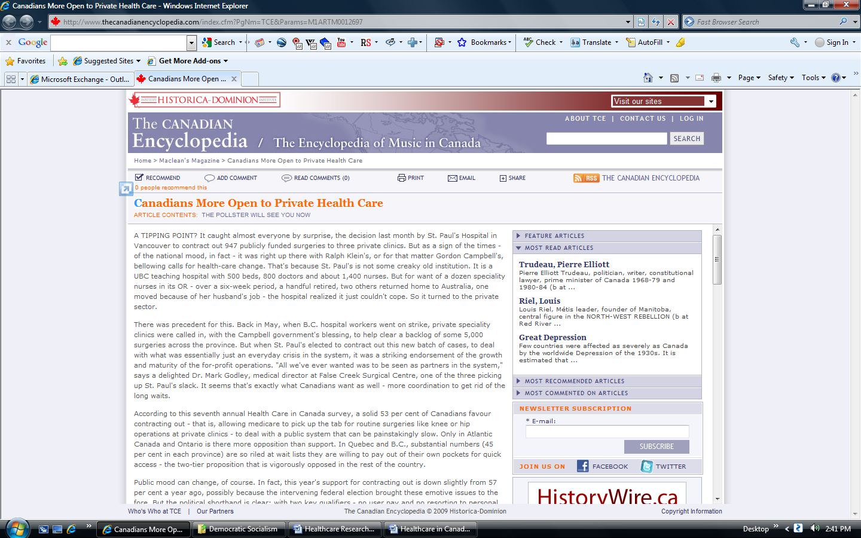

It caught almost everyone by surprise, the decision last month by St. Paul's Hospital in Vancouver to contract out 947 publicly funded surgeries to three private clinics. But as a sign of the times - of the national mood, in fact - it was right up there with Ralph Klein's, or for that matter Gordon Campbell's, bellowing calls for health-care change. That's because St. Paul's is not some creaky old institution. It is a UBC teaching hospital with 500 beds, 800 doctors and about 1,400 nurses. But for want of a dozen speciality nurses in its OR - over a six-week period, a handful retired, two others returned home to Australia, one moved because of her husband's job - the hospital realized it just couldn't cope. So it turned to the private sector.

There was precedent for this. Back in May, when B.C. hospital workers went on strike, private speciality clinics were called in, with the Campbell government's blessing, to help clear a backlog of some 5,000 surgeries across the province. But when St. Paul's elected to contract out this new batch of cases, to deal with what was essentially just an everyday crisis in the system, it was a striking endorsement of the growth and maturity of the for-profit operations. "All we've ever wanted was to be seen as partners in the system," says a delighted Dr. Mark Godley, medical director at False Creek Surgical Centre, one of the three picking up St. Paul's slack. It seems that's exactly what Canadians want as well - more coordination to get rid of the long waits.

According to this seventh annual Health Care in Canada survey, a solid 53 per cent of Canadians favour contracting out - that is, allowing medicare to pick up the tab for routine surgeries like knee or hip operations at private clinics - to deal with a public system that can be painstakingly slow. Only in Atlantic Canada and Ontario is there more opposition than support. In Quebec and B.C., substantial numbers (45 per cent in each province) are so riled at wait lists they are willing to pay out of their own pockets for quick access - the two-tier proposition that is vigorously opposed in the rest of the country.

Public mood can change, of course. In fact, this year's support for contracting out is down slightly from 57 per cent a year ago, possibly because the intervening federal election brought these emotive issues to the fore. But the political shorthand is clear: with two key qualifiers - no user pay and no resorting to personal wealth to jump the queue - Canadians appear just as ready for Klein's vision of medicare as for Paul Martin's. And why not? With no cumbersome labour rules and three state-of-the-art ORs running seven days a week, sometimes until 10 or 11 at night, False Creek can do 450 day or overnight surgeries a month, Godley says. What's more, he claims, his OR nurses are happier: the pay is better and the hours more predictable. For a generation raised on retail convenience, this seems to be how the system should work.

Broadly speaking, Canadians are still very wary about their health-care system, though they are less pessimistic today than in previous years, according to the *Maclean's*/Rogers Media poll, conducted by Pollara Inc. But Canadians are also very much in restructuring mode. The shortage of doctors and nurses is top of almost everyone's mind. And there is huge interest in the kind of change Ontario is trying to get its doctors to buy into - like requiring patients to register with a particular health-care provider, and requiring physicians to work in teams with nurse practitioners and other docs. In this, public opinion is well ahead of that of the medical profession.



Choosing your contentions:

Your **first contention** or claim:

Evidence to support your claim (facts, research, statistics, surveys, expert testimonial, real-world examples):



Your **first contention** or claim:

testimonial, real-world examples):

Your **second contention** or claim:

Evidence to support your claim (facts, research, statistics, surveys, expert testimonial, real-world examples):



Your **third contention** or claim:

Evidence to support your claim (facts, research, statistics, surveys, expert testimonial, real-world examples):



Your **fourth contention** or claim:

Evidence to support your claim (facts, research, statistics, surveys, expert testimonial, real-world examples):



Your **first contention** or claim:

Evidence to support your claim (facts, research, statistics, surveys, expert testimonial, real-world examples):



Your **second contention** or claim:

Evidence to support your claim (facts, research, statistics, surveys, expert testimonial, real-world examples):



Your **fourth contention** or claim:

Evidence to support your claim (facts, research, statistics, surveys, expert testimonial, real-world examples):



Your **third contention** or claim:

Evidence to support your claim (facts, research, statistics, surveys, expert testimonial, real-world examples):



**Understanding the Steps of Debate**

**Directions:** You’re about to watch a class debate. This chart will show you the steps a debate follows. Follow the arrows below to see how a debate takes place.

**Affirmative Side Negative Side**

**1st Speaker**

* **States Proposition**
* **Argues 2 Contentions**

**2nd Speaker**

* **Records Affirmative Contentions on Board**

**1st Speaker**

* **States any Counterarguments**
* **Argues 2 Contentions**

**2nd Speaker**

* **Records Negative Contentions on Board**

**2.**

**1.**

**3.**

**6.**

**5.**

**4.**

**2nd Speaker**

* **States any Counterarguments**
* **Argues 2 Contentions**

**1st Speaker**

* **Records Negative Contentions on Board**

**2nd Speaker**

* **States any Counterarguments**
* **Argues 2 Contentions**

**1st Speaker**

* **Records Affirmative Contentions on Board**

**1st Speaker**

* **Offers final Rebuttals of all Affirmative claims**
* **Gives Final Persuasive Summary**

**1st Speaker**

* **States any Counterarguments**
* **Offers final Rebuttals of all Negative claims**
* **Gives Final Persuasive Summary**



Your opponent will offer counterarguments to your contentions. Try to predict what they will say:

Your **first contention** or claim (brief re-statement):

Counterargument (predict what your opponent is likely going to say to counter your argument):

Rebuttal (how are you going to respond to your opponents counter argument):



Your **second contention** or claim (brief re-statement):

Counterargument (predict what your opponent is likely going to say to counter your argument):

Rebuttal (how are you going to respond to your opponents counter argument):



Your **third contention** or claim (brief re-statement):

Counterargument (predict what your opponent is likely going to say to counter your argument):

Rebuttal (how are you going to respond to your opponents counter argument):



Your **fourth contention** or claim (brief re-statement):

Counterargument (predict what your opponent is likely going to say to counter your argument):

Rebuttal (how are you going to respond to your opponents counter argument):



**Effective Word Choice for Debaters**

*from Bill McBride’s *“If they can argue well, they can write well”.*

**To counter your opponent’s contention, use the following four-step method:**

1. **“They say that ...”** (briefly restate the opponent’s point).
2. **“But we disagree that ...”** (briefly state that you disagree).
3. **“Because ...”** (give a strong and relevant counterargument).
4. **“Therefore...”** (explain to the audience how this wins your argument and why they should agree).

**Words and Phrases to Avoid in a Debate**

totally bad like awesome

stuff things good you know

uh whatever chill very

dude for real stupid really

always every time never impossible

**Words and Phrases to Persuade or Convince in a Debate**

as the evidence shows abolish avoid

for example powerful superior

in this case overcome mobilize

highly recommended prevent change

at this moment tradition urgent

take a bold new step guarantee eliminate

a proven method patriot(ism) honor

scientifically verified focus ensure

without a doubt values improve

cannot justify justice society

the truth is that oversimplify exaggerate

such an exaggeration breakthrough ultimate

one mustn’t confuse progress duty

the research is clear inherent crisis

the time has come restore act

one cannot deny call upon national interests