
IDE LOGY
SOCIAL STUDIES 30-1
TO WHAT EXTENT SHOULD WE EMBRACE AN

The following questionnaire will help you understand some of your own ideological beliefs. Answer each question as honesty as you can. Place an ‘X’ in one of the four spaces provided.

Strongly Strongly Agree Agree Disagree Disagree

- The death penalty is wrong and should not be allowed under any circumstances.

- The government should use taxpayer’s money to provide free day care for all parents.

- Directors of big companies that pollute our air and waste water should be personally fined and sent to prison.

- Canada should allow any immigrant who wants to move to Canada to do so.

- Canada’s Aboriginal people should be given the land they were promised in treaties signed with the government.

- If a factory is polluting our air and water, the government should order it
closed; even if this means that its workers would lose their jobs.

- The Canadian government should spend much less money on our armed forces.

- Laws should be passed and enforced that will ensure that women receive the same pay as men receive when they do work of equal value.

- The United States should not be allowed to test its Cruise missiles in Canada, even if they are not armed.

- High school students should be allowed to take any courses they want; there should be no compulsory subjects.

- If a person is poor, it is not his or her fault; the government should help such people by providing financial aid.

- The government should control the amount of rent that a landlord can charge tenants.

- Tax laws should be changed to make rich people and big companies pay
more than they do today.

- The government should provide a mother with enough money to allow her to stay at home for a longer time after she has had a baby.

- A woman who has decided that she wants to have an abortion should be allowed to do so without having to get anyone’s permission.

- No person or government should be allowed to censor any book, movie, or piece of music.

- Artists, writers, and musicians are more important in our society than are business executives.

- Workers who go on strike have good reasons and deserve to have the public’s support.

- The government should give more money to our universities and community colleges in order to keep student’s fees as low as possible, even if this means raising taxes.

- Canada should give more financial aid to poorer countries.

EVALUATION

1. Number of Strongly Agree _____ X 5 = ______
2. Number of Agree _____ X 3 = ______
3. Number of Disagree _____ X 2 = ______
4. Number of Strongly Disagree _____ X 0 = ______

TOTAL = _____

Place an ‘X’ on the line below that indicates your total.

100 75 50 25 0
Go to the following website and try the ideology quiz: http://www.politicalcompass.org/

What similarities and differences did you find between the surveys?

IDE LOGY
SOCIAL STUDIES 30-1
TO WHAT EXTENT SHOULD WE EMBRACE AN

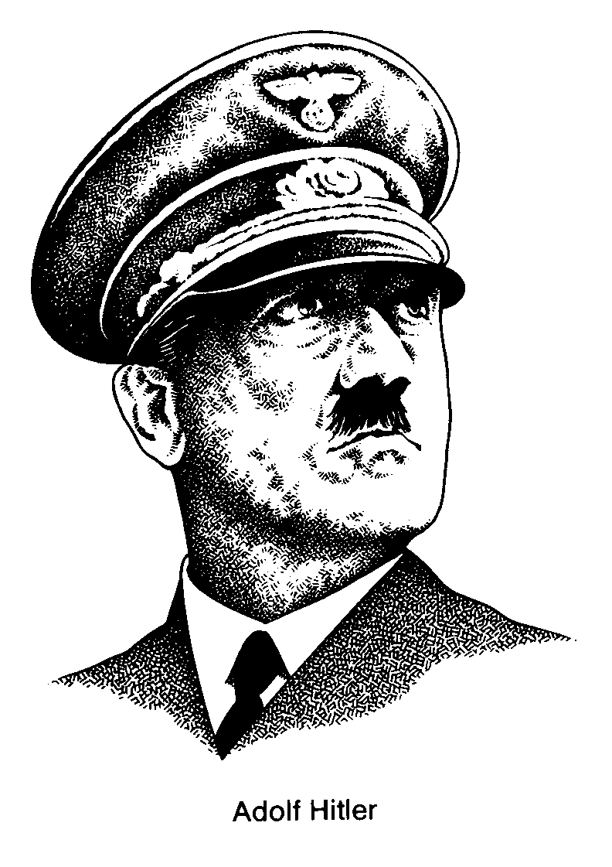
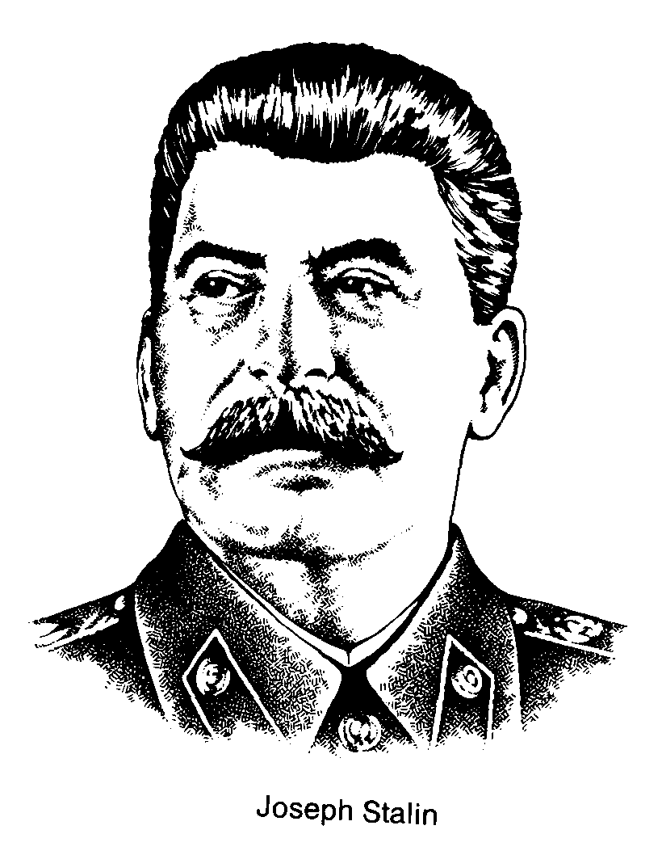

POLITICAL SPECTRUM

Attitudes About ‘Change’ in Society

REACTIONARY
RADICAL
LIBERAL
CONSERVATIVE

Communism
Stalinism
Fascism
Nazism

Favor immediate and fundamental change through violence and/or revolution.
Favor change through peaceful and legal means.
Resist change and favor the ‘status quo’.
Strongly resist change and favor a return to the past; willing to use violence.

ECONOMIC SPECTRUM

Individualism vs. Collectivism – Degree of Government Control

DEMOCRATIC SOCIALISM

Little or no government (state) control of the economy; producers and consumers in control

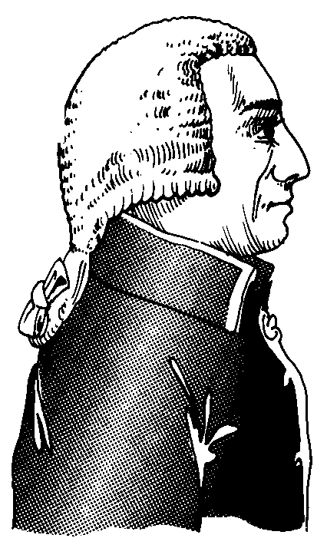
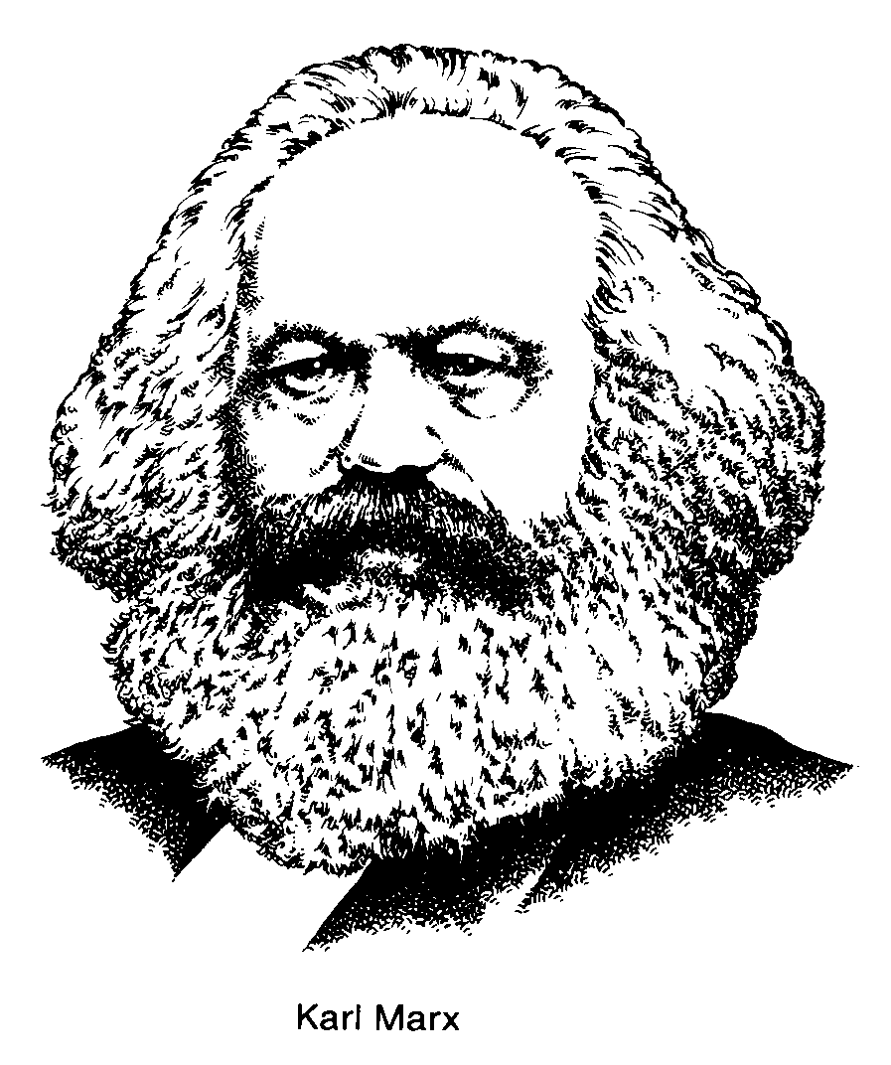
CAPITALISM
COMMUNISM
Total government (state) control of the economy; central planning
Canada
France
Former
Soviet Union
United
States
Mixture of left-wing and right-wing economic ideas
equality, egalitarianism, collectivism
individualism, competition, supply and demand, incentive, profit motive, private ownership

MODERN CONSERVATIVE VIEWPOINTS
Individualism and Competition: individuals looking out for themselves, not relying on others or on the government is important. Competition amongst individuals and businesses brings out the best in people, products and prices.
Laissez Faire and Decentralized Government: The federal government should not regulate business practices, but instead should let free market forces keep order in the business world. The federal government should be as small as possible, and most power should be vested in the state and local government.
Personal Responsibility: People have a responsibility to follow the rules/laws/norms set by society. Stern punishments should be given to those who break the rules/laws/norms.
Traditional Values: People should strive to live by the traditional moral codes that our grandparents followed. There are many dangerous moral trends in society today that we need to reverse. Religion should play a larger part of peoples lives and the government should reflect religious values.
Maximum Benefit: If every individual maximizes their own benefit (profit motive), everyone will be better off.
Property Rights: The government should pass and enforce laws that protect personal property.
These beliefs manifest themselves more strongly as we move farther right in the spectrum. Recently in Canada and the United States, conservatives have supported laws that would:
- cut government spending on social programs and aggressively eliminate deficits and pay down debt;
- deregulate industries to allow for more competition in key industries ie. Natural gas producers in Alberta
- privatization certain government controlled industries ie. alcohol sales in Alberta;
- cut taxes (especially taxes that mostly effect businesses and individuals with higher incomes);
- build more prisons and provide harsher penalties for convicted criminals;
- remove restrictions on how landowners can use their own property;
- make it more difficult or illegal for women to have abortions;
- prevent states from recognizing gay marriages;
- permit prayer in schools.
On the extreme right of the spectrum, we usually associate fascist politicians with foreign dictatorships. Fascist states usually direct extreme force toward their citizens in order to enforce rules, laws, and norms.

MODERN LIBERAL VIEWPOINTS
Group Responsibility: The government has a responsibility to help those who are disadvantaged or down on their luck. The government should work to equalize opportunities for everyone and also provide support for those who are unable to support themselves – social programs like welfare, employment insurance, health care etc..
Non-Traditional Values: Many traditional values represent old-fashioned ideas that are unfair to women and minorities. These traditional values tend to concentrate and consecrate power held by wealthy white men. Fight for the liberties of oppressed or exploited people and push for change in these areas.
Activist government: The government has a responsibility to regulate business to protect workers, the environment, and the public from abuse.
Use of Property for Public Good: The government has the right to tell people how to use their personal property in order to maximize the public good. Government should regulate and control key industries (necessary for all citizens to equal access to) so private owners cannot wield too much power over society; things like water, energy and utilities.
These beliefs manifest themselves more strongly as we move farther left in the spectrum. Recently in Canada and the United States, liberals have supported laws that would
- reinvest in social programs like education and health care
- raise some taxes to pay for specific programs, maintain current tax levels, or redistribute the tax burden from lower and middle class citizens to upper class and business tax payers;
- provide drug treatment and rehabilitation programs for criminals and at-risk youth;
- prevent landowners from harming endangered species or sensitive habitats on their own land;
- protect women's ability to have abortions and provide federal funding for women seeking abortions who cannot afford them;
- extend federal civil rights protections to gays;
- regulate how businesses treat their employees, and how they dispose of hazardous waste;
- reinforce our countries tradition of separation of church and state.
Taxes are a way of redistributing wealth in a society. People pay taxes to the government and the government provides services and social programs to create elements of equality within society (social programs like welfare, employment insurance, health care etc.). In general, supporters of liberal or left wing economic ideals support government involvement in the economy and support the idea of taxes as a way of redistributing wealth. Conversely, supporters of conservative or right wing economic ideals support less government involvement in the economy and therefore less taxation of the citizenry.
Socialist governments like those found in Scandinavian countries have large activist governments; citizens pay large taxes and in turn the government provides many of the services that private industry provides for a fee in the U.S. There are few communist governments left in the world, but they are usually marked by communal and government ownership of nearly all property. In practice, many communist governments look a lot like fascist governments.

Source: www.wikpedia.com , http://vantech.vsb.bc.ca/ss/pm/ss11/online/government/political_spectrum.htm

