The following timeline attempts to provide a brief overview of the evolution of the complex term LIBERALISM.
1500 1600 1700 1750 1776 1789 1800’s early 1900’s 1914-1932 1932 1919-1945 1945-1989 1989-present
FEUDAL SOCIETY
(absolute monarchies, hierarchical societies, no individual rights and no economic freedom for the vast majority of people [i.e. Estates in France])

ENLIGHTENMENT (AGE OF REASON)
(news ideas from people like John Locke, Montesquieu, Voltaire, Rousseau, Adam Smith, John Stuart Mill that seek to empower the individual with freedoms and rights)

INDUSTRIAL REVOLUTION
(factory system replaces domestic system and the rapid urbanization of the populations of Europe – rising middle class emerges [‘nouveaux riche’] to create some economic freedom and incentive – gap between rich and poor begins to grow again)

AMERICAN and FRENCH REVOLUTIONS
(news ideas from the Enlightenment lead to rejections of the old feudal order and lead to the birth or nationalism and the beginnings of our modern democratic rights and freedoms [i.e. Declaration of the Rights of Man and Woman])

CHALLENGES TO CLASSICAL LIBERALISM
(the growing gap between the rising middle class (bourgeoisie) and the working class (proletariat) raises opposition and reaction to new the new laissez-faire capitalist system – socialism grows through movements like Utopian Socialist Robert Owen, Karl Marx and Friedrich Engels write the Communist Manifesto which becomes the foundation for Marxism and Communism.
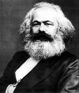

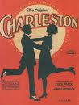
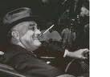
EARLY 20th CENTURY PROSPERITY and WELFARE CAPITALISM
(early 20th century sees the birth of our modern industrial society – better wages, more consumer goods, less work hours, money on credit, investing in stocks – prosperity in the new capitalist [‘laissez-faire’] system emerging in most western societies – corporations like Ford motor Company grow – ‘Robber Barons’ accused of exploitation – eventually industrialists agreed to concessions for workers to deal with growing demands from the labour movement –people like John Stuart Mill advocate for a more empathetic and equitable capitalism – Welfare Capitalism)

WORLD WAR I, the ROARING TWENTIES and the GREAT DEPRESSION
(Aftermath of World War I leave many nation in Europe in economic turmoil, especially Germany who was severely punished through the Treaty of Versailles - 1920’s great prosperity in the United States under laissez-faire capitalism - the Stock Market crash of 1929 leads to a economic downturn that spirals out of control – little government regulation and control in the economy [‘laissez-faire’ approach’] accelerates the process – people call for government help.)
GOVERNMENT INTERVENTION and the WELFARE STATE
(Franklin D. Roosevelt is elected in 1932 on a promise of a ‘New Deal’ for the United States to bring the country out of depression – strong government regulation and involvement – economic ideas inspired by John Maynard Keynes) – governments get involved to create jobs and social programs to support individuals in need – the Welfare State
CHALLENGES TO LIBERALISM
(as a result of post-World War I economic hardship and political unrest, liberal democracies are challenged by authoritarian fascist regimes in Germany under Hitler and in Italy under Mussolini, and a totalitarian regime under Stalin in Russia [Former Soviet Union]).)
POST WORLD WAR II to REAGAN and THATCHER (BIRTH of the NEO-CON)
(post-World War II rebuilding was a time of prosperity, opportunity and ideological competition amongst the two new superpowers [U.S. and U.S.S.R.] – in Western democracies many domestic industries are nationalized and social program are set up to help returning soldiers and families [i.e. universal healthcare in UK and Canada] – 1980’s height of the Cold War – Reagan in the U.S. and Thatcher in UK turn to privatizing industries, deregulating industries and cutting taxes on the rich in an attempt to stimulate the economy from the top (rich) down [‘trickle-down economics] – represents an economic shift to the right – modern conservatism – neo-conservatism)
MODERN LIBERALISM versus MODERN CONSERVATISM
(the shift towards classical liberal values that began in the 1980’s under Reagan and Thatcher have also be seen in many other liberal democracies – our modern discourse now revolves around the degree to which governments should be involved in lives of individuals and in the economy – individualist versus collectivist principles)

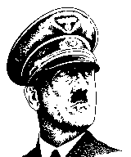
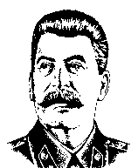

POLITICAL SPECTRUM

Attitudes About ‘Change’ in Society

REACTIONARY
RADICAL
CONSERVATIVE
LIBERAL

Fascism
Nazism
Communism
Stalinism

Resist change and favour the ‘status quo’.
Favor change through peaceful and legal means.
Strongly resist change and favor a return to the past; willing to use violence.
Favor immediate and fundamental change through violence and/or revolution.

ECONOMIC SPECTRUM

Individualism vs. Collectivism – Degree of Government Control

DEMOCRATIC
SOCIALISM
WELFARE
STATE
WELFARE
CAPITALISM
SOCIALISM
CAPITALISM and
CLASSICAL LIBERALISM
COMMUNISM
and MARXISM

MODERN
LIBERALISM
MODERN
CONSERVATISM
mixture of left-wing and right-wing economic ideas
Keynesian economics – Roosevelt’s ‘New Deal’
equality,
egalitarian,
collectivism
nationalization, government regulation
individualism, competition, supply and demand, incentive, profit motive, private ownership
total government (state) control of the economy; central planning
little government (state) control of the economy; producers and consumers in control

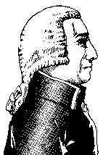
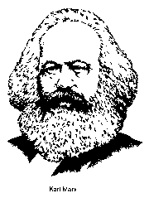

MODERN CONSERVATIVE VIEWPOINTS
Individualism and Competition: individuals looking out for themselves, not relying on others or on the government is important. Competition amongst individuals and businesses brings out the best in people, products and prices.
Laissez Faire and Decentralized Government: The federal government should not regulate business practices, but instead should let free market forces keep order in the business world. The federal government should be as small as possible, and most power should be vested in the state and local government.
Personal Responsibility: People have a responsibility to follow the rules/laws/norms set by society. Stern punishments should be given to those who break the rules/laws/norms.
Traditional Values: People should strive to live by the traditional moral codes that our grandparents followed. There are many dangerous moral trends in society today that we need to reverse. Religion should play a larger part of peoples lives and the government should reflect religious values.
Maximum Benefit: If every individual maximizes their own benefit (profit motive), everyone will be better off.
Property Rights: The government should pass and enforce laws that protect personal property.
These beliefs manifest themselves more strongly as we move farther right in the spectrum. Recently in Canada and the United States, conservatives have supported laws that would:
- cut government spending on social programs and aggressively eliminate deficits and pay down debt;
- deregulate industries to allow for more competition in key industries ie. Natural gas producers in Alberta
- privatization certain government controlled industries ie. alcohol sales in Alberta;
- cut taxes (especially taxes that mostly effect businesses and individuals with higher incomes);
- build more prisons and provide harsher penalties for convicted criminals;
- remove restrictions on how landowners can use their own property;
- make it more difficult or illegal for women to have abortions;
- prevent states from recognizing gay marriages;
- permit prayer in schools.
On the extreme right of the spectrum, we usually associate fascist politicians with foreign dictatorships. Fascist states usually direct extreme force toward their citizens in order to enforce rules, laws, and norms.

MODERN LIBERAL VIEWPOINTS
Group Responsibility: The government has a responsibility to help those who are disadvantaged or down on their luck. The government should work to equalize opportunities for everyone and also provide support for those who are unable to support themselves – social programs like welfare, employment insurance, health care etc..
Non-Traditional Values: Many traditional values represent old-fashioned ideas that are unfair to women and minorities. These traditional values tend to concentrate and consecrate power held by wealthy white men. Fight for the liberties of oppressed or exploited people and push for change in these areas.
Activist government: The government has a responsibility to regulate business to protect workers, the environment, and the public from abuse.
Use of Property for Public Good: The government has the right to tell people how to use their personal property in order to maximize the public good. Government should regulate and control key industries (necessary for all citizens to equal access to) so private owners cannot wield too much power over society; things like water, energy and utilities.
These beliefs manifest themselves more strongly as we move farther left in the spectrum. Recently in Canada and the United States, liberals have supported laws that would
- reinvest in social programs like education and health care
- raise some taxes to pay for specific programs, maintain current tax levels, or redistribute the tax burden from lower and middle class citizens to upper class and business tax payers;
- provide drug treatment and rehabilitation programs for criminals and at-risk youth;
- prevent landowners from harming endangered species or sensitive habitats on their own land;
- protect women's ability to have abortions and provide federal funding for women seeking abortions who cannot afford them;
- extend federal civil rights protections to gays;
- regulate how businesses treat their employees, and how they dispose of hazardous waste;
- reinforce our countries tradition of separation of church and state.
Taxes are a way of redistributing wealth in a society. People pay taxes to the government and the government provides services and social programs to create elements of equality within society (social programs like welfare, employment insurance, health care etc.). In general, supporters of liberal or left wing economic ideals support government involvement in the economy and support the idea of taxes as a way of redistributing wealth. Conversely, supporters of conservative or right wing economic ideals support less government involvement in the economy and therefore less taxation of the citizenry.
Socialist governments like those found in Scandinavian countries have large activist governments; citizens pay large taxes and in turn the government provides many of the services that private industry provides for a fee in the U.S. There are few communist governments left in the world, but they are usually marked by communal and government ownership of nearly all property. In practice, many communist governments look a lot like fascist governments.

Source: www.wikpedia.com , http://vantech.vsb.bc.ca/ss/pm/ss11/online/government/political_spectrum.htm

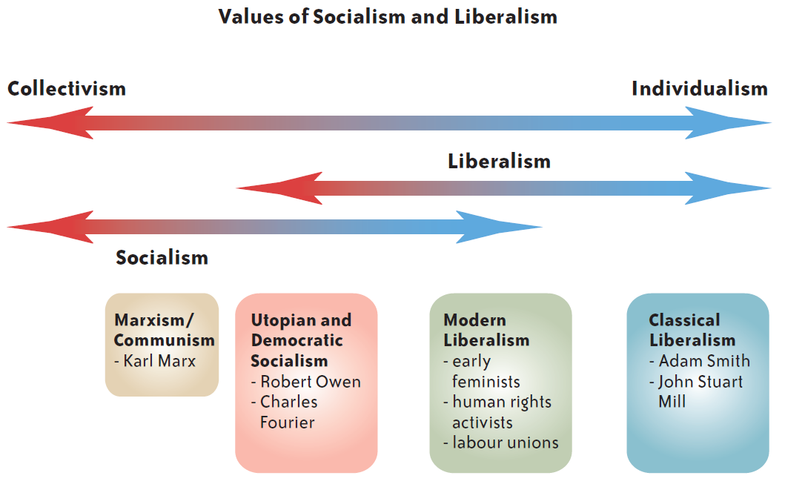

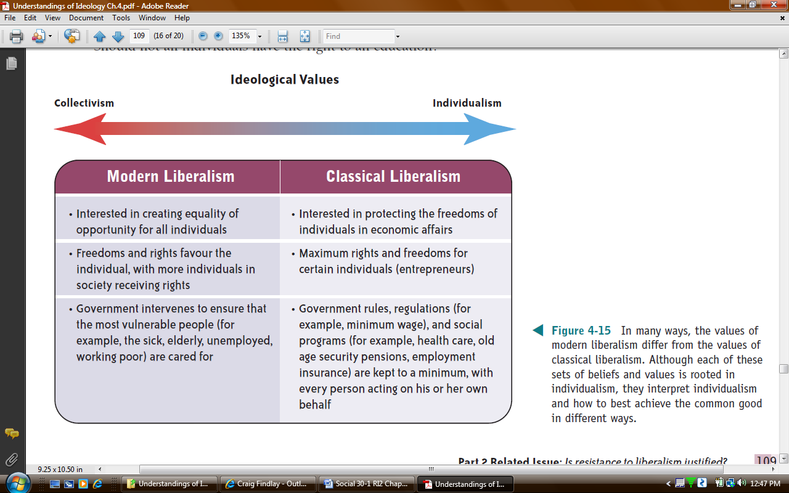
Source: Understandings of Ideology. Oxford University Press, 2009.

