

Related Issue 1
To what extent should ideology be the foundation of identity?

General Outcome
Students will assess explore the relationship between individualism and common good.

Specific Outcomes

Values and Attitudes
Students will:

1.1 appreciate various perspectives regarding identity and ideology
1.2 appreciate various perspectives regarding the relationship between individualism and common good

Knowledge and Understanding
Students will:

1.3 explore factors that may influence individual and collective beliefs and values (culture, language,
media, relationship to land, environment, gender, religion, spirituality, ideology)

1.6 explore themes of ideologies (nation, class, relationship to land, environment, religion, progressivism)

1.7 analyze individualism as a foundation of ideology (principles of liberalism: individual rights and
freedoms, self-interest, competition, economic freedom, rule of law, private property)

1.8 analyze collectivism as a foundation of ideology (principles of collectivism: collective responsibility, collective interest, cooperation, economic equality, adherence to collective norms, public property)
TASK ONE:

Read through the scenario presented on the next page. To add dramatic effect you may want
watch some segments from the 1980’s movie entitled ‘The Day After’ which portrays what it would have been like to live through a global nuclear war. Another option is to read or watch a brief portion of the epic story ‘Lord of the Flies’.

Preamble: All societies function by, and are structured on, basic beliefs and assumptions about how life should be lived. Inherent in this are the rules of political and economic decision making, and ultimately who possesses decision making power. These beliefs and assumptions are known as ideologies. We inherit the ideologies of our ancestors, the founders of our cultures and our countries, but what if you could create your own society? Start from scratch?
In the story the Lord of the Flies, a group of young boys are stranded on a desert island and are forced to survive together. The author presents a scenario, which contrasts the goodness and the evil of human nature. What would happen if you were placed in a similar situation?

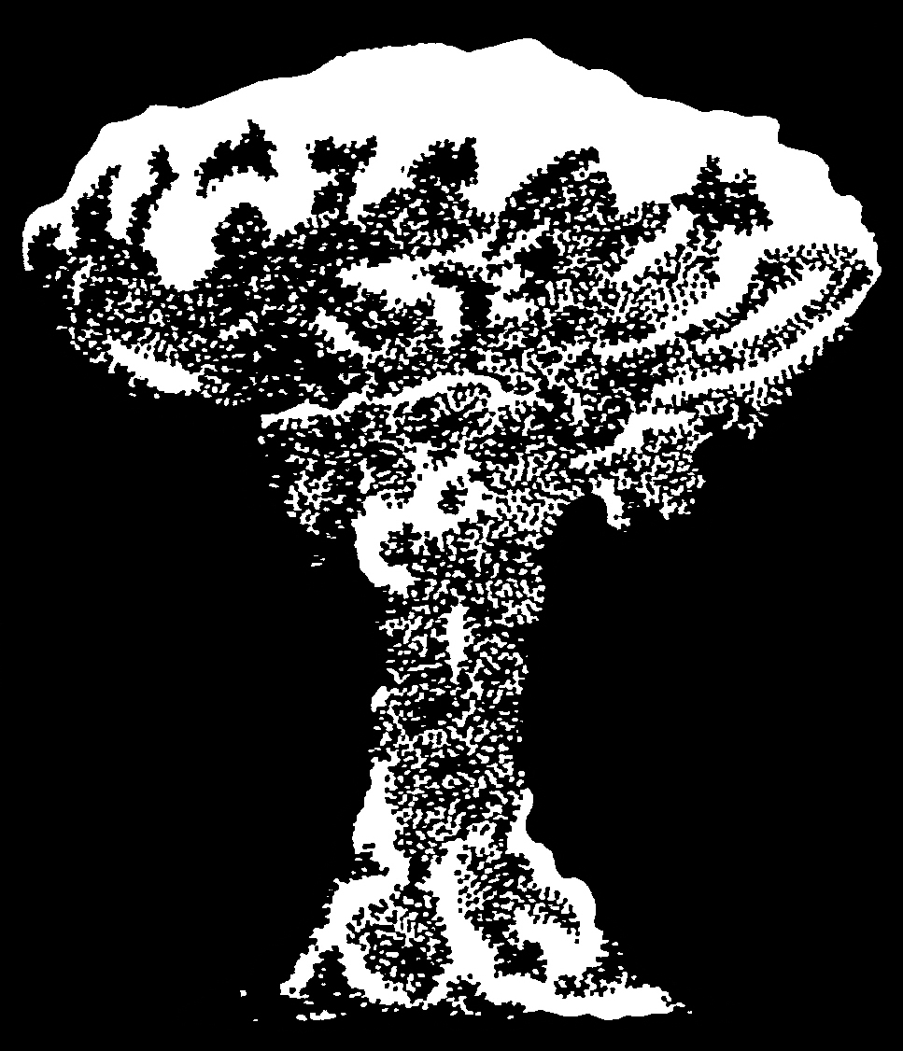
Scenario: The world has undergone a full-scale nuclear war. The war happened so quickly that the causes and the details are unknown to
most survivors of this catastrophic event, including your group.
All major cities and towns in North America, as well as areas
surrounding these centers, have been destroyed.
Fortunately, during the course of this global nuclear war,
your entire school was on a camping trip in a remote mountain
location. Therefore, at this point, all you know is that your school population, including students, teachers, support staff, and caretakers are the only survivors. All you have are the clothes on your back and the basic camping supplies you all brought with you.
Your situation is bleak but you must go on. Answer the following questions about how you would start to create your new society.

TASK TWO:

In small groups, discuss and answer the following questions about the new society in which
find yourself:

- List the ten most important rules rules/laws members of your society would have to follow.
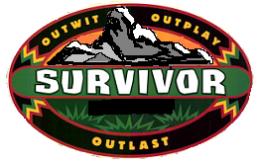

Place a star beside the three most important rules. Write brief rationale for your selections.

- How would you enforce the rules/laws? Explain.

- How would leadership work in your society? How would you choose leaders? Explain.

- How would your society make important decisions? Explain the process.

TASK THREE:

Based on what you have learned thus far, where would you place yourself on the spectrum below?
Provide a clear rationale for your placement.

RATIONALE:

TASK FOUR:

Where would your society fall on the following spectra that explore the principles of liberalism?
You must provide a clear rationale for your placement.

INDIVIDUAL RIGHTS AND FREEDOMS

RATIONALE:

SELF-INTEREST

RATIONALE:

COMPETITION

RATIONALE:

ECONOMIC FREEDOM

RATIONALE:

RULE OF LAW

RATIONALE:

PRIVATE PROPERTY

RATIONALE:

COOPERATION

RATIONALE:

ECONOMIC EQUALITY

RATIONALE:

TASK FIVE:

Your final task is to present your society to the class. The group will decide which societal structure
they like best (groups will not be able to vote for themselves). You need to consider the most effective way to share your society.

You will need to create a 2-3 minute presentation that your group will give.

Develop some criteria for what makes a good presentation…


CRITERIA
FOR A GOOD
PRESENTATION

Your presentation needs to include the following:

      - answers to all of the questions from TASK 2
      - rationales from TASK 3 and TASK 4
      - an audio-visual component

PLANNING:

IDE LOGY
SOCIAL STUDIES 30-1
TO WHAT EXTENT SHOULD WE EMBRACE AN

UNDERSTANDING

Incomplete: an incomplete account but with apt and insightful ideas; extends and deepens some of what was learned; some "reading between the lines"; account has limited support/ argument/data or sweeping generalizations. There is a theory, but one with limited testing and evidence. | Developed: an account that reflects some personalized ideas; the student is making the work her own, going beyond the given—there is some supported theory, but insufficient or inadequate evidence and argument. | In-depth: an atypical and revealing account, going beyond what is obvious or what was explicitly taught; makes subtle connections; well supported by argument and evidence; novel thinking displayed. | Sophisticated: a thorough, elegant, and inventive account (model, theory, or explanation); fully supported, verified, and justified; deep and broad: goes well beyond the information given. | T=  S=  O=
Incomplete: an incomplete account but with apt and insightful ideas; extends and deepens some of what was learned; some "reading between the lines"; account has limited support/ argument/data or sweeping generalizations. There is a theory, but one with limited testing and evidence. | Developed: an account that reflects some personalized ideas; the student is making the work her own, going beyond the given—there is some supported theory, but insufficient or inadequate evidence and argument. | In-depth: an atypical and revealing account, going beyond what is obvious or what was explicitly taught; makes subtle connections; well supported by argument and evidence; novel thinking displayed. | Sophisticated: a thorough, elegant, and inventive account (model, theory, or explanation); fully supported, verified, and justified; deep and broad: goes well beyond the information given. | T=  S=  O=
Literal: a simplistic or superficial reading; mechanical translation; a decoding with little or no interpretation; no sense of wider importance or significance; a restatement of what was taught or read. | Interpreted: a plausible interpretation or analysis of the importance/ meaning/ signficance; makes sense of a story; provides a history or context. | Perceptive: a helpful interpretation or analysis of the importance/ meaning/ significance; tells a clear and instructive story; provides a useful history or con- text; sees different levels of interpretation. | Profound: a powerful and illuminating interpretation and analysis of the importance /meaning/ significance; tells a rich and insightful story: provides a rich history or context; sees deeply and incisively any ironies in the different interpretations. | T=  S=  O=
Literal: a simplistic or superficial reading; mechanical translation; a decoding with little or no interpretation; no sense of wider importance or significance; a restatement of what was taught or read. | Interpreted: a plausible interpretation or analysis of the importance/ meaning/ signficance; makes sense of a story; provides a history or context. | Perceptive: a helpful interpretation or analysis of the importance/ meaning/ significance; tells a clear and instructive story; provides a useful history or con- text; sees different levels of interpretation. | Profound: a powerful and illuminating interpretation and analysis of the importance /meaning/ significance; tells a rich and insightful story: provides a rich history or context; sees deeply and incisively any ironies in the different interpretations. | T=  S=  O=
The work is awkward and lacks clarity. Targeted skills and processes were not consistently met (see comments). | The work is straightforward and functionally ordered. Targeted skills and processes were sometimes met, but there was inconsistency with resepct to their application (see comments). | The work is clear and purposefully ordered. Targeted skills and processes were met, but some areas have room for improvement (see comments). | The work is fluent, skillfully structured, and judiciously ordered. Targeted skills and processes were skillfully met (see comments). | T=  S=  O=
1.3 explore factors that may influence individual and collective beliefs and values (culture, language, media, relationship to land, environment, gender, religion, spirituality, ideology)

(circle)
1.
2.
3.
4.
5.

1.6 explore themes of ideologies (nation, class, relationship to land, environment, religion, progressivism)

1.7 analyze individualism as a foundation of ideology (principles of liberalism: individual rights and freedoms, self-interest, competition, economic freedom, rule of law, private property)

S
O
T

1.8 analyze collectivism as a foundation of ideology (principles of collectivism: collective responsibility, collective interest, cooperation, economic equality, adherence to collective norms, public property)

SKILLS AND
PROCESSES

TOTALS:
( / )
STUDENT NAME:
COMMENTS:

