

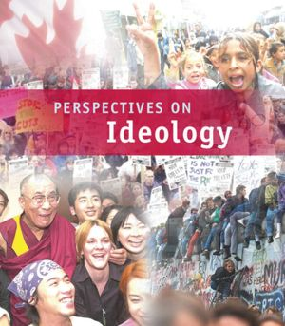

**RELATE ISSUE 1 REVIEW**

Specific learner outcomes:

1.1 appreciate various perspectives regarding identity and ideology

1.2 appreciate various perspectives regarding the relationship between individualism and

common good

1.3 explore factors that may influence individual and collective beliefs and values (culture,

language, media, relationship to land, environment, gender, religion, spirituality, ideology)

1.4 identify historic and contemporary expressions of individualism and collectivism

1.5 examine the characteristics of ideology (interpretations of history, beliefs about human nature,beliefs about the structure of society, visions for the future)

1.6 identify themes of ideologies (nation, class, relationship to land, environment, religion)

1.7 examine individualism as a key value of ideology (values of liberalism: individual rights and freedoms, self-interest, competition, economic freedom, rule of law, private property)

1.8 examine collectivism as a foundation of ideology (values of collectivism: collective responsibility, collective interest, cooperation, economic equality, adherence to collective norms, public property)

1.9 examine the relationship between individualism and common good in contemporary societies

1.10 analyze the extent to which personal identity should be shaped by ideologies

The following terms, concepts and questions for inquiry frame the main concepts you need to know.

**Chapter 1 Issue**:

To what extent are ideology and identity interrelated?

Thomas Hobbes

Jean Jacques Rousseau

pluralism

beliefs

ideology

human nature

values

identity

point of view

perspective

collective identity

individualism

collectivism

worldview

Tommy Douglas

John Locke

**Chapter 2 Issue**:

To what extent are individualism and collectivism foundations

of ideology?

autonomy

private property

liberalism

rule of law

individualism

collective responsibility

collective norms

self-interest

entrepreneur

liberty

individual rights and freedoms

public property

economic freedom

competition

collective interest

collectivism

common good

economic equality

egalitarianism

self-reliance

**ESSENTIAL UNDERSTANDINGS:**

You should be able to do the following:

* explain some of the factors that may influence individual and collective beliefs and values (culture, language, media, relationship to land, environment, gender, religion, spirituality, ideology)
* explain the characteristics of ideology (interpretations of history, beliefs about human nature [Locke, Hobbes, Rousseau], beliefs about the structure of society [Locke, Hobbes, Rousseau], visions for the future)
* explain themes of ideologies (nation, class, relationship to land, environment, religion, progressivism)
* explain individualism as a foundation of ideology (principles of liberalism: individual rights and freedoms, self-interest, competition, economic freedom, rule of law, private property)
* explain collectivism as a foundation of ideology (principles of collectivism: collective responsibility, collective interest, cooperation, economic equality, adherence to collective norms, public property)
* explain the dynamic between individualism and common good in contemporary societies (the healthcare issue is a great case study to explore the dynamic)
* explain your own ideology and discuss the extent to which personal identity should be shaped by ideology.

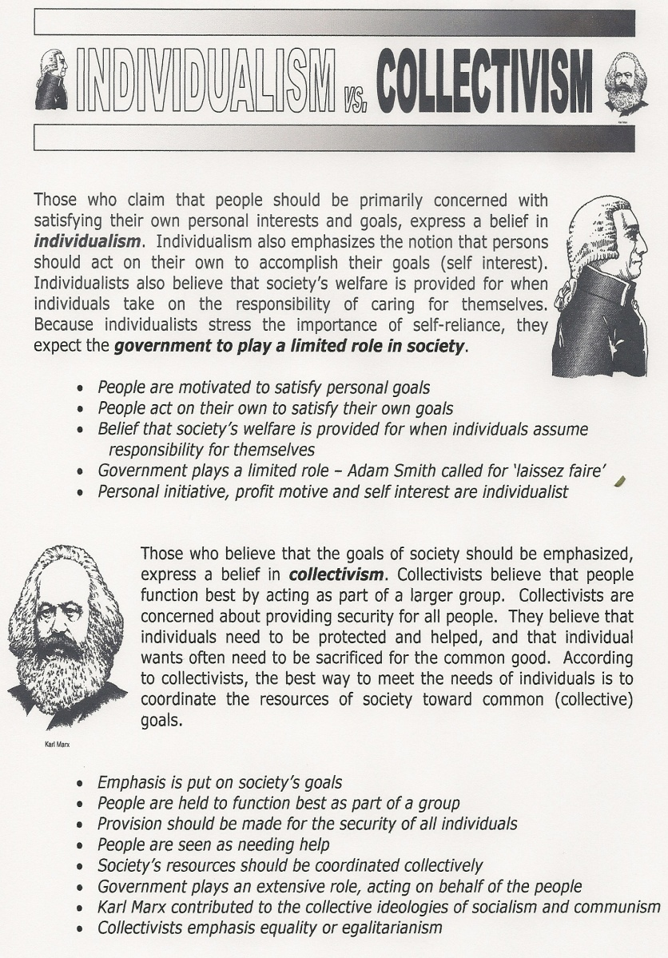

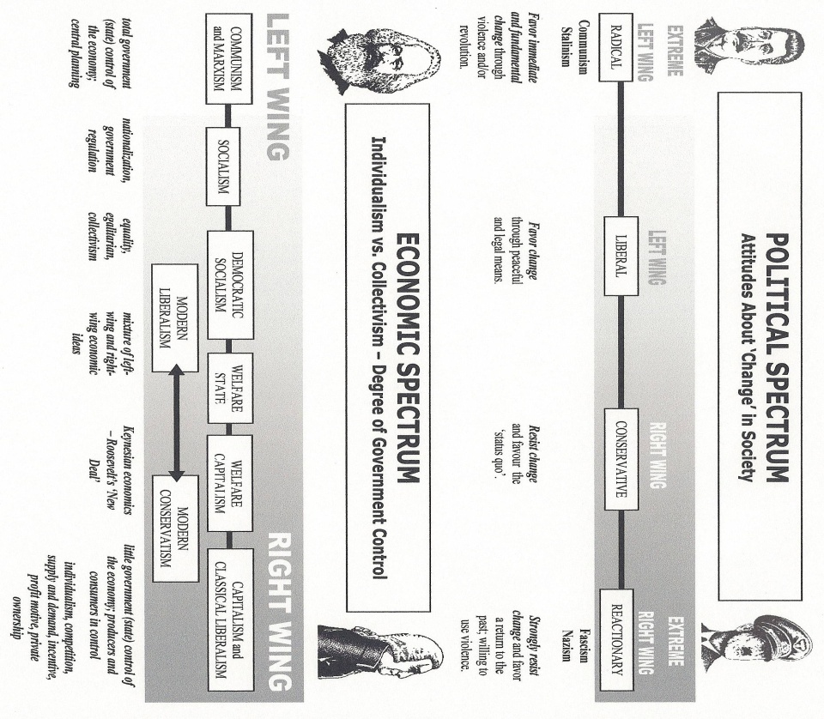

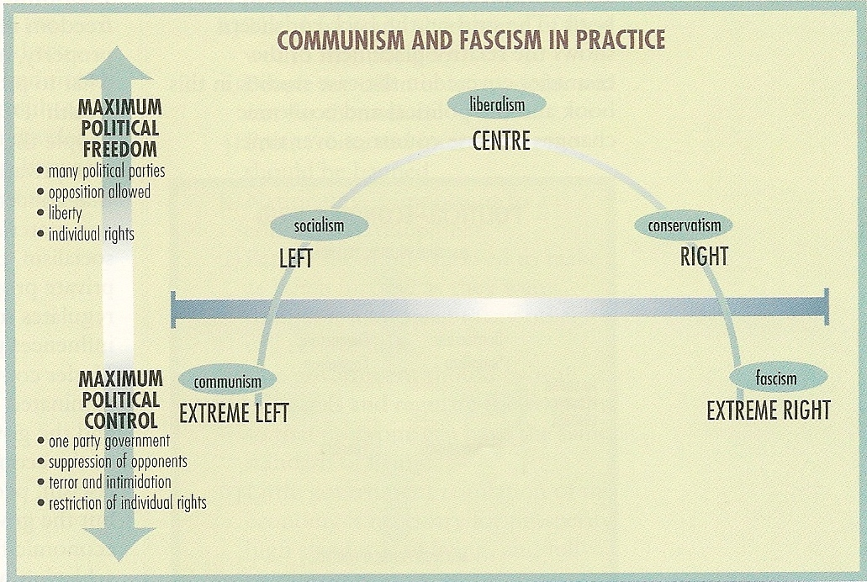

#### MODERN CONSERVATIVE VIEWPOINTS

***Individualism and Competition***: individuals looking out for themselves, not relying on others or on the government is important. *Competition* amongst individuals and businesses brings out the best in people, products and prices.

***Laissez Faire and Decentralized Government***: The federal government should not *regulate* business practices, but instead should let free market forces keep order in the business world. The federal government should be as small as possible, and most power should be vested in the state and local government.

***Personal Responsibility***: People have a responsibility to follow the rules/laws/norms set by society. Stern punishments should be given to those who break the rules/laws/norms.

***Traditional Values***: People should strive to live by the traditional moral codes that our grandparents followed. There are many dangerous moral trends in society today that we need to reverse. Religion should play a larger part of people’s lives and the government should reflect religious values.

***Maximum Benefit***: If every individual maximizes their own benefit (profit motive), everyone will be better off.

***Property Rights***: The government should pass and enforce laws that protect personal property.

These beliefs manifest themselves more strongly as we move farther right in the spectrum. Recently in Canada and the United States, conservatives have supported laws that would:

* cut government spending on social programs and aggressively eliminate deficits and pay down debt;
* deregulate industries to allow for more competition in key industries ie. *Natural gas producers in Alberta*
* privatization certain government controlled industries ie. *alcohol sales in Alberta*;
* cut taxes (especially taxes that mostly effect businesses and individuals with higher incomes);
* build more prisons and provide harsher penalties for convicted criminals;
* remove restrictions on how landowners can use their own property;
* make it more difficult or illegal for women to have abortions;
* prevent states from recognizing gay marriages;
* permit prayer in schools.

On the extreme right of the spectrum, we usually associate fascist politicians with foreign dictatorships. Fascist states usually direct extreme force toward their citizens in order to enforce rules, laws, and norms.

#### MODERN LIBERAL VIEWPOINTS

***Group Responsibility***: The government has a responsibility to help those who are disadvantaged or down on their luck. The government should work to equalize opportunities for everyone and also provide support for those who are unable to support themselves – social programs like welfare, employment insurance, health care etc..

***Non-Traditional Values***: Many traditional values represent old-fashioned ideas that are unfair to women and minorities. These traditional values tend to concentrate and consecrate power held by *wealthy white* *men*. Fight for the liberties of oppressed or exploited people and push for change in these areas.

***Activist government***: The government has a responsibility to regulate business to protect workers, the environment, and the public from abuse.

***Use of Property for Public Good***: The government has the right to tell people how to use their personal property in order to maximize the public good. Government should regulate and control key industries (necessary for all citizens to equal access to) so private owners cannot wield too much power over society; things like water, energy and utilities.

These beliefs manifest themselves more strongly as we move farther left in the spectrum. Recently in Canada and the United States, *liberals* have supported laws that would

* reinvest in social programs like education and health care
* raise some taxes to pay for specific programs, maintain current tax levels, or redistribute the tax burden from

lower and middle class citizens to upper class and business tax payers;

* provide drug treatment and rehabilitation programs for criminals and at-risk youth;
* prevent landowners from harming endangered species or sensitive habitats on their own land;
* protect women's ability to have abortions and provide federal funding for women seeking abortions who cannot

afford them

* extend federal civil rights protections to gays;
* regulate how businesses treat their employees, and how they dispose of hazardous waste;
* reinforce our countries tradition of separation of church and state.

***Taxes*** are a way of redistributing wealth in a society. People pay taxes to the government and the government provides services and social programs to create elements of equality within society (social programs like welfare, employment insurance, health care etc.). In general, supporters of liberal or left wing economic ideals support government involvement in the economy and support the idea of taxes as a way of redistributing wealth. Conversely, supporters of conservative or right wing economic ideals support less government involvement in the economy and therefore less taxation of the citizenry.

Socialist governments like those found in Scandinavian countries have large activist governments; citizens pay large taxes and in turn the government provides many of the services that private industry provides for a fee in the U.S. There are few communist governments left in the world, but they are usually marked by communal and government ownership of nearly all property. In practice, many communist governments look a lot like fascist governments.



**CRITERIA FOR A GOOD SHORT ANSWER RESPONSE**

* The question is clearly addressed and a logical answer is clearly articulated. A rationale, where appropriate, is provided to explain your answer.
* Specific information (examples and case studies from class and current events) are used to explain and support your response.

* Vocabulary is precise and deliberately chosen. Sentence structure is controlled and sophisticated; ideas are judiciously organized. The writing demonstrates skillful control of mechanics and grammar.