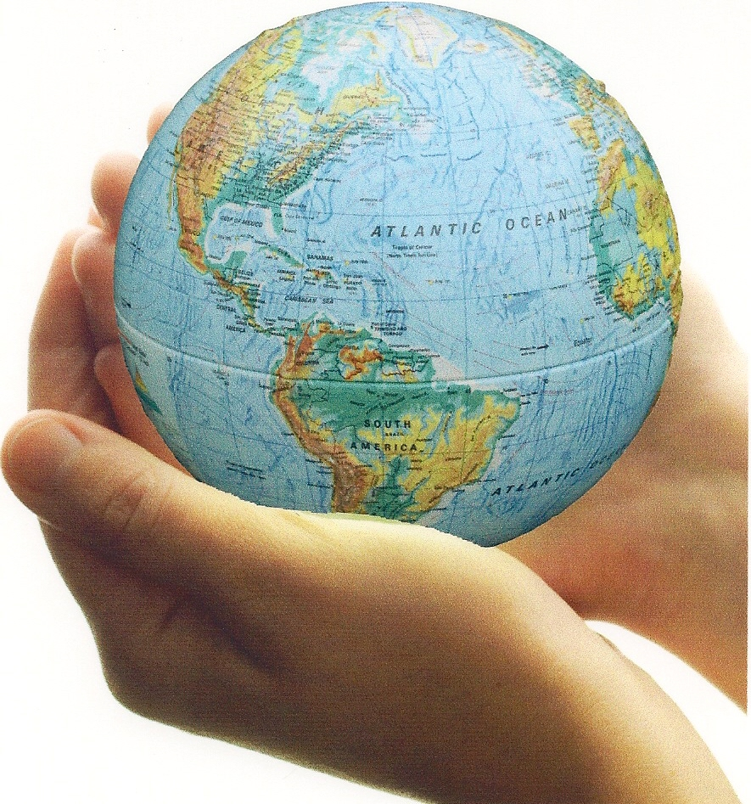

The Characteristics of Ideology (adapted from Perspectives on Ideology textbook)

All ideologies contain a set of beliefs and values about similar things. They are all concerned with the essential questions of life, such as

• What are humans like, and why do they act as they do?
• How should society be organized?
• How has the world worked in the past?
• How should it work in the future?

The answers an ideology provides to these questions form the characteristics of that ideology.

The Nature of Human Beings
Beliefs about human nature—about whether people are essentially good or bad, for example—are fundamental to any ideology. Do you usually trust people until they give you a reason not to, or do you generally approach people with caution? If you approach people openly, it is likely that you believe humans are essentially good. If you are cautious, you likely believe that they are not. This core belief will be part of the way you deal with the world.

Do you believe people are innately good or evil? What are the implications of your answer?

The Structure of Society
Social structures are what bind us together as a society and help the society to function in an orderly fashion. The social structures of any society reflect the beliefs and values of that society. Economics is an example of a structure of society. For example, there are both wealthy people and people living in poverty in Canadian society, but our provincial governments do have minimum wage laws, meaning that all businesses must pay a minimum amount of money to their workers. Through these means, these governments are trying to maintain the structure of what they perceive to be a fairer society. There are also informal social structures. Informal social structures are the unwritten rules about acceptable social behaviour and actions. For example, some societies show more respect for people who are elderly and disadvantaged, or place more importance on gender equality, than others do.

How should society be structured? Should everyone be equal (politically and economically)?

Interpretations of History
Interpretations of history, or the past, are another characteristic of ideology, because the events of our pasts tend to influence the beliefs and values that we hold. An individual whose life has been difficult may have a pessimistic view of life and consider that life is a struggle against the odds. Other individuals may grow up believing that it is their duty in life to help people who are disadvantaged because they themselves have been privileged. Their views of the past affect their identities and the way they interpret the world.
Countries also have ideological interpretations of their histories that affect the identities of their citizens. This is sometimes manifested as demonstrations of patriotism, in which the citizens tell their stories to themselves and the world. Remembrance Day ceremonies are an example of such an event, as Canadians pay tribute to the men and women who made sacrifices to protect the liberal democratic traditions of Canada. These stories inform a nation’s or a country’s historical interpretations, which provide it with an ideology that guides its subsequent actions.
Adolf Hitler believed that there were two great reigns for his country in European history: the first under the Charlemagne and the Holy Roman Empire, and the second under Otto von Bismark leading up to World War I. Hitler wanted to create a third reign for the German empire, what he called the ‘Third Reich’. This was his interpretation of history and his vision for the future.

Do you have an interpretation of history that has an impact on your ideology? (Hint: think of the World Wars)

Visions of the Future
Graduating from high school is a sobering experience for many 17- and 18-year-olds. Students getting ready to graduate sometimes experience anxiety about what is in store for them in the future. You most likely have a good idea of what you want your future to look like. If your vision of the future is something like having a job you love, enough money for you to be comfortable, and a happy family, you need to think about the actions you need to take in order to achieve these goals. The same is true for an ideology, which has a vision of what the world should be like in the future. This vision of the future will help guide the actions of people who embrace the ideology.

What is your vision for your own future and the future of Canada and the world? What impact does this have on your ideology?

The Themes of Ideology

Typical themes of concern to ideologies include nation, class, race, environment and relationship to the land, gender, and religion, among others. Most ideologies talk about, or are concerned with, these themes.
In some cases, it may seem as though one or two themes predominat in an ideology—for example, Marxists concentrate heavily on the theme of class, and capitalists emphasize the theme of freedom.

Progressivism is an umbrella term for various ideologies that advocate moderate political and social reform through government action, such as using anti-trust laws to prevent corporations from establishing monopolies in the marketplace. Progressive ideologies generally support social justice and the rights of workers.
The table below displays some of the more important themes of ideologies and examples of each of them.

What themes do you think have the greatest impact on an individual’s ideology? Provide a brief rationale to explain your choices.

