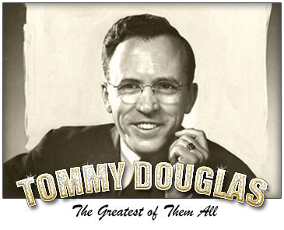
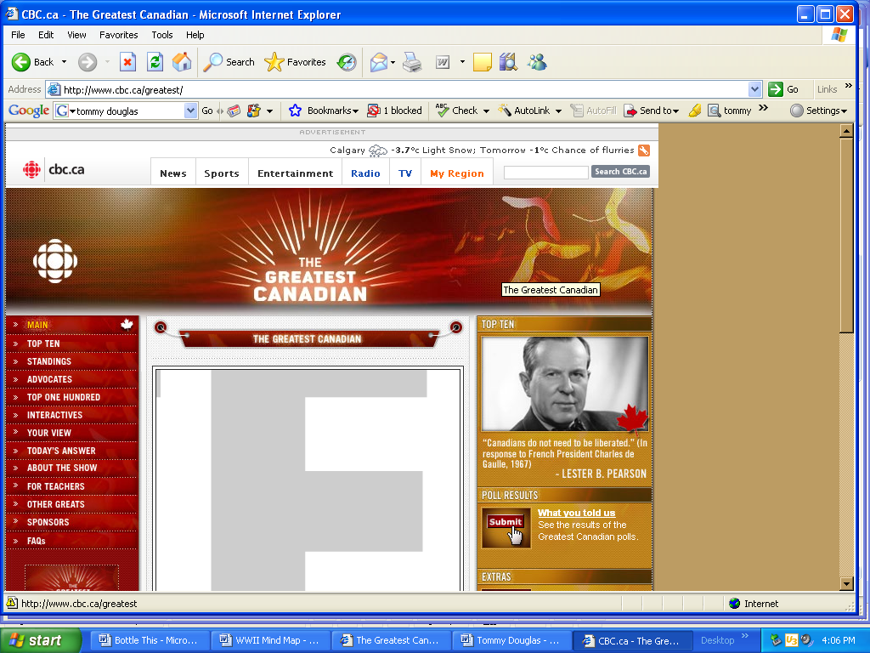
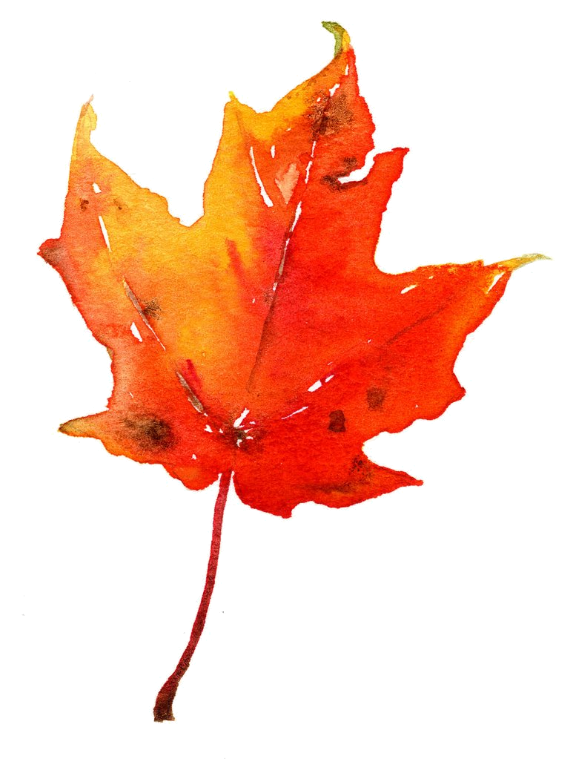

"My friends, watch out for the little fellow with an idea." Tommy Douglas 1961.

For more than 50 years, his staunch devotion to social causes, rousing powers of speech and pugnacious charm made Tommy C. Douglas an unstoppable political force. From his first foray into public office politics in 1934 to his post-retirement years in the 1970s, Canada's 'father of Medicare' stayed true to his socialist beliefs -- often at the cost of his own political fortune -- and earned himself the respect of millions of Canadians in the process.

The child of Scottish immigrants, Douglas spent his formative years in Winnipeg, Manitoba in a home where politics, philosophy and religion were side dishes at the dinner table. His father, a veteran of two wars, worked part-time in an iron foundry. When money was tight, Douglas and his two sisters had to drop in and out of school as they worked occasional jobs to help pay the bills.

His family's socialist leanings were solidified after Douglas was hospitalized at the age of 10. Due to a bone infection suffered four years earlier, Douglas's knee required several operations - none of which were successful. Without the money to pay for a specialist, his parents were told that the only option was to amputate their son's leg before the infection spread to the rest of his body. But before that could happen, a visiting surgeon offered to operate on Douglas for free, as long as his students were allowed to attend. The surgery saved Douglas's leg - quite possibly his life - and would serve as his inspiration for his dream of universally accessible medical care.

Not long after this, Douglas would witness firsthand the violent end of Canada's first general strike on a day known as "Bloody Saturday". In the summer of 1919, a teenaged Douglas watched from a rooftop as officers fired on participants in the Winnipeg General Strike and killed two men. The forceful and violent end of the strike further mobilized his dedication to the working man.
During his youth, he tried many different occupations: amateur actor, boxer and apprentice printer. Douglas found his true calling in 1924 when he enrolled in a liberal arts college run by the Baptist church. It was here that he refined his notion of the "social gospel," a vision of religion-in-action that he would carry through his life. Following several post-graduation years working as a minister in Depression-era Saskatchewan, Douglas made the move to politics in 1935 when he was elected as an MP in the Co-operative Commonwealth Federation, or CCF.

After nine years in the House of Commons polishing his fiery public-speaking talent, Douglas was elected the leader of the provincial CCF in Saskatchewan. With interest in socialism peaking in post-war Canada, the party won a landslide victory in 1944 and Douglas found himself an instant celebrity as the head of North America's first-ever socialist government.
Amid widespread skepticism, Premier Douglas mobilized aggressively, passing more than 100 bills during his first term. He introduced paved roads, sewage systems and power to most farmers and managed to reduce the provincial debt by $20 million. Over the next 18 years he weathered Communist fear campaigns and a province-wide doctor's strike. Elected to five terms, he introduced Saskatchewan residents to car insurance, labour reforms and his long-standing dream of universal Medicare.
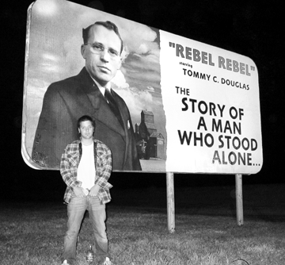
But the years spent reforming his home province worked against him when he made his transition to national politics. By the time he was elected to the leadership of the newly formed national New Democratic Party in 1961, many provincial governments had already adopted many of his ideas, diluting his progressive luster. That, combined with a fervent anti-Medicare campaign by Saskatchewan's medical professionals, helped to deal him his first significant defeat in the 1961 federal election. The NDP won only 19 seats, and Douglas lost his cherished seat in Regina.

Douglas continued to promote his socialist policy through the 1960s, but never managed to secure the highest office in the land. The adoption of national Medicare and a pension plan by Lester B. Pearson's Liberals gave him hope. He took his final and most controversial stand during the October Crisis of 1970, when he voted against the implementation of the War Measures Act in Quebec. The move was devastating to his popularity at the time, but he would be heralded years later for sticking by his principles of civil liberty.

He stepped down as leader in 1971 but he stayed on with the party. In 1979, he resigned his seat in Parliament and retired to a house in the Gatineau Hills just outside Ottawa, where he devoted himself to reforesting his land. He continued to make appearances at NDP functions where he gave his trademark speeches. Douglas died of cancer in 1986.
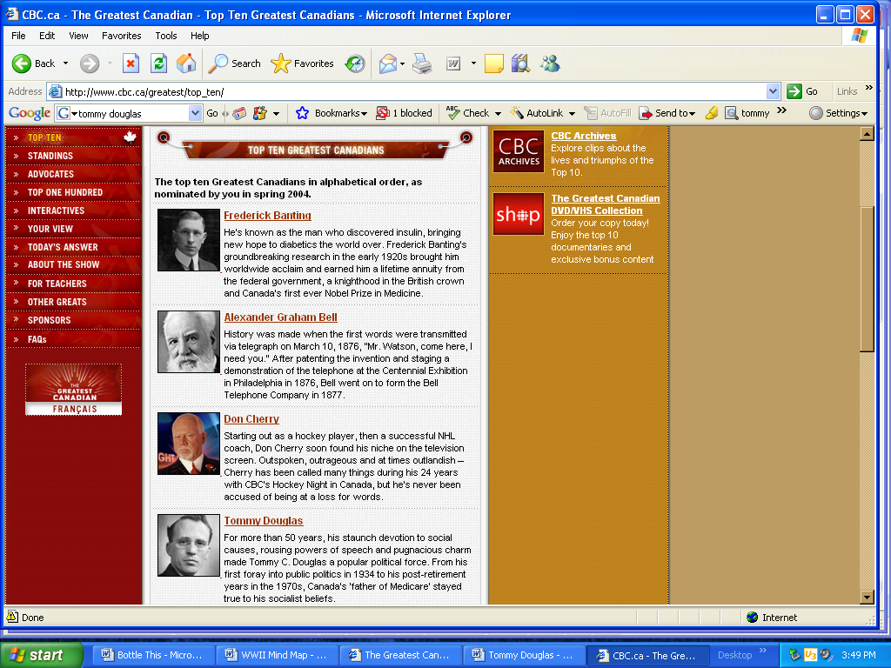
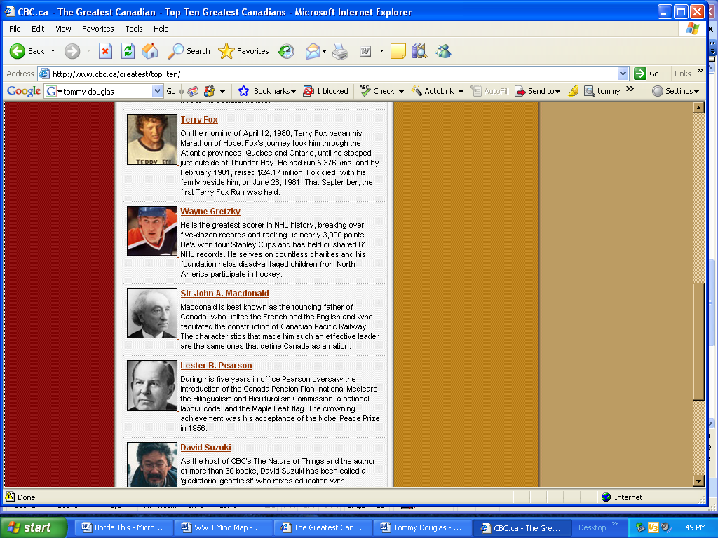
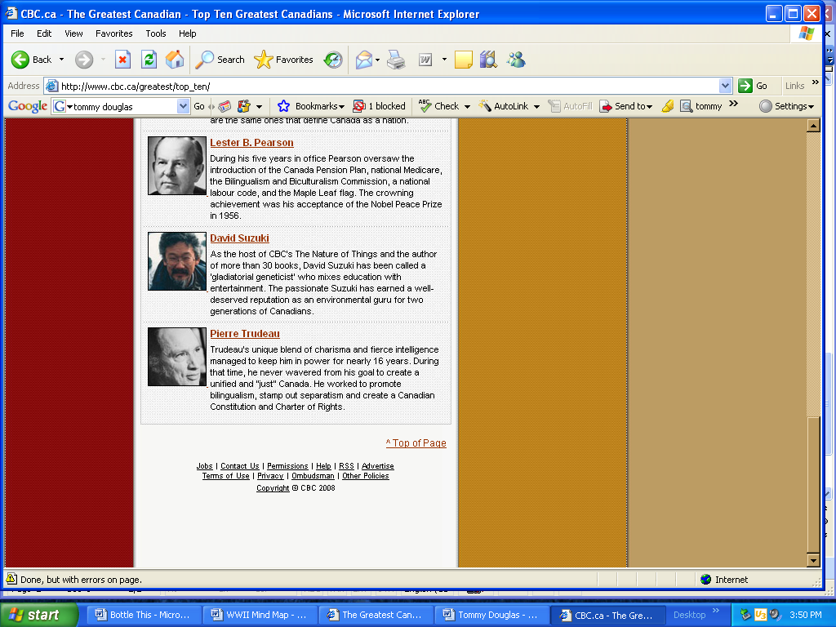
Tommy Douglas's legacy as a social policy innovator lives on. Social welfare, universal Medicare, old age pensions and mothers' allowances -- Douglas helped keep these ideas, and many more, watching as more established political parties eventually came to accept these once-radical ideas as their own.
1
4
9
7
2
8
6
5
3

Watch a clip on Tommy Douglas at:

http://archives.cbc.ca/society/celebrations/topics/1455/

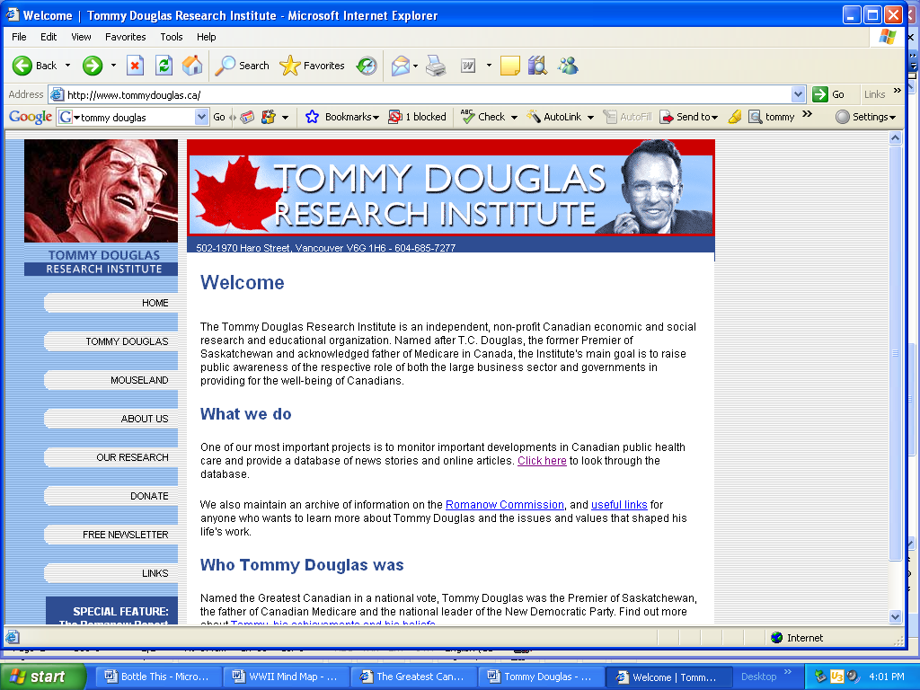

The Tommy Douglas Research Institute is an independent, non-profit Canadian economic and social research and educational organization. Named after T.C. Douglas, the former Premier of Saskatchewan and acknowledged father of Medicare in Canada, the Institute's main goal is to raise public awareness of the respective role of both the large business sector and governments in providing for the well-being of Canadians.

One of our most important projects is to monitor important developments in Canadian public health care and provide a database of news stories and online articles. We also maintain an archive of information on the Romanow Commission, and useful links for anyone who wants to learn more about Tommy Douglas and the issues and values that shaped his life's work.

http://www.tommydouglas.ca/
10

