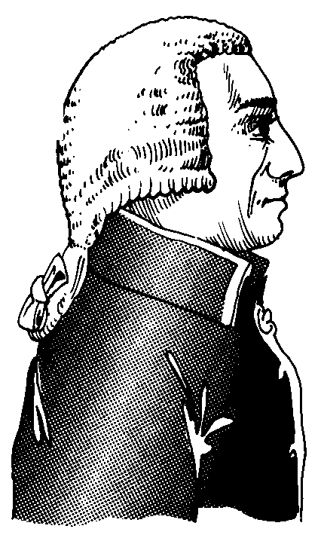
During the 18th century, people such as Sir Isaac Newton in England, began to develop ideas about natural laws. Newton's explanation of gravity is typical of such laws, which said that all things in the physical world were governed by unchangeable rules. At about the same time a group of thinkers got together in Paris. Taking their name from the growing interest in the physical world, they called themselves physiocrats. They reasoned that if laws governed the physical world, then other laws must govern the economic, social and political world. If that was true, all artificial rules and laws created by people were unnecessary and should be done away with. This doctrine became known as laissez-faire, which means “leave to do”. In Scotland, a philosopher called Adam Smith took a look at the ideas of the physiocrats and liked what he saw. He was moved to write a book. In 1776, it was published under the long-winded title An Inquiry into the Nature and Causes of the Wealth of Nations.
Smith's major notion was that each person has his or her own self-interest was at heart. If that self-interest is allowed complete freedom, then the tremendous force of competition will drive the economy – driven by an invisible hand. Smith's theory worked for a few: those who owned capital. For the majority it didn’t work at all. The competition force led to mechanization and mechanization led to a lower demand for labour at a time when the supply of workers was increasing. The results were low wages, terrible working conditions, and awful poverty for the masses. However, during the second half of the 19th century things got better. Gradually, the surplus of labour was used up. The masses began to benefit as they shared in the general prosperity. With that as background, what do capitalists believe in today?
- The people who own capital should be left alone to decide how to use it.
- It is industry, through the production of goods and services, that is the engine that drives the economy – competition among industrialists.
- The individual is supreme and should be free to make decisions as to how he or she will live.
- Each person is responsible for his or her own well-being – individualism.
- Profit, whether corporate or individual is the best incentive for getting maximum effort – profit motive.
- Competitive forces will ensure that the products and services produced are the highest quality for the best prices.
- Those who take the greatest risk (through investment), or produce the most (through effort) should receive the highest rewards. The opposite also holds; those who contribute least should get the lowest rewards.

Not all capitalists believe in all these ideas. For instance, most capitalists today accept that government should have a role in the economy': although most would say government's role should be less than it is.

