The business cycle is a phenomena resulting from the interplay of forces within a market. There are times of economic prosperity when an economy or business is strong, and times when an economy is stagnating and struggling. There are a number of key economic indicators to help economists diagnose the economy. Economists may look at things like:

    - Unemployment rate
    - Number of new jobs created or lost in the economy
    - Growth in the Gross Domestic Product (GDP)
    - New housing starts
    - Rate of inflation
    - Consumer spending numbers

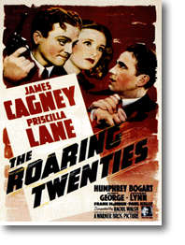
The history of the business cycle phenomena can be traced to the early industrial society that started to experience ‘booms’ and ‘busts’. The classic example of this can bee seen in the early part of the twentieth century in the United States. The 1920’s were a time a great prosperity in the U.S. (the ‘roaring twenties’) with low unemployment, strong wages, new businesses opening, and people spending their extra disposable income on an array of new consumer products. In addition, people began to invest money into the emerging stock market in an attempt to make more money. People also began to take advantage of the new concept of credit – buy now, pay later. People even began to buy stock in companies on credit – ‘on margin’ in which they only had to pay 10% up front. There was very little government regulation of the economy – it was perhaps the closest the world has come to pure capitalism.
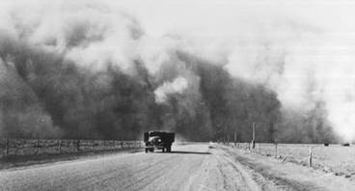
The 1930’s were a different story. Panic selling in October of 1929 caused the stock market in the United States to crash, as thousands of investors called for their money back. Stock prices plummeted and many people lost all of their investments and wealth. Banks could not handle the pressure of loans being called in and investors pulling their money, so many went bankrupt and thousands more people lost all of their savings. Business and bank collapse caused massive unemployment across the country. Severe poverty started to cause untold social problems, even starvation and death in extreme cases. In addition to hardship in the cities, much of the mid-west ‘bread basket’ of the country was suffering through terribly dry agricultural conditions. The dry drought conditions and the ensuing dust storms gave birth to the term ‘dirty thirties’ as a descriptor of the era. The economy had collapsed and there was no consumer or business confidence to rebuild what had been lost.

Here is what the basics of the business cycle look like:

1920’s in the U.S. (‘roaring twenties’)

DEPRESSION: low point in the economy with high unemployment. People have no money to spend, businesses suffer (many shut down) creating even more unemployment. Little or no confidence in the economy to stimulate recovery. The price of goods can rise (inflation) as a result of low production levels and restricted supply.
RECOVERY: stimulus to the economy like lowering interest rates, government spending on job creation or training. Attempt to create jobs so people have money to spend. If people start to spend then business prospers and hire workers. The cycle starts in the other direction
PROSPERITY: high point in the economy with low unemployment, most people have jobs and money to spend. Businesses prosper and expand creating more jobs. As businesses prosper wages often increase and the price of goods (inflation) starts to rise. If inflation starts to rise too much, interest rates may be increased to slow consumer spending.
RECESSION: inflation eventually gets too high and consumers stop spending, causing businesses to suffer. Slow business often leads to layoffs and higher unemployment. Fewer jobs means less spending, businesses suffer more and the cycle starts in the other direction.
1930’s in the U.S. (‘dirty thirties’)

