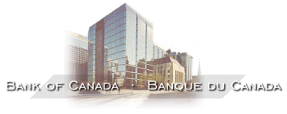

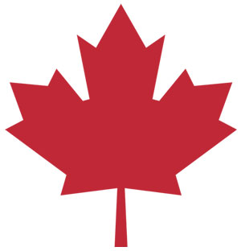
Probably the closest Canada has come to a pure laissez faire capitalist economy was during the 1920’s. During that decade governments followed Adam Smith’s advice, and left the privately-owned economy alone. Since government did little, taxes were low and there was no income tax.
Then came the crash of 1929 followed by the Great Depression. Most Canadians experienced major economic hardships throughout the 1930’s. Business owners and workers began to feel that government should do something to prevent such a massive economic collapse from ever happening again, and to provide help to the helpless individuals in society. Since this era, the governments in Canada have steadily broadened their role in the economy. We are now a true mixed economy or democratic socialist state.

Here is a list of some of the ways that governments are involved in the Canadian economy:

Stabilization policy – preventing boom and busts in the economy

-monetary policy – increasing and decreasing interest rates through the Bank of Canada
-fiscal policy – increasing and decreasing taxes
-increasing and decreasing government spending on programs

Regulation of the marketplace

-quality and safety controls on consumer products
-some price controls
-prevention of monopolies to preserve competition and to protect consumers

Regulation of the environment
-pollution controls and regulations
-conservation policy

Redistribution of wealth and to provide security to citizens

-social assistance (welfare)
-old age pension (CPP)
-employment insurance (EI)
-family allowance

Provision of public service – transfer payments to provincial and municipal governments

-universal health care
-education – K-12 and post-secondary
-police services
-fire protection services
-parks

Business subsidies – financial assistance to business

-farm subsidies for low crop prices
-emergency relief
-tax relief and/or interest free loans

Ownership of companies by government (nationalization) – ‘crown corporations’
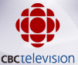
-CBC Radio and TV
-Canada Post
-Ontario Power, Hydro Quebec
-Canada Mortgage and Housing
-Via Rail Canada

KEY TERMS

Privatization: when a company or business is released from government control to private ownership and control

Nationalization: when a company of business is owned and controlled by government

Public sector: areas of the economy owned and controlled by the government

Private sector: areas of the economy owned and controlled by individuals or private investors

Regulation: direct government control over certain aspects of an industry

De-regulation: removing government control over aspects of an industry

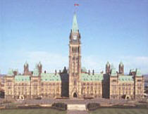
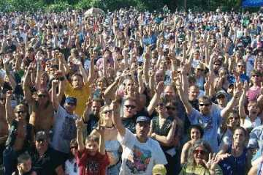
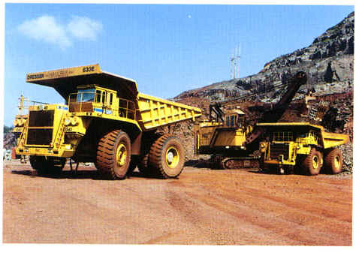
GOVERNMENT
SERVICES
TRANSFER
PAYMENTS
GOVERNMENT
SERVICES
SUBSIDIES
CAPITAL
ASSISTANCE

FEDERAL POWERS

Canada Health Act
Military
Currency
Aboriginal Affairs

PROVINCIAL POWERS

Health Care
Education
Resources

Licensing

MUNICPAL POWERS

Police Services
Fire Services
Public Transit
Water Treatment

What Taxes Apply in Canada Today?

Taxation in Canada can be viewed as ‘redistribution policy’. The government collects various taxes so it can provide programs and services it decides are important to Canadians. Canadian taxes consist of direct taxes and indirect taxes. "Direct taxes" are taxes are imposed on the income of Canadian resident individuals, Canadian corporations and various other entities that either reside or carry on business in Canada. Non-resident individuals and businesses may be subject to taxation in Canada if they have a connection with Canada. Whether non-residents are required to pay Canadian income taxes or are otherwise required to file income tax returns depends not only on Canadian income tax laws but also on international tax treaties.
Income taxes are also levied at the provincial level. For the most part, these taxes are collected by the federal government on behalf of the provinces. Only Quebec has a separate income tax regime at the individual level, while Quebec, Ontario and Alberta have their own corporate income tax laws and administration.
"Indirect taxes" are generally consumption taxes levied on property and services, which distinguishes them from direct taxes, such as income taxes. In Canada, the term "commodity taxes" is often used in place of indirect taxes.
In a Canadian context, indirect taxes encompass the sales taxes of general application as well as the other indirect taxes that are levied on commodities such as fuels, tobacco products and alcoholic beverages. They also include excise taxes and customs duties, since both excise taxes and customs duties are selective taxes on goods.
Canada's system of indirect taxation is unique among industrialized countries in that there are two levels of government, federal and provincial, that impose a general sales tax on the same transactions. The federal government levies the Goods and Services Tax, or GST, which is a 7% value-added tax on virtually all goods and services sold in Canada. Most provinces levy their own separate retail sales taxes on sales of goods, and a limited number of services, to users or consumers. On the other hand, Quebec has repealed its retail sales tax in favor of a multi-stage tax modeled after the GST. New Brunswick, Nova Scotia and Newfoundland have replaced their respective retail sales taxes with a federal tax that is collected as an additional component of the GST. This 15% combined tax is known as the Harmonized Sales Tax, or HST. Alberta and Canada's two territories do not have a separate sales tax system.

http://www.benderoff.ca/comtaxes.htm

The Birth of Income Tax

By 1917, Canada had had its share of unique finance ministers. There had been Alexander Galt, Canada's first minister of finance, who had resigned before the first Parliament had even met. His successor, Sir Francis Hincks caused the resignation from the Conservative ranks of one of it's brightest young backbenchers. That same backbencher, Richard Cartwright became Minister of Finance during the short four-year reign of the Right Hon. Alexander Mackenzie. Sir Wilfrid Laurier quelled a separatist provincial government in Nova Scotia by bringing its premier into the federal cabinet, as finance minister. William Fielding remained at the position for 15 consecutive years, and later returned under Mackenzie King in 1921 for another four.
On April 24, 1917, White tabled his annual budget in the House of Commons. Despite the recent entry of the United States into the conflict, the military requirements of the allies was draining the resources of Canada. From Baghdad to the North Sea, men, equipment and supplies were in constant need. The cost of the war to Canada had reached $600-million, White told the House. Already, Great Britain and the United States had implemented income tax schemes but, added White, "it would appear to me that income tax should not be resorted to (in Canada)."
At least not until the House went into Committee of the Whole, on July 25, 1917. On that day, the 50-year old finance minister tabled a resolution which called for income tax: 4% on all income of single men over $2,000. For others, the personal exemption was $3,000. For those Canadians with annual incomes of more than $6,000, the tax rate ranged from 2 to 25 per cent.
The Canadian Constitution gives the Federal Government the right to raise money through taxation. Originally designed as "temporary", to assist in paying for our military efforts in World War I, taxation of income has been with us ever since. Provincial governments now, also, resort to taxation to raise money to pay for provincial programs and services. Prior to the Second World War, the government managed to pay for all its endeavours mainly by taxing imported goods. By 1948, the Income War Tax Act had become the Income Tax Act.

The most universal tax is personal income tax, which most Canadians pay directly off their pay cheques. Except for Quebec, the Federal Government collects personal income tax, sharing the money with the provinces. Quebec collects its personal income tax directly through separate forms which its citizens have to fill out in addition to the federal form. Quebec, Alberta and Ontario also have separate corporate income tax collection systems. Other taxes are collected by the federal government for itself and on behalf of the provinces.
"An income tax shall be paid as hereinafter required upon the taxable income for each taxation year of every person resident in Canada at any time in the year". So starts the Income Tax Act, the longest and most complicated law on the books. To make matters worse, the Act is changed frequently, most notably after every federal budget (usually in February), when the financial changes proposed by the government of the day translate into changes to the Income Tax Act.
Corporations pay income tax as do people but with regard to the latter group, only if they have resided in Canada for 183 days or more of a calendar year. But even then, non-residents pay tax on money earned in Canada. The list of organizations which do not pay income tax includes Federal, Provincial and Municipal governments and Crown corporations, chambers of commerce, labour organizations and pension trust corporations. Municipal governments also collect taxes – in Alberta these are primarily property taxes. These taxes are levied to owners of property depending on the size and net worth of the property.

Use this ficticious chart to assess which system you think is the fairest:

When you combine all of the various direct and indirect taxes, from all three levels of government, Canadians pay some of the highest rates of tax in the world.

How do you feel about paying taxes? What kind of taxation system do you thinks is best? What do our taxes pay for? What is ‘redistribution policy’? Discuss these questions with your class.

