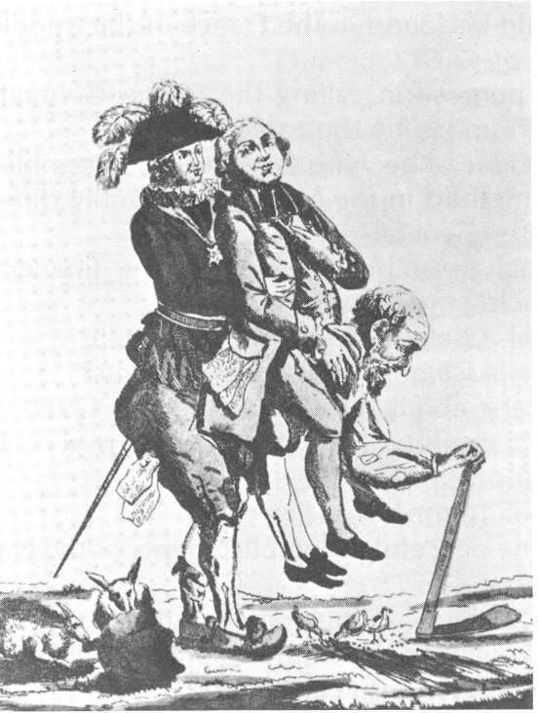

The following are the major causes of the French Revolution:

First Estate: Clergy - 130 000
- exempt most taxes
- owned church lands
Second Estate: Nobility (aristocracy) 300 000
- exempt from taxes
- owned lands
Third Estate: Peasants – 27 000 000
- pay all of the taxes
- have no rights or privileges
- France in heavily in debt
- money in France’s treasury are spent foolishly
- money spent on wars – American Revolution
against England
- heavy tax burden on Third Estate
- King needs more money – requests fail
- King calls the Estates General in an attempt
to raise money
- bread and food shortages anger peasants
- small, relatively wealthy and educated part of
the Third State
- wanted the right to participate in government
- wanted more economic freedom

- the monarch was in complete and absolute
control
- claimed to govern by ‘divine right’ – power
granted from God
- no democratic rights for people
- many ideas from thinkers and philosophers
encourage people to think and question
- French philosophes like Rousseau, Voltaire,
Diderot, present new ideas
- people start to draw up grievance lists or
cahiers
- she was an Austrian born Queen
- nicknamed madame deficit - she spent
lavishly on foolish things – Petit Trianon,
palaces, play village
- personal scandals about her behavior as
Queen
- to raise money Louis XVI calls the Estates
General for the first time since the 1600’s
- block voting system – each Estate voted
together with one vote
- Third Estate frustrated
- Third Estate locked out of their meeting place
- gather in nearby indoor tennis court
- collectively pledge not to stop meeting until
France had a new constitution, limiting the
power of the monarch
- Louis XVI orders all three estates to meet in
in what becomes called National Assembly

