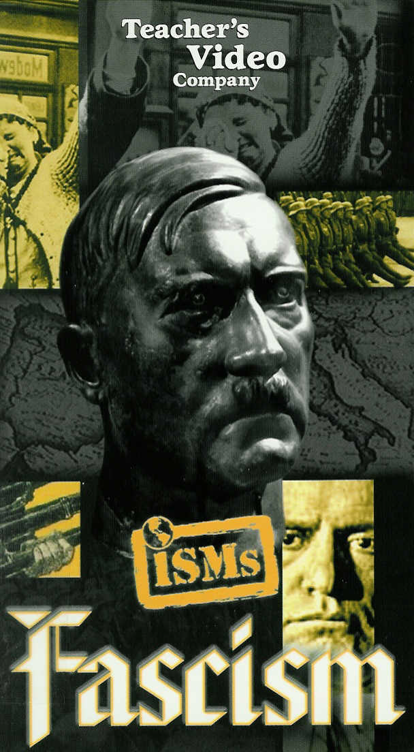

Watch the video from the ISMs series entitled Fascism, and answer the following questions:
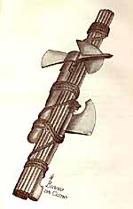
- Define fascism as an ideology.

- What does the term fascis mean? What was the first symbol of fascism?

- The first fascist state evolved in what country? __________________

- List the common characteristics of fascist dictatorships:

From the cover of Leo Pollini. Mussolini. Padre del Popolo Italiano. [Milan]: Ambrosiana Editoriale, ca. 1935.
A highly romanticized biography, with illustrations in color by the well-known Fascist artist Bruno da Osimo, and typical of books on Mussolini in this period.

- Who are some of the people that influenced fascist ideology?

- What conditions in post World War I Italy allowed Benito Mussolini to rise to power?
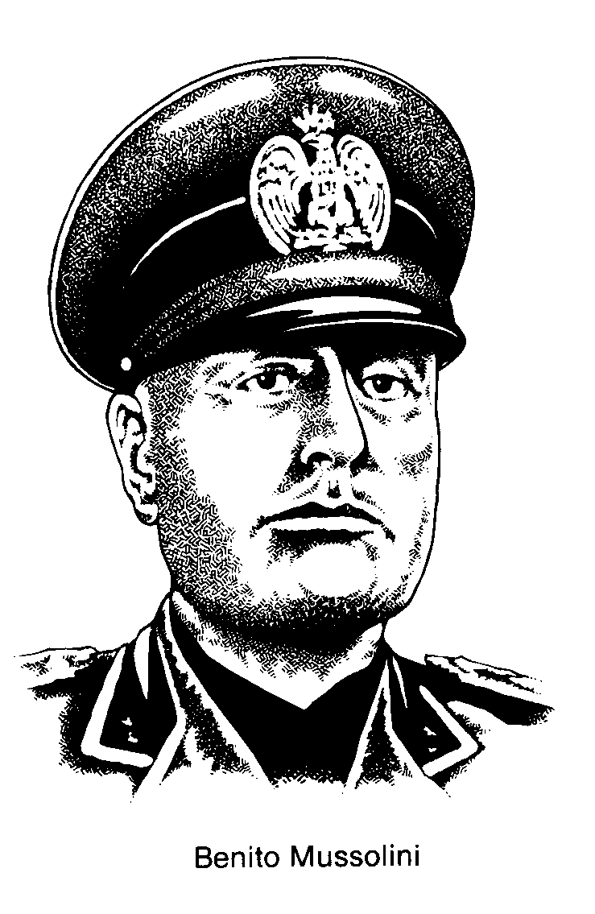
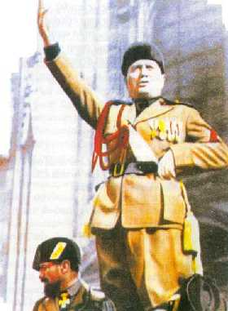

- Who were the fasci di combattimento (‘blackshirts’) or squadristi? Explain.

- What did the March on Rome bring about? Explain.

- What was the ‘Pact of Steel’?

- Who did Hitler’s fascist regime scapegoat for Germany’s problems?

- What did Hitler’s fascist regime build at place like Auschwitz and Dachau?

- What did Hitler’s fascist regime’s rearmament program do for Germany?

- In what other countries have fascist elements grown?

