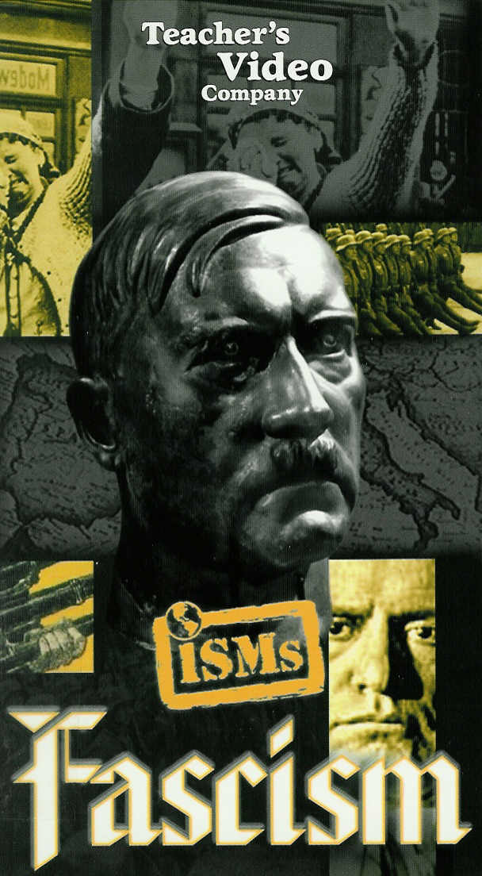

Watch the video from the ISMs series entitled Fascism, and answer the following questions:
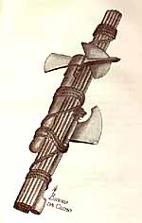
- Define fascism as an ideology.
A political system based on a totalitarian state. Individual rights are perceived as a threat to the goals of the state. Total loyalty to the nation state – unltranationalism!

- What does the term fascis mean? What was the first symbol of fascism?
Fascis is an ancient Roman symbol of power government and authority. Benito Mussolini was infatuated with Ancient Rome – wanted Italy to be a glorious as ancient Rome.

- The first fascist state evolved in what country? ___Italy___

- List the common characteristics of fascist dictatorships:
ultranationalism
single charismatic leader

From the cover of Leo Pollini. Mussolini. Padre del Popolo Italiano. [Milan]: Ambrosiana Editoriale, ca. 1935.
A highly romanticized biography, with illustrations in color by the well-known Fascist artist Bruno da Osimo, and typical of books on Mussolini in this period.

absolute national unity
masters of manipulation (propaganda)

regulation of the economy (not ownership)
contempt for democracy and communism

aggressive military expansion (social Darwinism)

- Who are some of the people that influenced fascist ideology?
Arthur Schopenhaure (1788-1860), George Sorel (1847-1922), Giovanni Gentile (1875-1945), Friedrich Nietzsche (1844-1900), Benito Mussolini (1888-1945)

- What conditions in post World War I Italy allowed Benito Mussolini to rise to power?
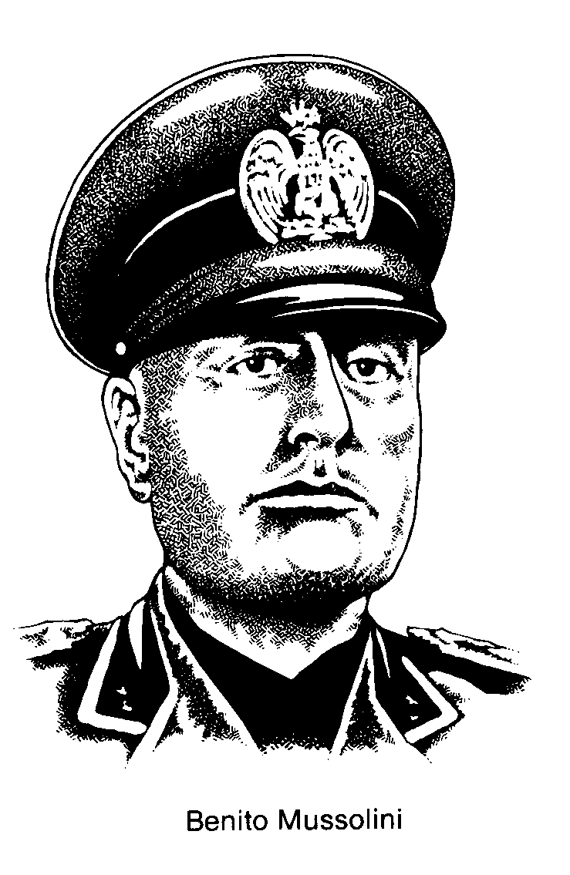
few gains from the end of WWI – promised by Allied nations
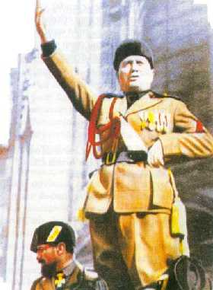
economy in ruins after WWI – no more Allied aid – massive unemployment – many soldiers returning from war

dissatisfied workers – few quality jobs - unsympathetic factory owners

radical groups offering political alternatives (communists)

diminished national pride

lack of confidence in traditional leadership

- Who were the fasci di combattimento (‘blackshirts’) or squadristi? Explain.
Groups of fascist thugs who sympathized with industrialists – they helped break up union strikes and leftist (communist) demonstrations.

- What did the March on Rome bring about? Explain.
King Victor Emmanuel allowed the Fascists to form a government with Benito Mussolini as the Prime Minister. Mussolini moves to quickly secure political control of the country.

- What was the ‘Pact of Steel’?
It was Mussolini and Italy’s alliance with Hitler and Germany. Hitler admired Mussolini.

- Who did Hitler’s fascist regime scapegoat for Germany’s problems?
They scapegoated anyone outside of Hitler’s definition of the pure Aryan race (undesirables) including Jews, Gypsies, Slavs, and homosexuals, as well as political opponents – communists.

- What did Hitler’s fascist regime build at place like Auschwitz and Dachau?
They were concentration and death camps to carry out the ‘Final Solution’ of purifying Germany and Eastern Europe – referring to the eradication of ‘undesirables’.

- What did Hitler’s fascist regime’s rearmament program do for Germany?
The rearmament program rebuilt the economy by providing jobs to ex-soldiers in the new military and in the factories that were preparing war materials. It helped to boost German pride and nationalism, while preparing Germany for expansion (Lebensraum) and for war.

- In what other countries have fascist elements grown?
There were many! Norway, Britain, Argentina

General Francisco in Spain – Hitler and Mussolini supported Franco in the Spanish Civil War (1936). Franco implements a ‘watered down’ version of their fascism. Franco had no aspirations of Spanish expansion.

Neo-Fascists movements have grown in North America and Europe with white supremacy groups who are against immigration.

‘Ethnic Cleansing’ has emerged in Rwanda and in Bosnia during the 1990’s.

