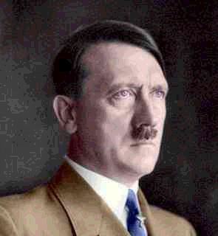
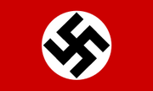
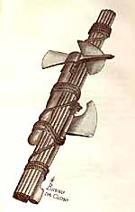

FASCISM
RISE to POWER
TECHNIQUES of DICTATORSHIP

FEAR and TERROR

PROPAGANDA

SCAPEGOATING

INDOCTRINATION
WWI Soldier – medals of honor
failed Munich
(‘Beer Hall’) putsch
resentment of
Treaty of Versailles
- lost territory
- lost Germans
- reparations
- hurt German pride
Mein Kampf
1933 elections, Nazi success, Chancellor
National Socialist German Workers Party - NAZI
Reichstag Fire
Emergency Decrees
Enabling Act
economic depression – hyperinflation , 1923
Weimar Republic
Hindenburg dies –
the ‘Fuhrer’
eliminates all political opponents – political parties, unions
extensive network of Secret Police in all parts of society
Gestapo, SS, SA,
‘Night of the Long Knives’

Ultranationalism
Hitler’s vision of a
‘Third Reich’
Racism – pure German Aryan race
Anti-communist
- blame communists for the Reichstag fire
Anti-semitic – hatred of Jews
Pure German – eliminate all ‘undesirables’
‘Final Solution’ - holocaust
Nuremburg Race Laws
Kristallnacht – ‘night of the broken glass’
Ghettos, Concentration, Work, and Death camps
Dachau
Auschwitz
Buchenwald
Militarism –
re-armament
Wehrmacht
Kriegsmarine
Luftwaffe
‘Lebensraum’ – living space
expansion – reclamation of lost territory
Rhineland
Sudetanland
Polish Corridor
charismatic leader -
anti-communist
-Social Darwinism
Mussolini in Italy
(fascis)

Joseph Geobbels
Minister of Propaganda and Public Enlightenment
rallies at Nuremburg
control of all media
‘Hitler Youth’
Gleischaltung – Nazi organiztions throughout society
posters, bill boards of Hitler everywhere
- re-write history

