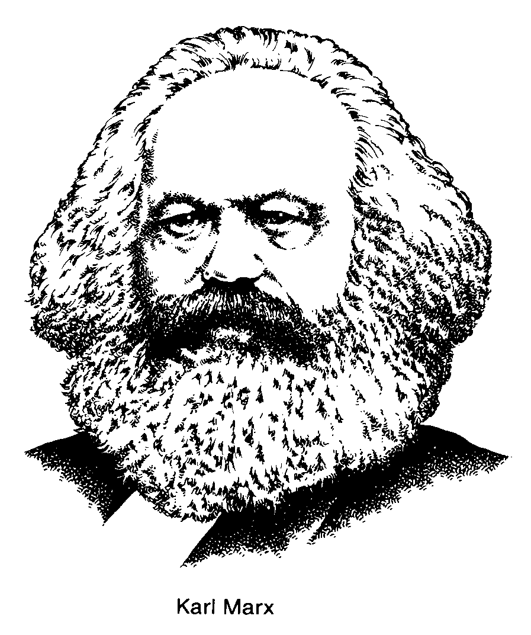
Socialism owes its existence to capitalism. It grew as a counter to the excesses of free enterprise. As the industrialization of Europe took place, the workers suffered. Groups of intellectuals came to believe that capitalism had failed to bring the benefits that Adam Smith had promised. One such group formed in the same city that was capitalism's birthplace - Paris. Called the League of the Just, it began in 1836. Its members argued that, as capitalism had failed the people, an alternative system was needed. The League of the Just changed and became, in 1847, the Communist League. In the year it formed, the Communist League held an important meeting in London, England. Two German intellectuals were invited to take part; they were Karl Marx and Friedrich Engels. The Communist League asked Marx and Engels to write a
document outlining the group's aims. The next year, 1848, The Communist Manifesto was published. It became the foundation of modern socialism. (It is important to know that the communism of Marx and Engels is, not much like the communism of China and the Soviet Union. Today's socialists say these communist states distort socialist principles beyond recognition.)
Marx and Engels predicted that as capitalism advanced the ownership of industry would be concentrated into fewer and fewer hands. They said that capitalists would exploit workers and consumers in their drive for ever higher profits. They also said capitalism wouId cause a series of depressions, and that one of these downturns would cause the system to collapse. Following the collapse, the workers (proletariat) would seize control of the means of production from industry owners (bourgeoisie).
In fact, although there have been shaky spells, capitalism has not collapsed. Slowly, most socialists have accepted that free enterprise has a place in the scheme of things. Most socialist ideas have developed as a reaction to capitalism. Here are some of the things they believe in today:

- The common good is more important than individual wealth and success.
- Society should be cooperative not competitive – equality (egalitarianism) most important
- Major industries - transportation, minerals, etc.- should be owned by the state to ensure they operate for the common good.
- The government should have a major role in the economy to direct private enterprise to produce what the government determines is necessary.
- Through taxation, wealth should be taken from the rich to be distributed among the poor
- The government should regulate business to ensure: fair prices, safety in the workplace, good employment practices, and pollution-free industry.

As with capitalism, there are varying shades of opinion among socialists. Some don't go as far in their beliefs as the list above, while others go further.

