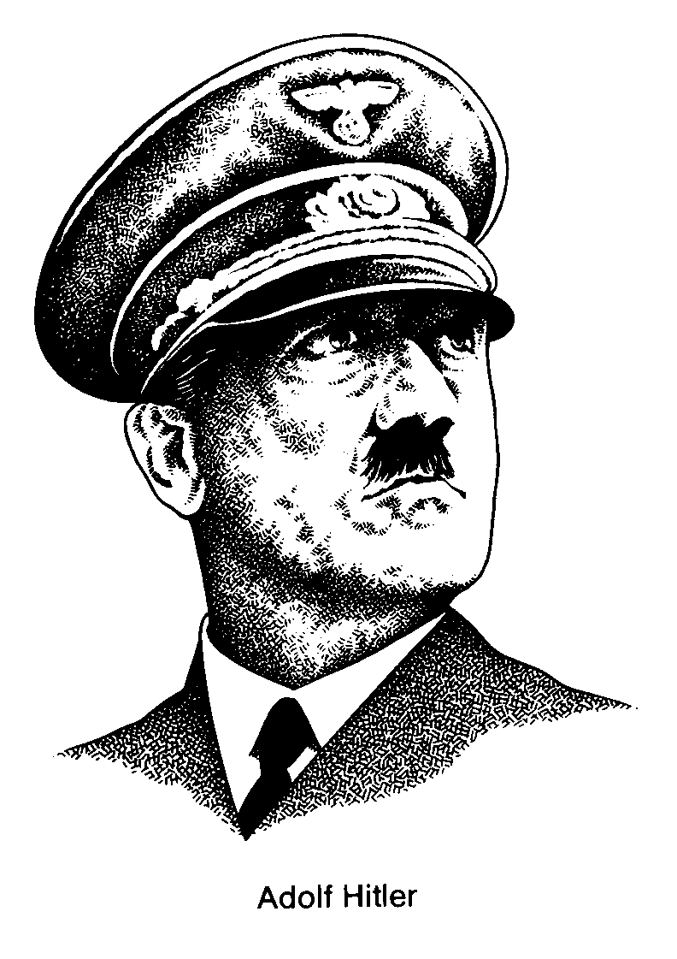

Watch the video entitled Life Under Hitler, and answer the following:

- Did Hitler first come to power as Chancellor legally (constitutionally) in 1933? Explain.

- Explain how the Reichstag fire was used by Hitler to gain support, power and control.

- How did Hitler gain absolute power after the 1933 elections? Explain.

- Explain the Nazi Party policy of Gleichschaltung.

- What groups did Hitler and the Nazis ban? Why?

- What was the Gestapo? What was the SA (Stormtroops)?

- What was the ‘Night of the Long Knives’? Why was it so significant?

- How did the leadership of Germany change after President Hindenburg died?

9. How did the Nazis rebuild the German economy and German pride (nationalism)?

10. What were the Workers Fronts (DAF)? What impact did they have?

- What was the economic policy of autarky?

- Explain the extent of Nazi organizations. How did they impact the youth?

- How were the focus of boys and the girls different in the ‘Hitler Youth’ organizations?

- Explain the quote “If first you burn books, it will not be long before you will burn people.”

- Who was Joseph Goebbels? What was his role in the Nazi empire?

- Who did the Nazis scapegoat for Germany’s problems? What were the Nuremburg Laws?

- What was the ‘Final Solution’? Explain.

- What attitude did most of the general German population
take towards the terror in their country?

19. What was Germany’s policy of Lebensraum? Explain.

