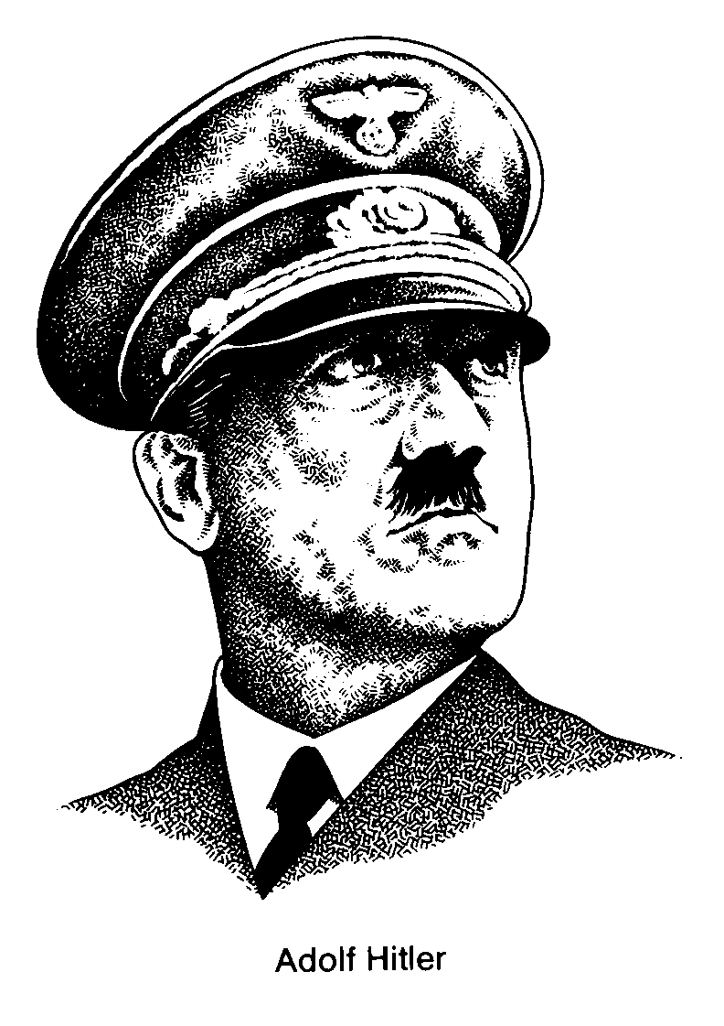

Watch the video entitled Life Under Hitler, and answer the following:

- Did Hitler first come to power as Chancellor legally (constitutionally) in 1933? Explain.
Yes! After a failed putsch (coup d’etat) in Munich (Beer Hall Putsch) in 1923, Hitler is imprisoned and writes ‘Mein Kampf’`(My Struggle). He realizes he must build the support for the Nazis and come to power constitutionally (legally).

Weimar Republic –German Reichstag Elections - NAZI Seats

Election Seats Election Seats

May 1928 12 Sept. 1930 107
July 1932 230 Nov. 1932 196
Jan 1933 Hitler Chancellor March 1933 288

- Explain how the Reichstag fire was used by Hitler to gain support, power and control.
The Reichstag building is set on fire. Hitler immediately blames his political opponents – the communists. Hitler uses this to raise the paranoia of the German people and offers them calm and security if the Nazis are given the power to do so.

- How did Hitler gain absolute power after the 1933 elections? Explain.
After the Reichstag fire President Hindenburg passes the Emergency Decrees to suspend civil liberties. Then members of the Reichstag vote overwhelmingly (441 to 94) to support the Enabling Acts which give Hitler and the Nazis exclusive executive power for four years.

- Explain the Nazi Party policy of Gleichschaltung.
This was the Nazi policy that extended control of the party to all aspects of society. Countless Nazi organizations were created. It also suspended the power of regional governments and centralized that power with the Nazis in Berlin.

- What groups did Hitler and the Nazis ban? Why?
They banned all other political movements, being especially harsh on the left wing parties like the communists. They also banned church groups, unions, and any other organization that could possibly threaten their power and control.

- What was the Gestapo? What was the SA (Stormtroops)?
The Gestapo was the most important branch of the secret police network. The Nazi military was known as the SA. The SA was 20 times bigger than the German army left over from WWI.

- What was the ‘Night of the Long Knives’? Why was it so significant?
SA leaders become restless, feeling they were not being justly rewarded for their work. Post-WWI German military leaders are worried about the SA, and they are the only remaining threat to Hitler. Hitler cuts a deal with the German military. He will purge key members of the SA if German military pledges allegiance to him. Hundreds of key SA members were executed.

- How did the leadership of Germany change after President Hindenburg died?
Hitler takes over Presidency and calls himself ‘Fuhrer’ (the leader) – no more separation of powers.

9. How did the Nazis rebuild the German economy and German pride (nationalism)?
He created large public work projects – public housing, bridges, highways (autobahns), a car for every German (Volkswagen). He also spent a lot of money on re-arming Germany – Luftwaffe (airforce), Wehrmacht (army), Kriegsmarine (Navy) – in violation of Versailles.

10. What were the Workers Fronts (DAF)? What impact did they have?
They replaced unions which were banned and workers were glorified for rebuilding Germany – the ‘Third Reich’. Incentives were used – family holidays. Young men enlisted for one years public service.

- What was the economic policy of autarky?
Autarky = self sufficiency. Hitler did not want to have to rely on other nations for anything.

- Explain the extent of Nazi organizations. How did they impact the youth?
The organizations stretched into every aspect of German life ie. small gardeners associations, teachers and student organizations, doctors, lawyers, and even Nazi fisherman’s organizations. He even tried to establish a National Reich Church. Key were the Hitler Youth (HJ) organizations that were intended to indoctrinate the young.

- How were the focus of boys and the girls different in the ‘Hitler Youth’ organizations?
Boys in the HJ were preached fitness, obedience to the Fuhrer, military skills, discipline and courage. Girls were preached home economics, motherhood, and racial purity. Women taught that they should contribute to growing the pure Aryan race for Germany.

- Explain the quote “If first you burn books, it will not be long before you will burn people.”
Books represent ideas. Ideas come from people. If you are willing to burn books…

- Who was Joseph Goebbels? What was his role in the Nazi empire?
He was the Minister of Public Enlightenment and Propaganda. The ministry controlled all forms of culture – media, books, radio, film, art, school curriculum. He organized massive rallies to grow ultranationalistic feelings – grounds at Nuremburg were built. 1936 Olympics.

- Who did the Nazis scapegoat for Germany’s problems? What were the Nuremburg Laws?
Main ‘scapegoats were the Jewish people and communists. Also scapegoated any other ‘undesirables’ in Germany – gypsies, homosexuals, mentally and physically handicapped.

- What was the ‘Final Solution’? Explain.
Program devised at the Wannsee Conference to systematically eliminate Jews and other undesirables from Germany and Eastern Europe. Concentration and death camps were set up to carry out the master plan – Dachau, Mauthausen, Auschwitz, Treblinka, Sobidor, Chelmno

- What attitude did most of the general German population
take towards the terror in their country?
Life dramatically improved for most Germans under the leadership of Hitler and the Nazis until the outbreak of WWII. Most did not support the evil aspects of the regime, but were too scared to speak out.

19. What was Germany’s policy of Lebensraum? Explain.
Lebensraum = living space. Hitler and the Nazis start to speak of needing more room for the ‘Third Reich’ and as a result achieve autarky.

