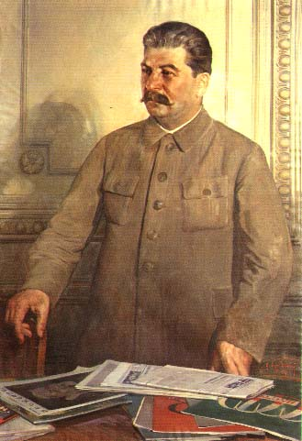
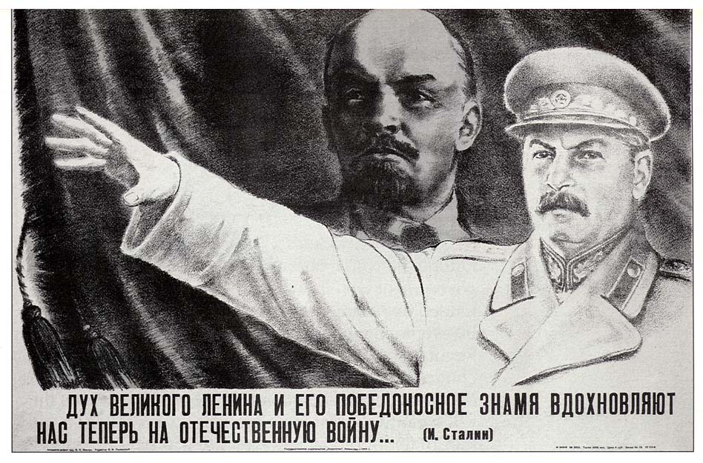

Watch the video entitled Life Under Stalin and answer the following questions:

- How did Stalin take control of the Communist Party after Lenin’s death?

- What eventually happened to Leon Trotsky?

- What was Stalin obsessed with doing to the Soviet Union?

- Who were the Kulaks? What was the policy of de-Kulakization?

- What was collectivization? Was the policy a success? Why or why not?

- What was the Great Famine in the Ukraine? Why did it happen?

- Describe what happened in the First Five Year Plan.
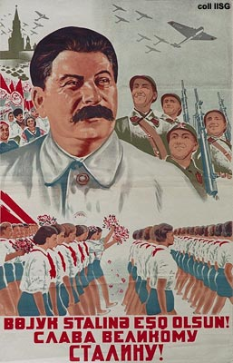

- Describe what happened in the Second Five Year Plan.

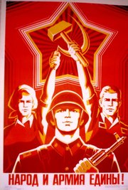
- How was propaganda used in Stalin’s Soviet Union?

- Describe Stalin’s totalitarianism.

- What changes did Stalin make to society in terms of women and education?

- Describe what Stalin did to build a personality cult around him?

- Describe the ‘Great Terror’ and the ‘purges’. Who were the targets and why?

- What were ‘show trials’ in Stalin’s Soviet Union?

- What was life like in the gulags?

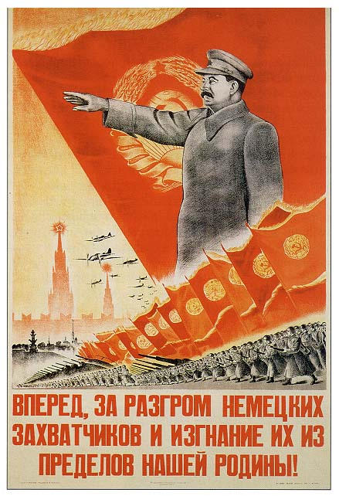

- What did Stalin do in 1939 to try and protect the Soviet Union? Did it work?

- Did Stalin’s ends justify his means?
